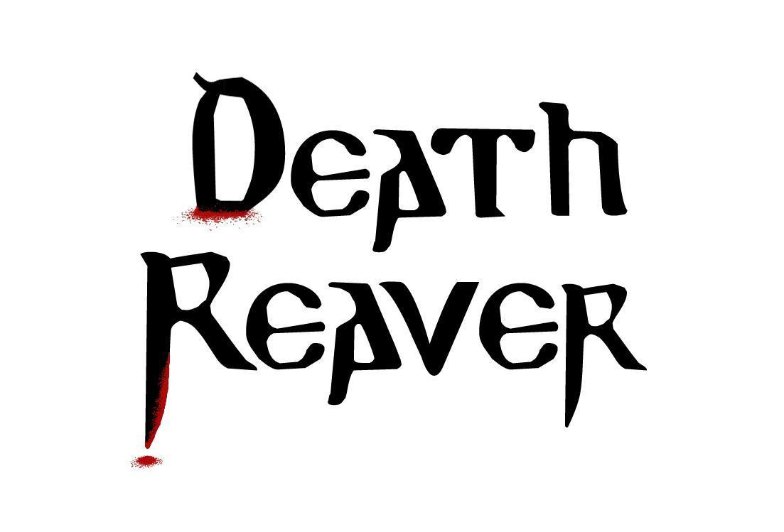

**Art Style Guide**

HORSEMEN

V 1.0

|  |  |  |
| --- | --- | --- |
| **Team Roster** | | |
| **Position** | **Name** | **Signature** |
| Designer / Artist | Nicholas Hunter |  |
| Aritst | Aundray Oritz |  |
| Artist / Animation | Jared Bittner |  |
| Artist | Ryan Tonks |  |
| Artist | James Countryman |  |
| Programmer/ Designer | Ian Smith |  |
| Executive Producer | Gideon Shbeeb |  |

**Document Revision Table**

|  |  |  |  |
| --- | --- | --- | --- |
| **Version** | **Updates** | **Advocate** | **Date** |
| 1.0 | Initial Document | Jared Bittner | 03/01/15 |
| 2.0 | RTM | Nicholas Hunter | 04/25/15 |
|  |  |  |  |
|  |  |  |  |
|  |  |  |  |
|  |  |  |  |
|  |  |  |  |
|  |  |  |  |

Contents

Aesthetic Summary 6

Game Art Overview 7

Technical Overview 8

Lighting 8

Colors 8

Materials/Textures 9

Asset List 9

Models: 9

Ancient documents 10

Ancient plate 11

Ancient tablet 12

Armor pick-up item 12

Autopsy table 13

Baton 13

Bench 14

Bomb 14

Cannon 15

Car – blue 15

car – green 16

car – red 16

car – yellow 17

Column 17

Display cube 18

Door 19

Fence post 20

Gore Pile 20

Grenade from the future 21

Guillotine 21

Human Female civilian - All variants 22

Human Male Civilian - All variants 24

Jet engine 26

Jousting lance 26

Kesh exhibit left 27

Kesh's exhibit forward 27

Kesh's exhibit Right 28

Kesh's mace 29

Kesh's staff 30

Kesh's sword 31

Lab table 31

Large pot – Blue 32

Large pot – Green 32

Large pot – Red 33

Lobby desk 33

Long display case 34

Medical tool table 34

MG-32 35

Modern art - windows – blue 35

Modern art - windows – brown 36

Modern art - windows – green 36

Modern art - windows – pink 37

Modern art - windows – purple 38

Modern art – boxes 38

Morning star 39

Mural – blue 40

Mural – green 40

Mural – red 41

Obelisks 42

Paintings - 10 variations 43

Podium 44

Police barricade 44

Police car 45

Potted shrub – short 45

Potted shrub – tall 46

Pyramid – green 46

Pyramid – purple 47

Pyramid – tan 47

Revolver 48

Rocket 48

Round shield 49

Satellite 49

Scientist 50

Seal 50

Sickle 51

Space capsule 51

Stanchion 52

Stanchion and rope 52

Stone wall 53

Tall bush 53

Tall display case 54

Tank 54

Templar shield 55

Thompson sub-machine gun 55

Tree 56

Vase – brown 56

Vase – green 57

Vase - light blue 57

vase – purple 58

Window 58

Wooden fence 59

Animations: 59

Particles: 60

Armor pickup 60

Block 61

Blood burst 62

Charge 63

Drive 64

Gunshot 65

Exit Scene helper 66

Stalwart 67

Unbreakable 68

Textures and Materials: 69

# Aesthetic Summary

The world is stylized, vivid and is filled with bright pastel colors. The game takes place in an idealized version of 1950’s post-war America. The museum is a grand spectacle of granite and marble and feels as if it’s filled with all the world’s wonders. Thematically speaking in terms of the story, it is a monolithic temple to the arrogance of mankind in its golden age. This setup creates a nice dichotomy visually and emotionally for the player once our protagonist Kesh is awoken and begins committing his vengeance killings. He is comprised of dark, earthy colors represents something ancient and unknown coming to clash with the modern era.

# Game Art Overview

All objects are spaced evenly throughout the game, however as the story progresses from the lab out into the open world outside of the Museum objects are spread further and further apart. The lab is packed tightly with an operating table, several NPCs to kill and many machines which fill the space up. The exhibit is more open however it still is filled with NPCs and many of Kesh’s items. The main floor of the museum and exterior spread game objects and NPCs/ Enemies out while opening up the space. The camera also zooms out little by little with each successive level. In this way the game creates a sense of claustrophobia for the player which can only be overcome by level progression. This effect is aided by the lighting. Visual consistency is established through the use of lighting and color, however it is the player that breaks this consistency. Kesh is a point of dissonance in this serene and vivid world through his actions, colors and demeanor. Metaphorically speaking, he is a bull in a china shop clamoring to be free. Therefore the architecture and game elements open up to compensate for this throughout gameplay.

# Technical Overview

## Lighting

All of the lighting for both the interior and exterior of the museum takes on the color of pastel yellow. Lighting is low key throughout the majority of the museum, however it gradually brightens as the player progresses through the game. For example, beginning with the Lab the room will be dimly lit, containing only 2-3 ambient lights of low intensity. Progressing out into the exhibit, the walls will be lined with ambient lights of medium intensity. The same medium intensity ambient lights decorate the walls of the interior of the large bulk of the museum however, large windows around the main floor’s walls flood the rooms with high intensity directional lights to give the illusion of natural light breaking into the museum and cast long diffuse shadows. The museum’s exterior is lit with a single high intensity directional light high above the scene in order to mimic the effects of daylight. This general progression of darkness to light throughout gameplay lends the player a sense of escape as Kesh awakens and commences his bloody quest for revenge.

## Colors

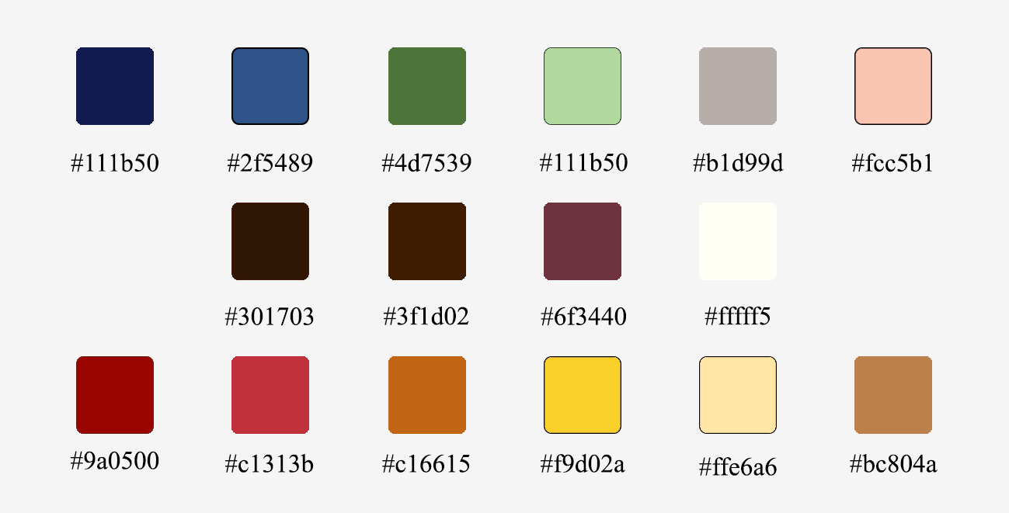

Colors in the world of Death Reaver are mostly bright primary and pastel colors, which lends the world a certain authenticity and realism to the game. Kesh’s primary color palette will consist of dark earth tones, purples and oranges to contrast with the bright primary colors of the rest of the world and what NPCs wear such as ladies in pastel green sun dresses, men in blue jeans with light grey tweed jacket or the police officers in dark blue uniforms.

# Materials/Textures

Textures and materials in Death Reaver are converted into faux low-poly representations within unity by making use of the *PolyWorld for Unity* plugin. This editor allows users to paint swabs of color directly onto models and characters for increased workflow. All character textures have resolutions of 512, with the exception of the protagonist, Kesh, whose textures 2048.

# Asset List

## Models:

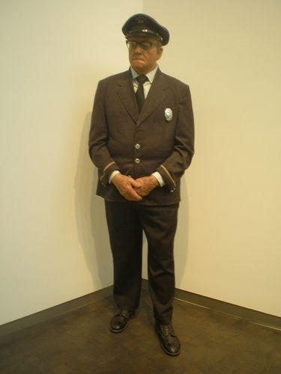

### Ancient documents

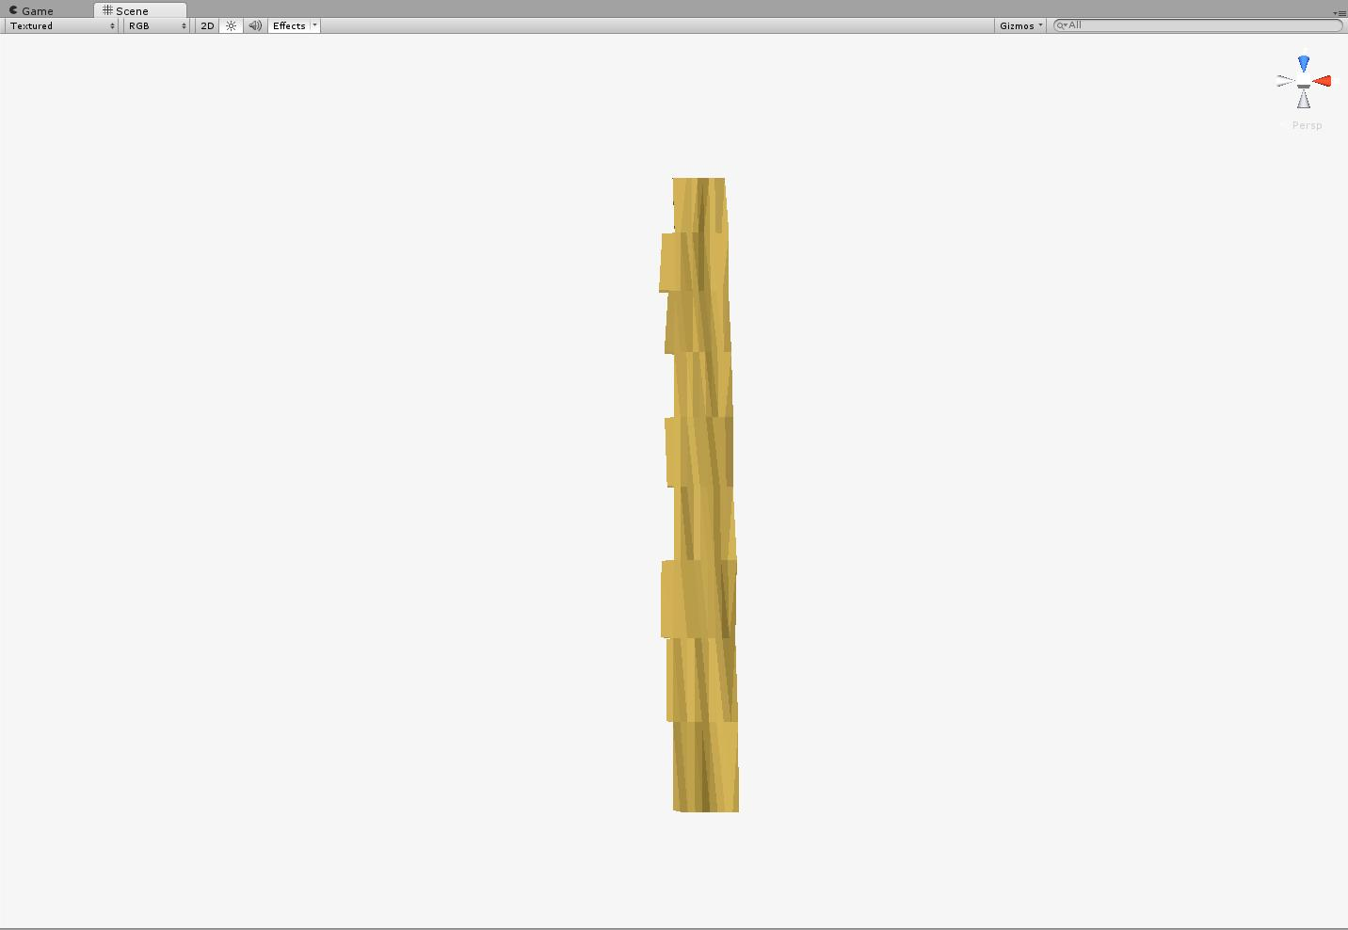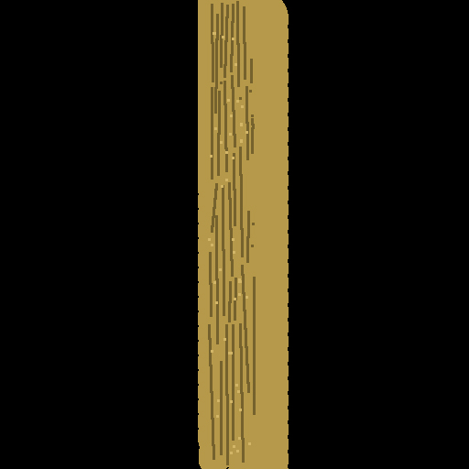

Figure : Ancient documents – 218 polys

### Ancient plate

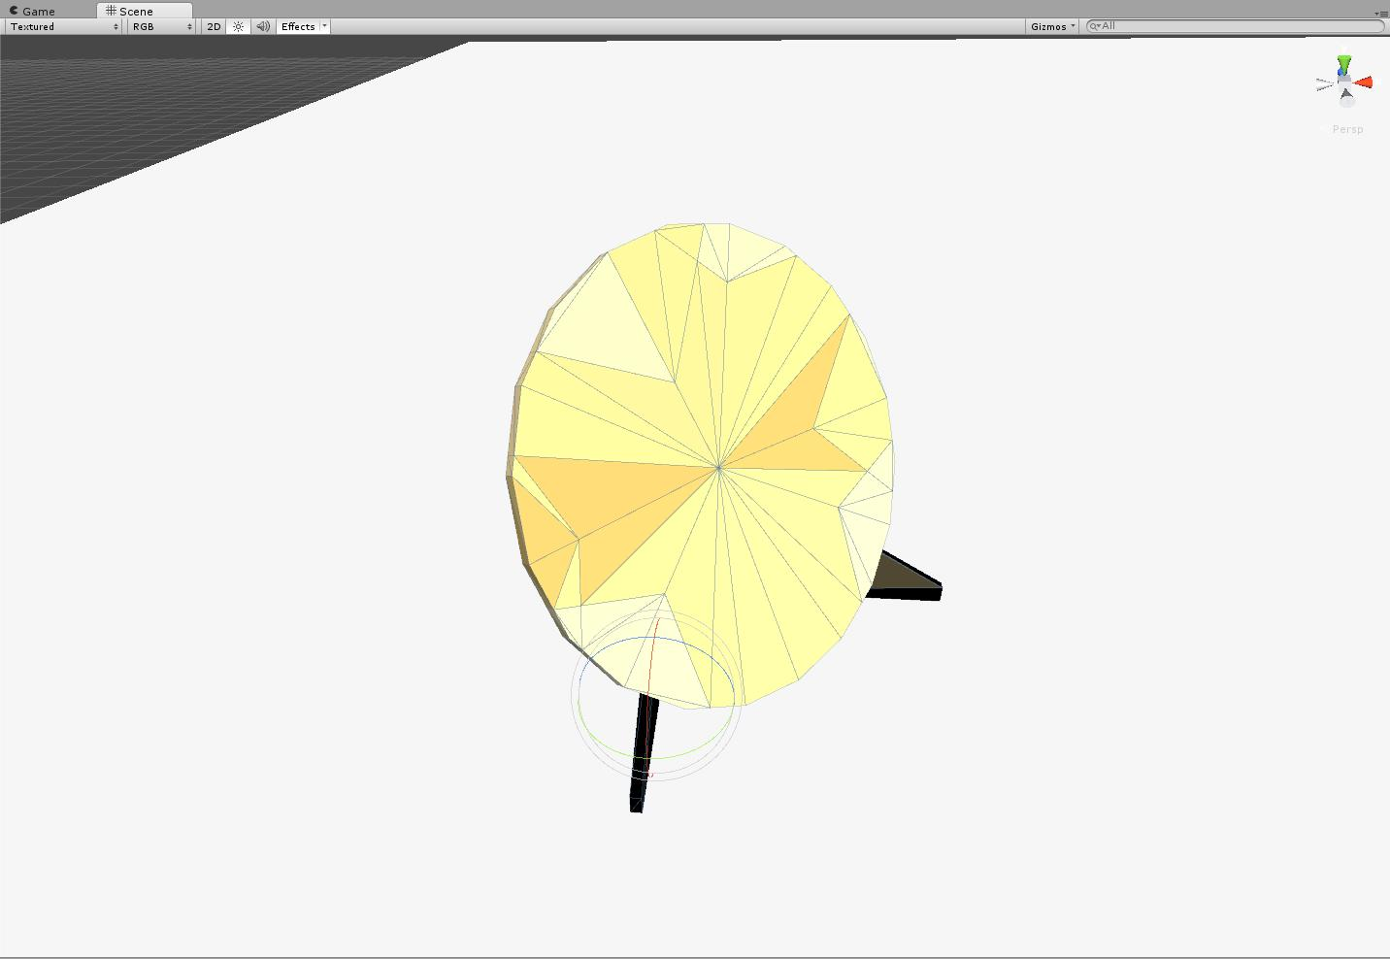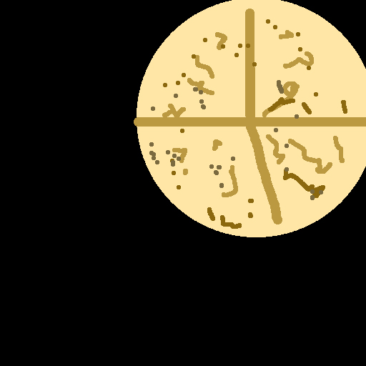

Figure : Ancient plate – 94 polys

### Ancient tablet

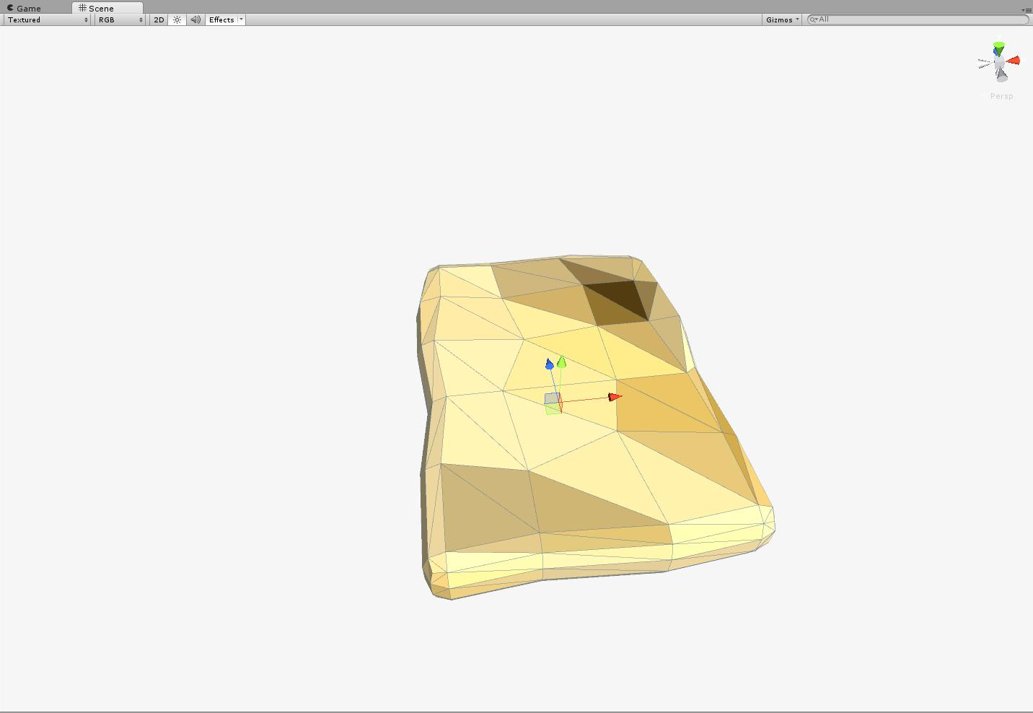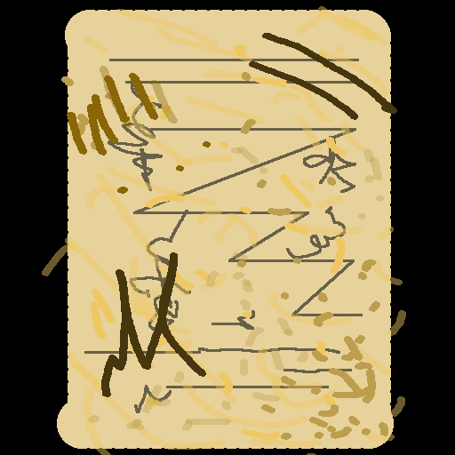

Figure : Ancient tablet – 142 polys

### Armor pick-up item

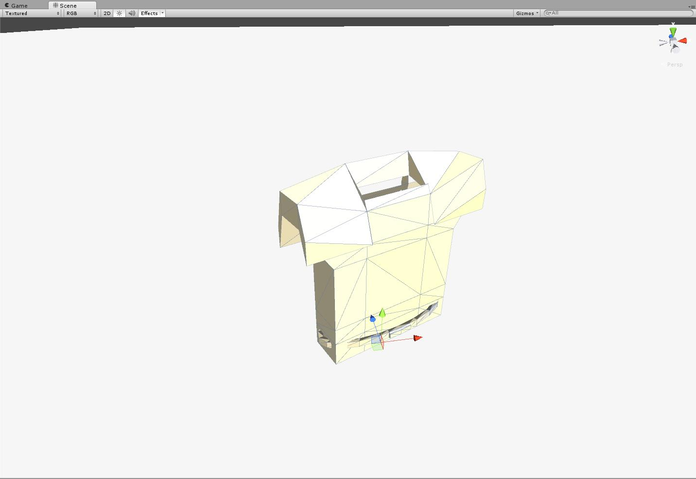

Figure : Armor pick-up item – 161 polys

### Autopsy table

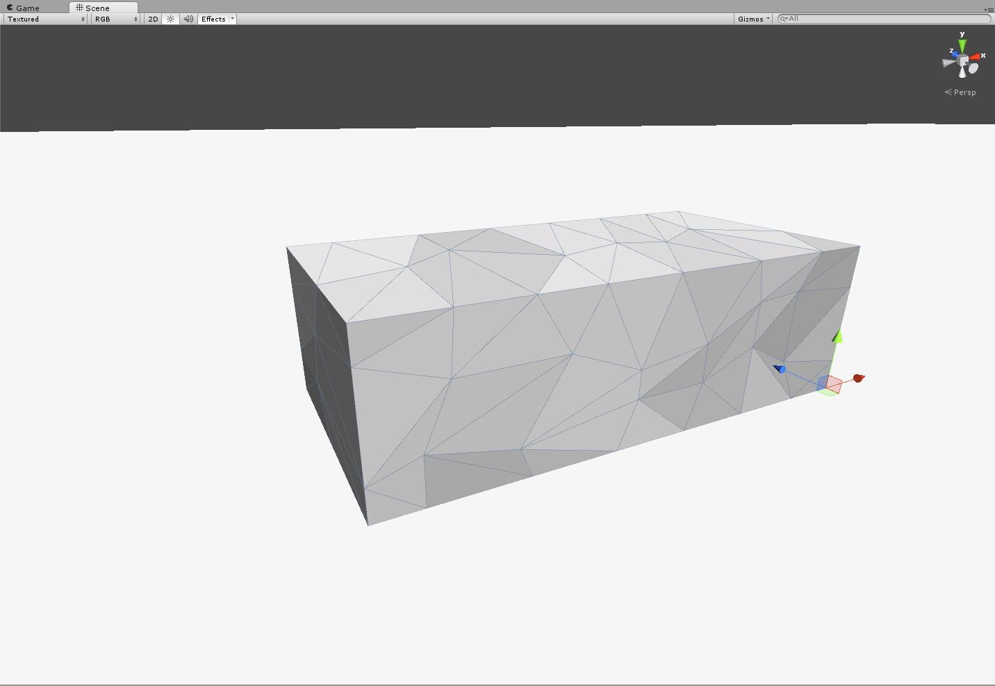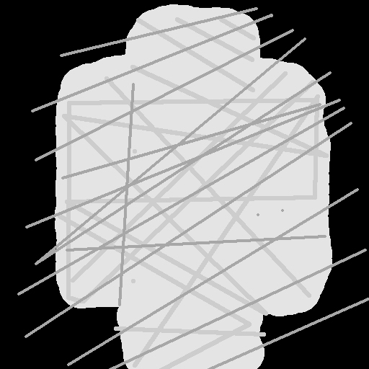

Figure : Autopsy table – 68 polys

### Baton

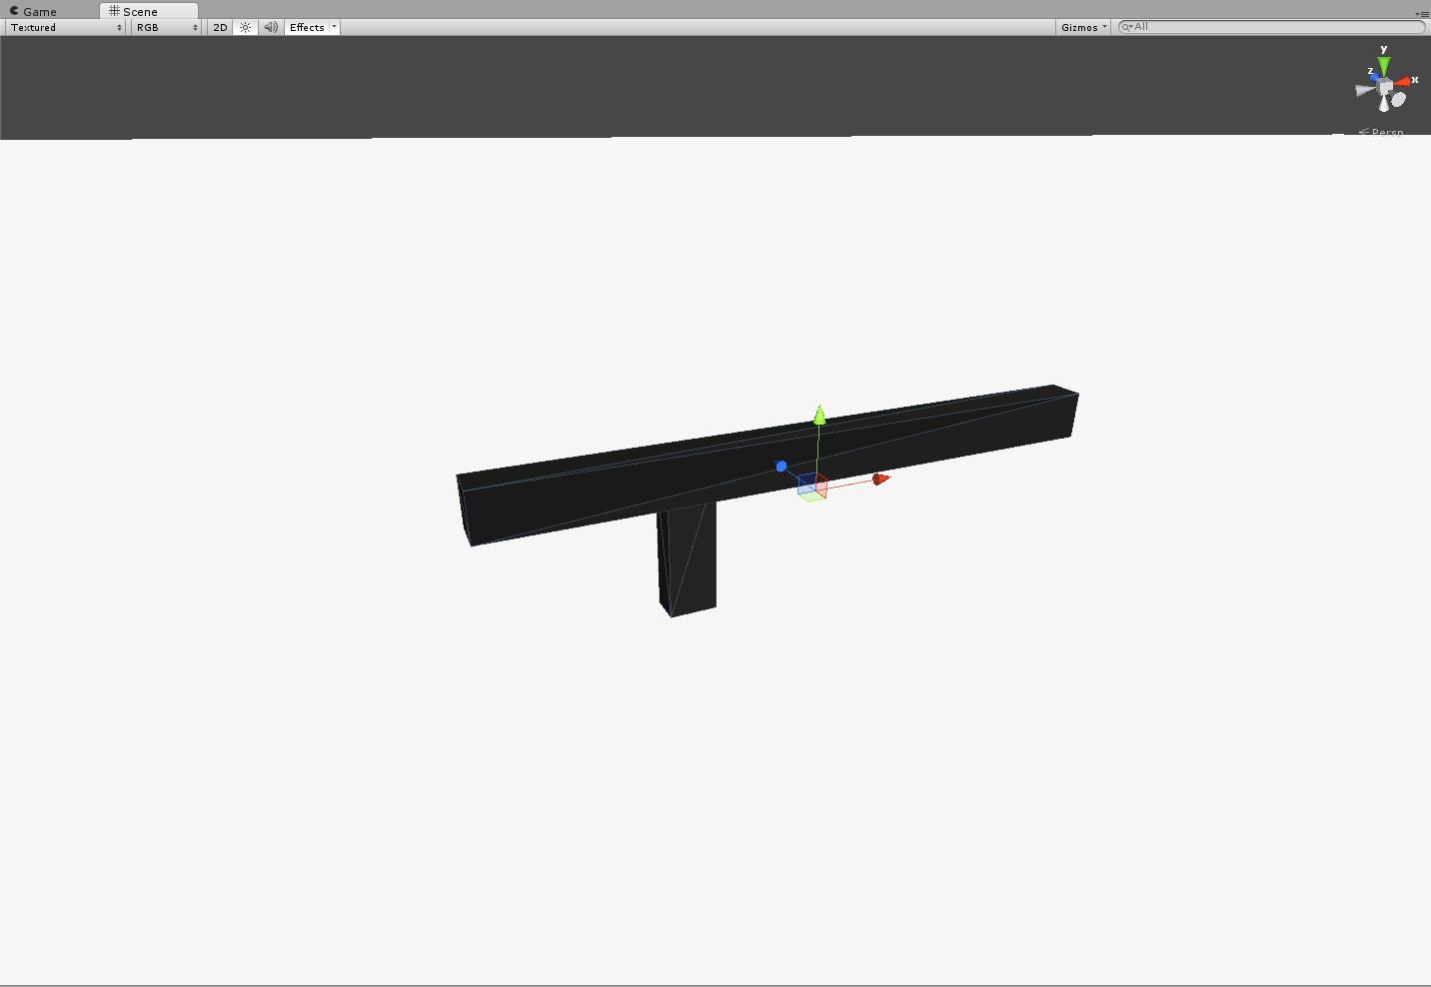

Figure : Baton – 12 polys

### Bench

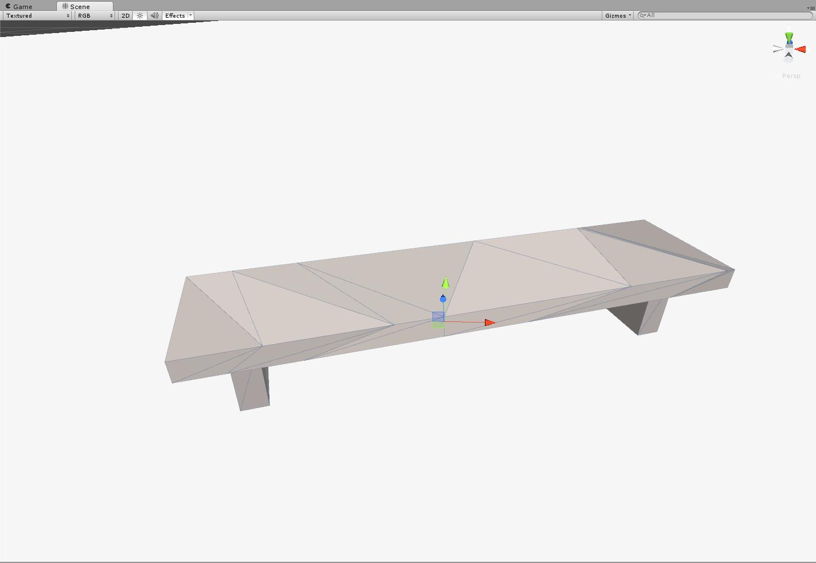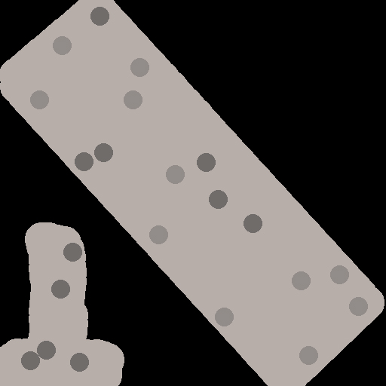

Figure : Bench – 38 polys

### Bomb

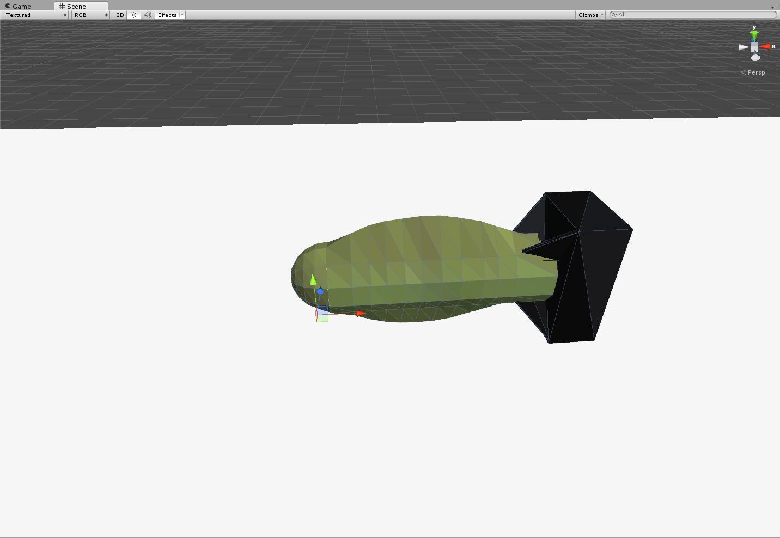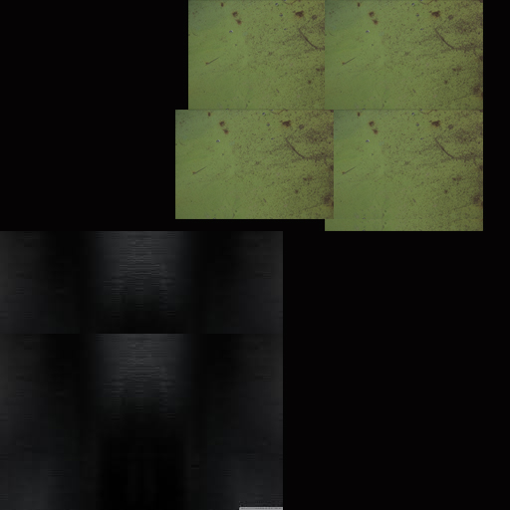

Figure : Bomb – 210 polys

### Cannon

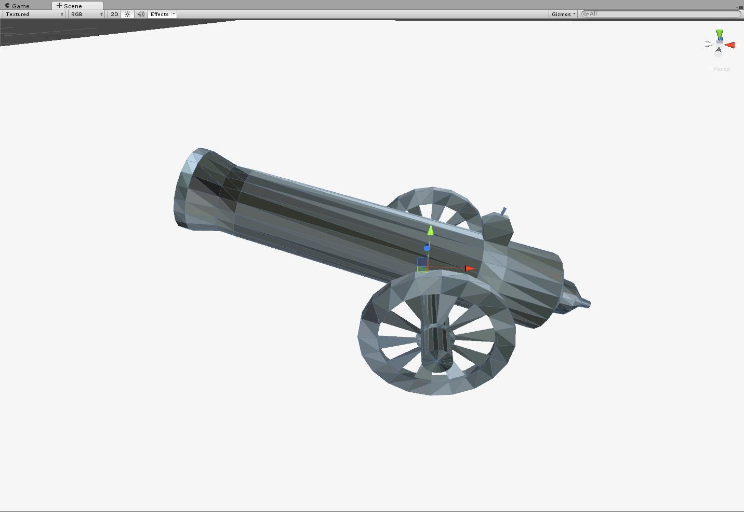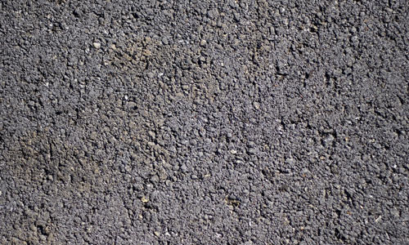

Figure : Cannon – 948 polys

### Car – blue

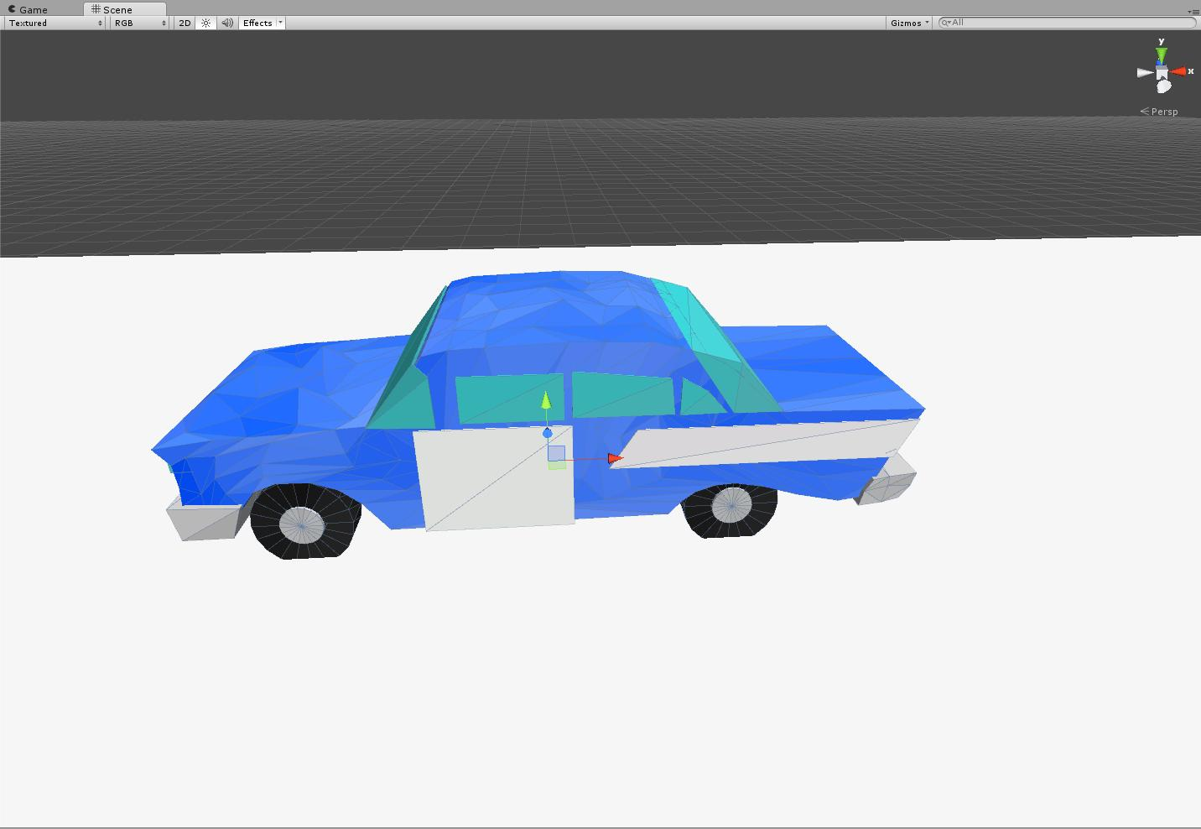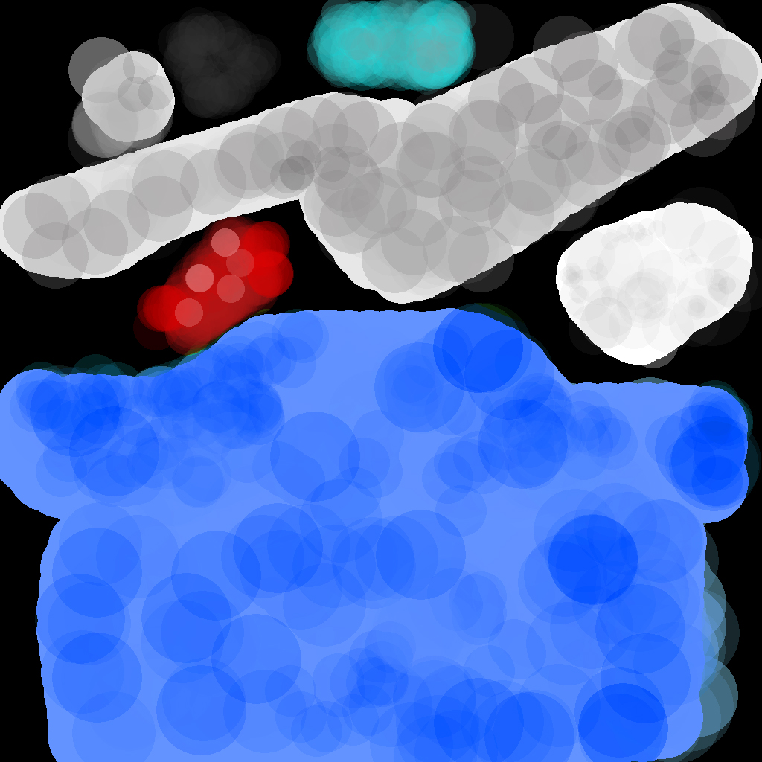

Figure : Car – blue – 763 polys

### car – green

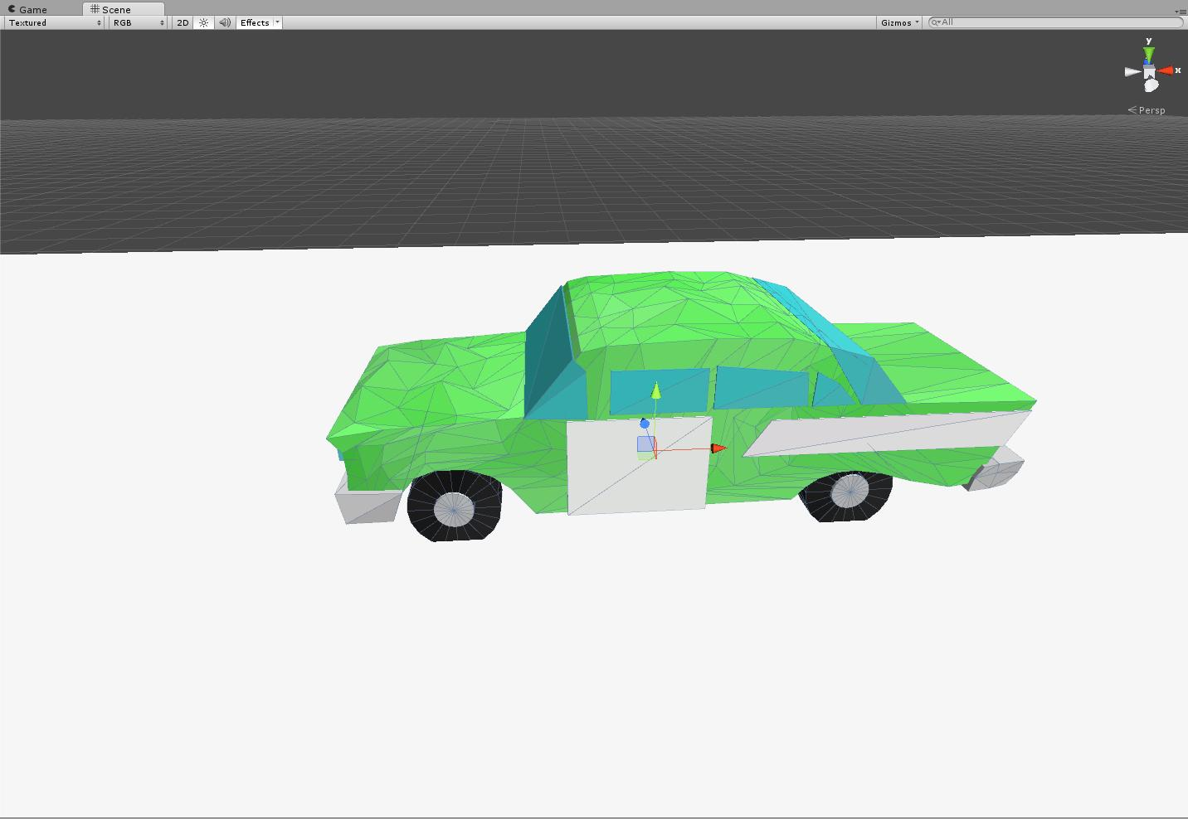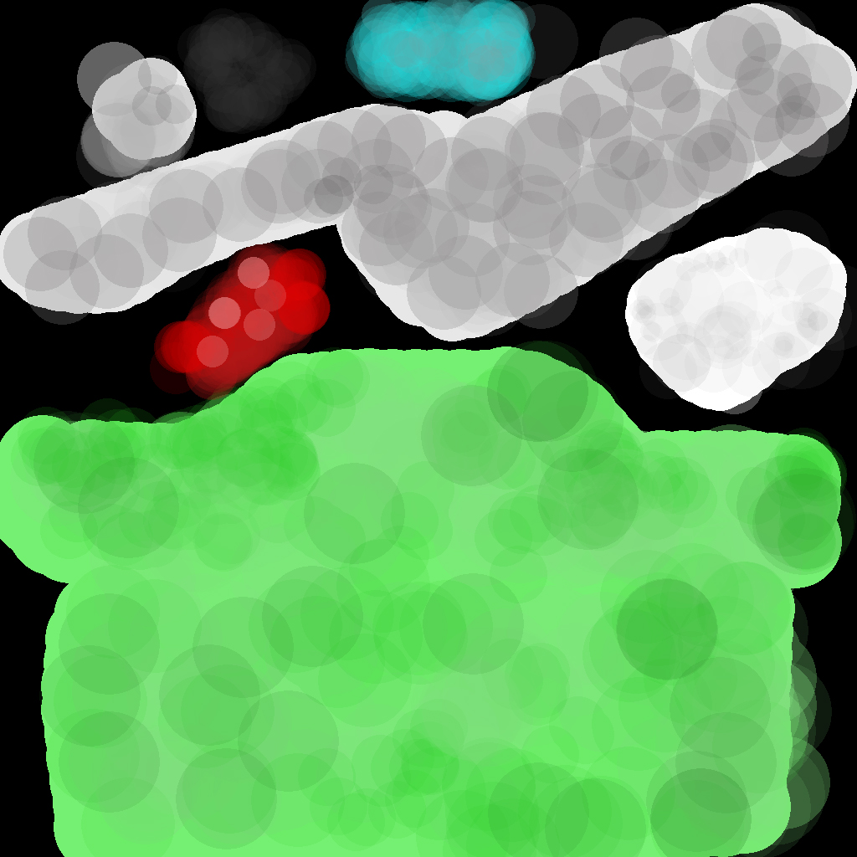

Figure : car – green – 763 polys

### car – red

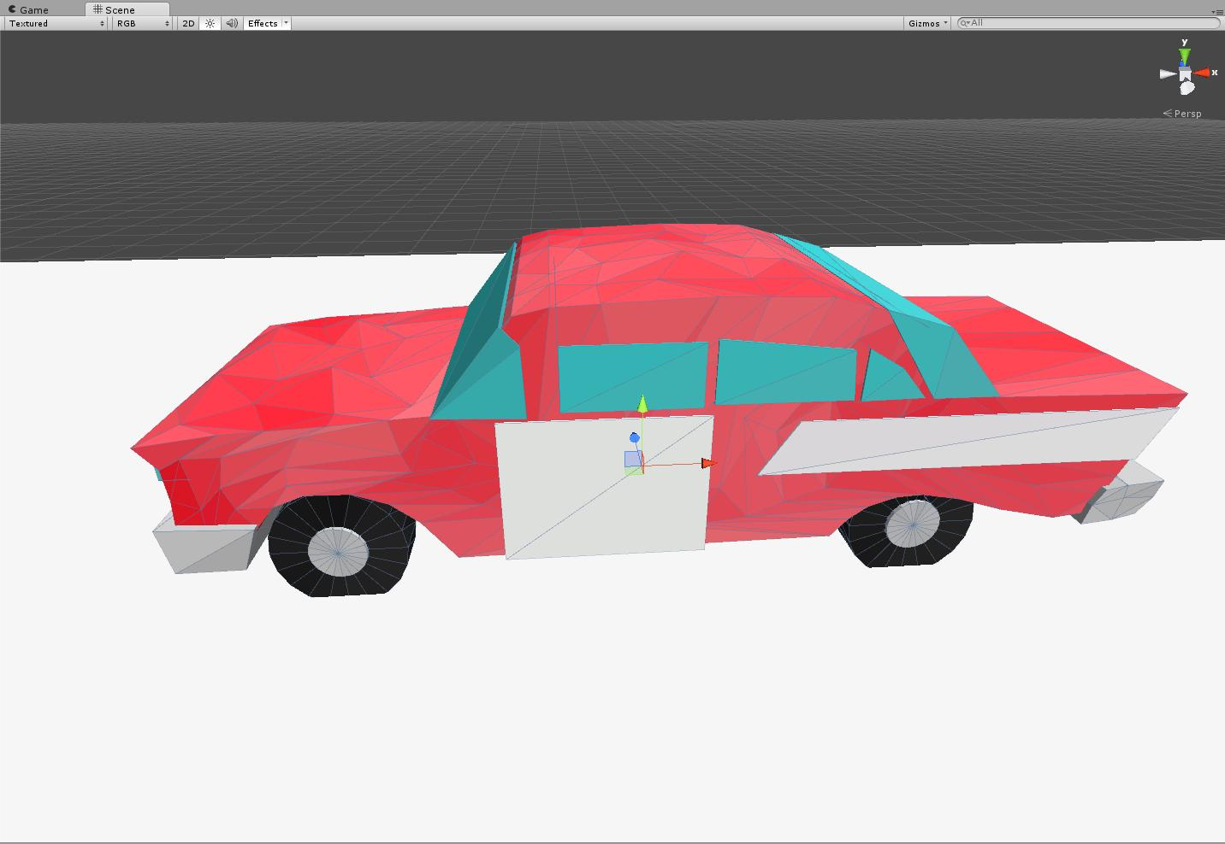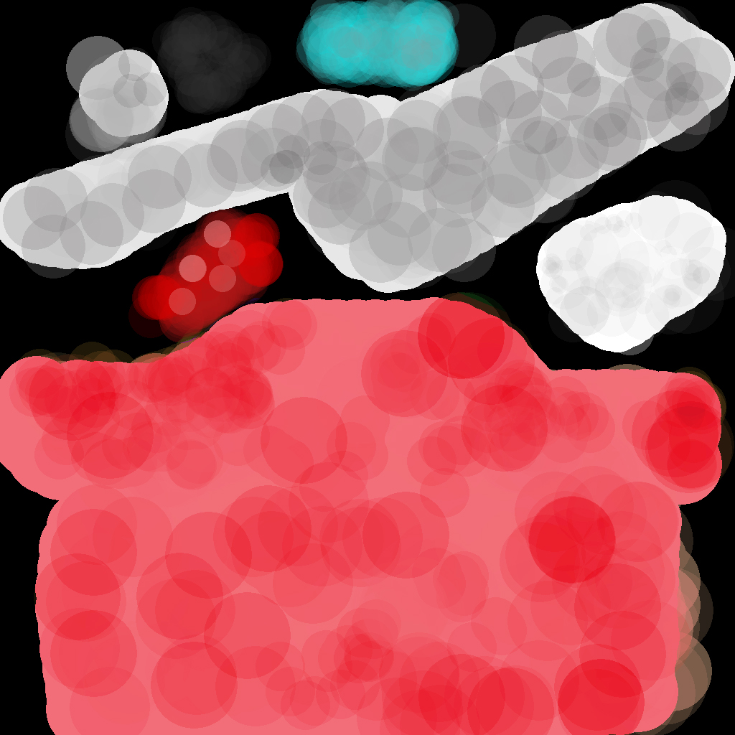

Figure : car – red – 763 polys

### car – yellow

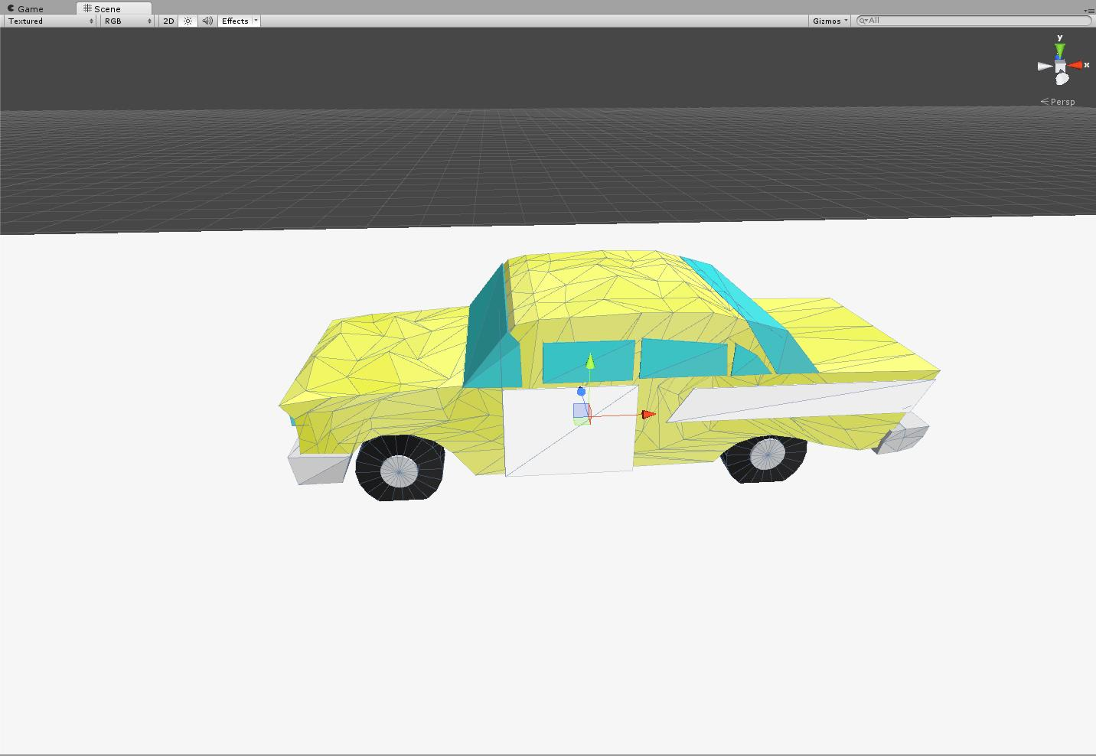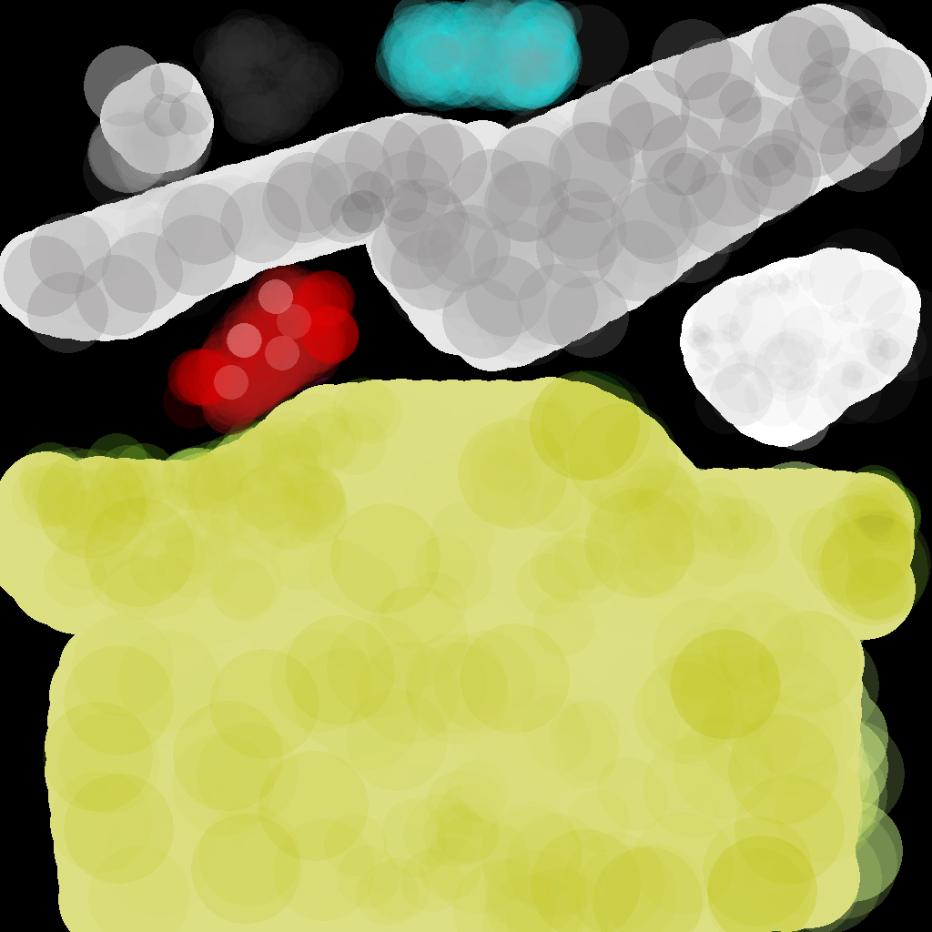

Figure : car – yellow – 763 polys

### Column

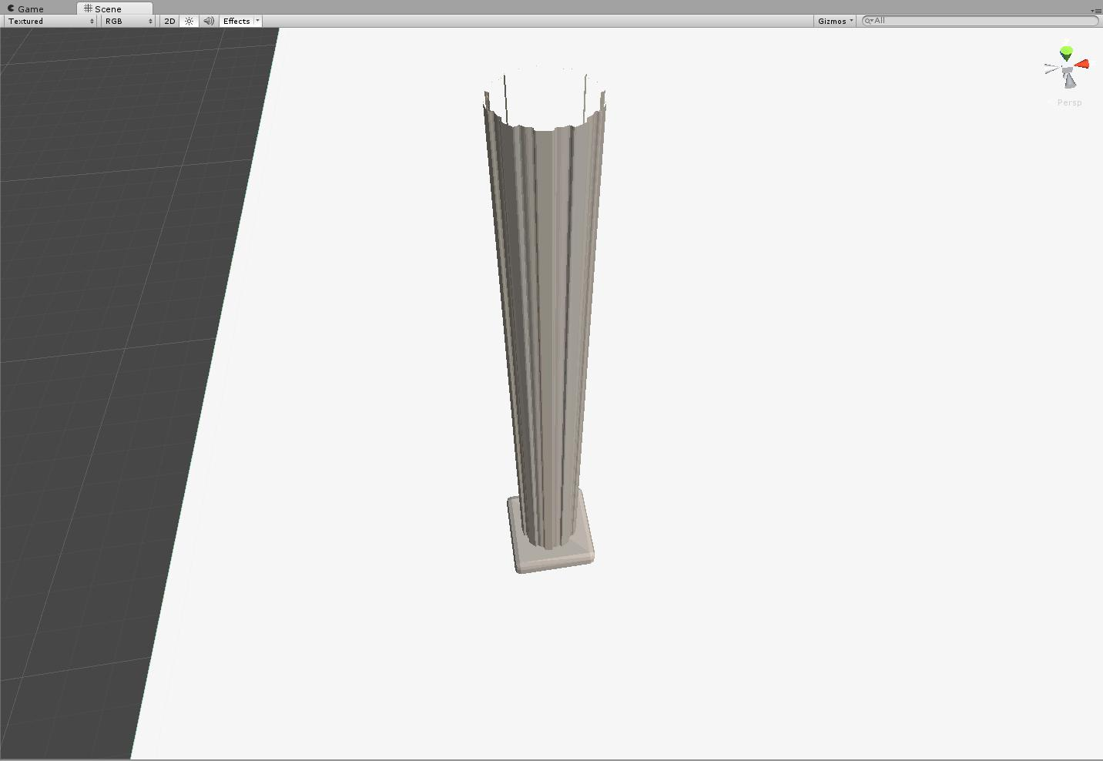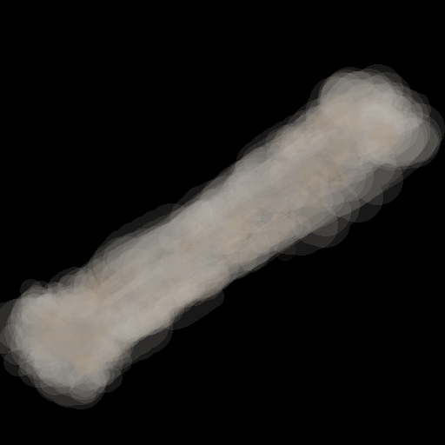

Figure : Column – 287 polys

### Display cube

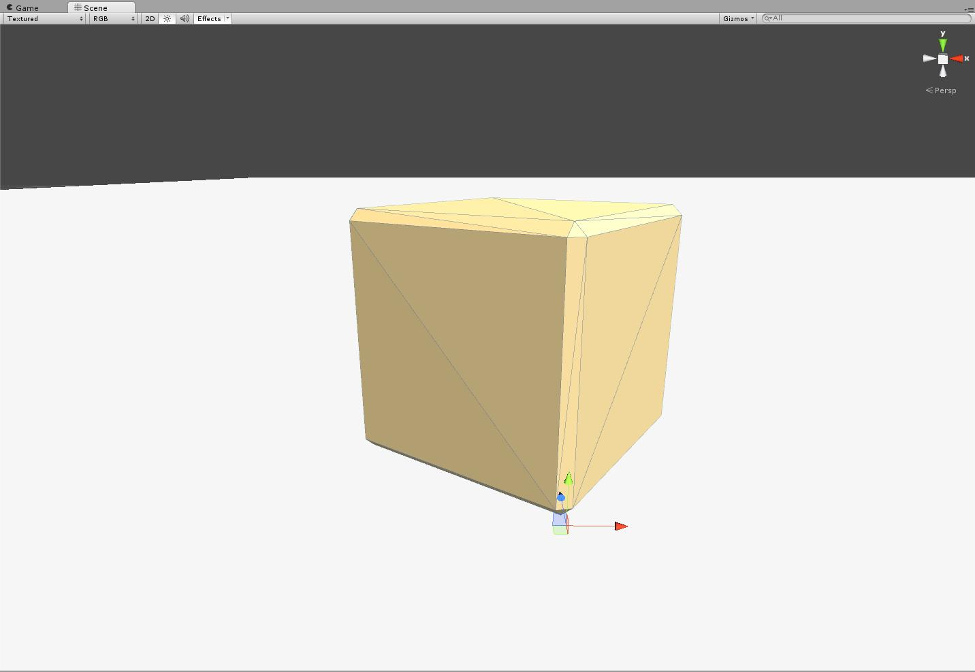

Figure : Display cube – 26 polys

### Door

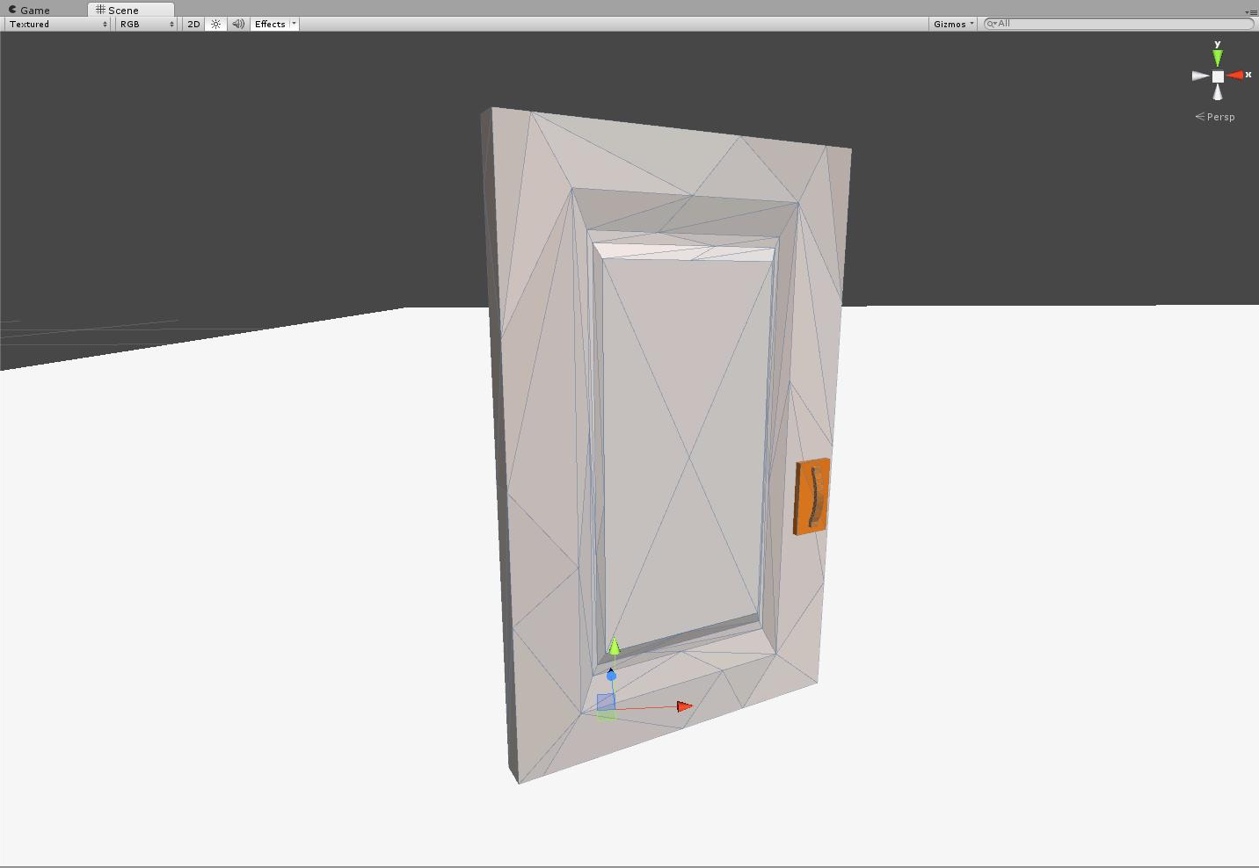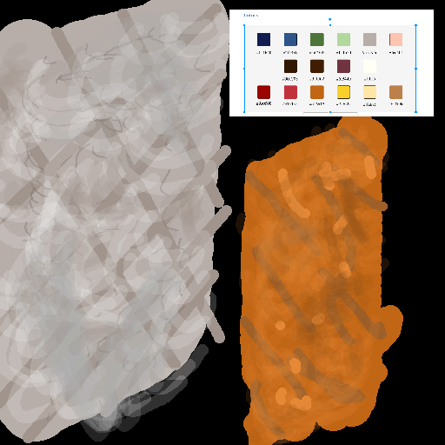

Figure : Door – 107 polys

### Fence post

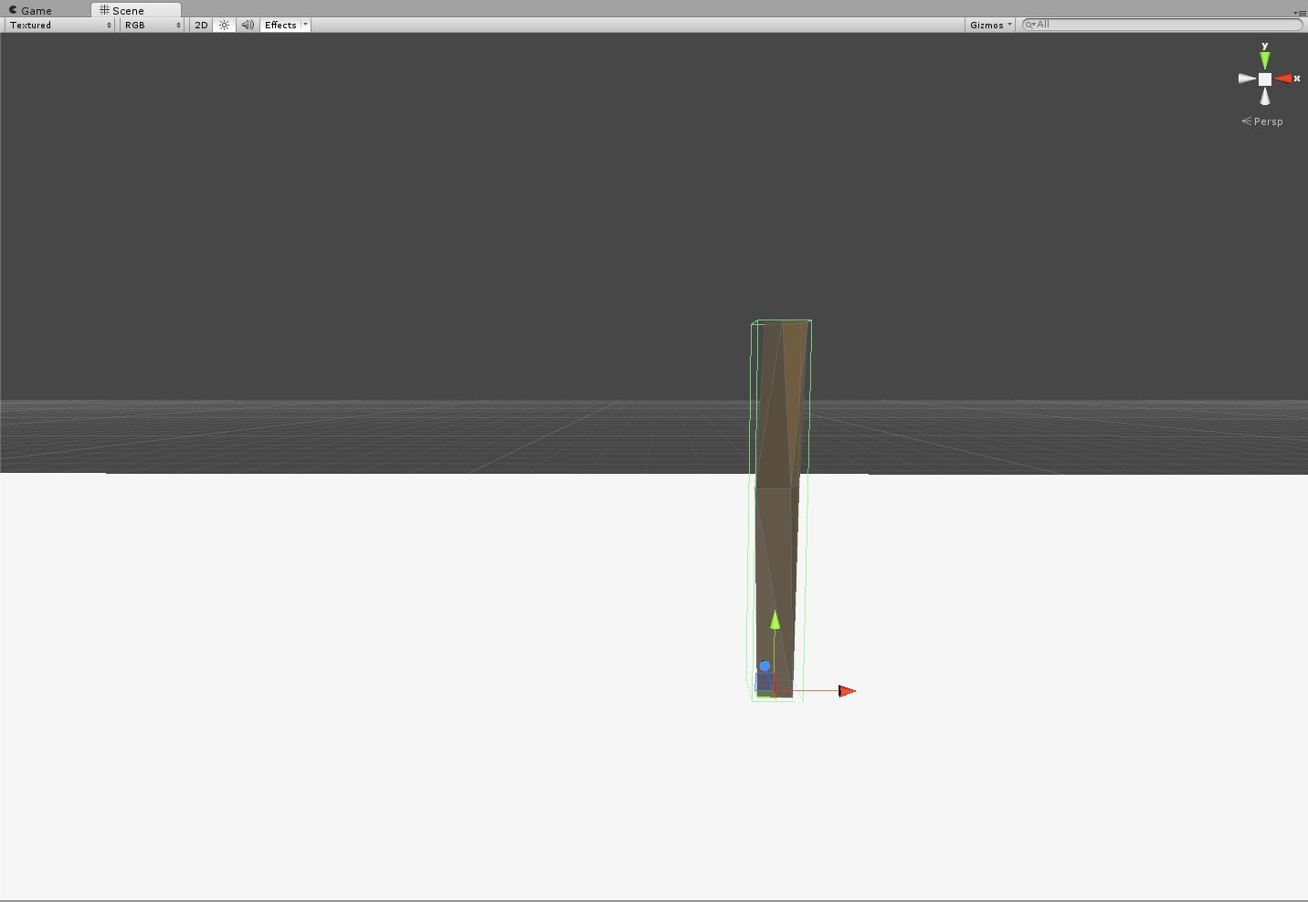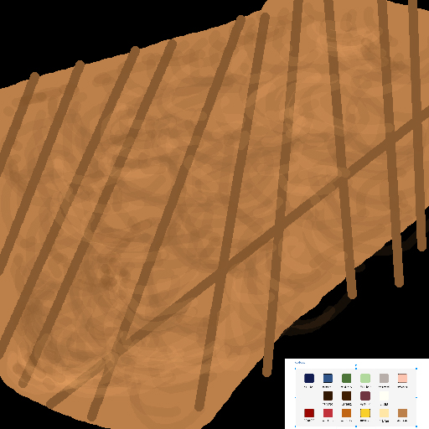

Figure : Fence post - 28 polys

### Gore Pile

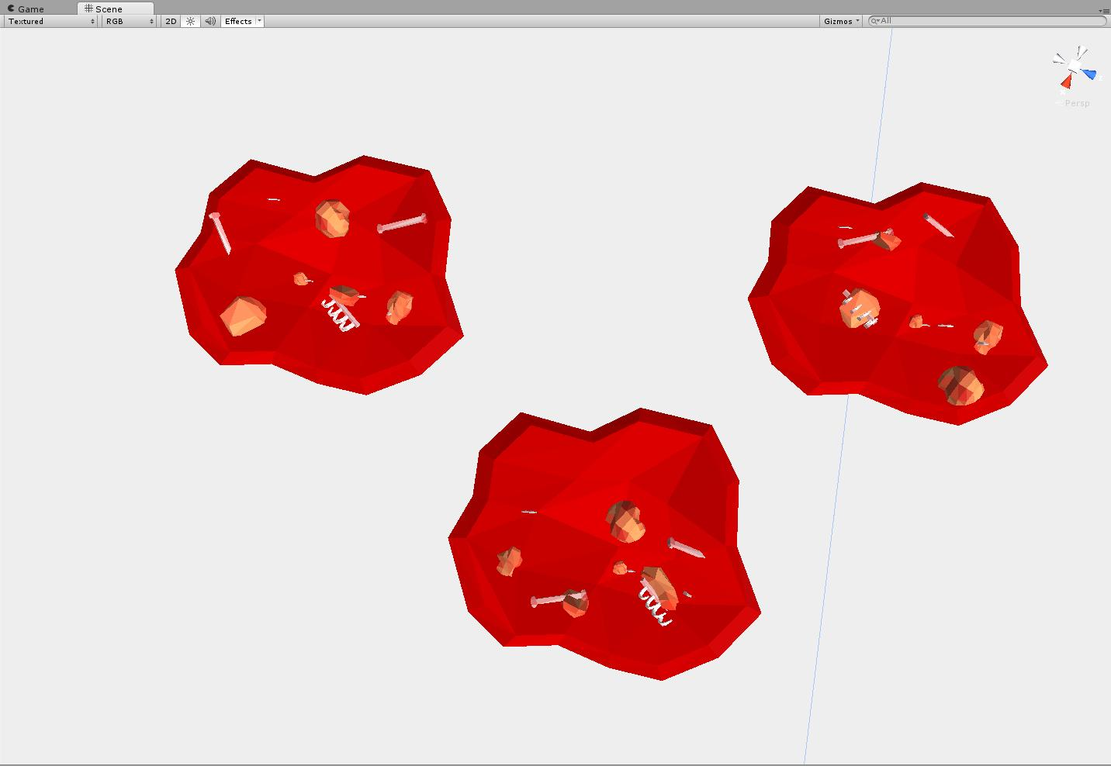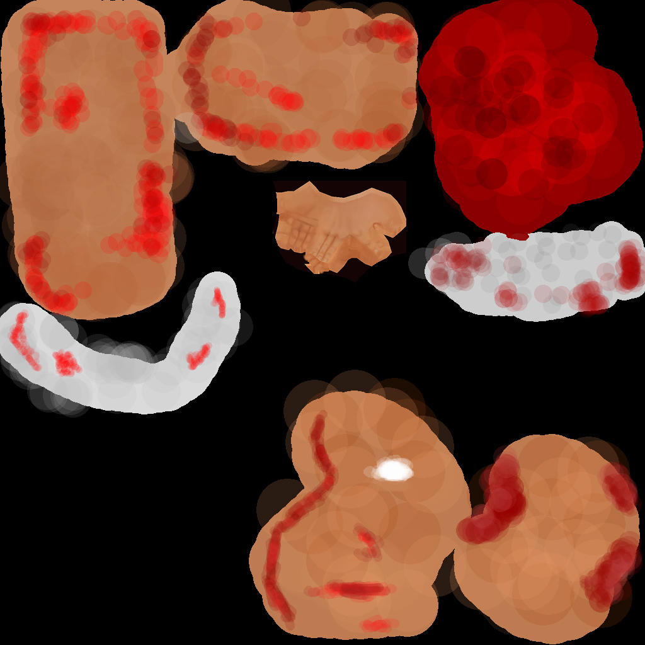

Figure : Various gore piles - 490 polys each.

### Grenade from the future

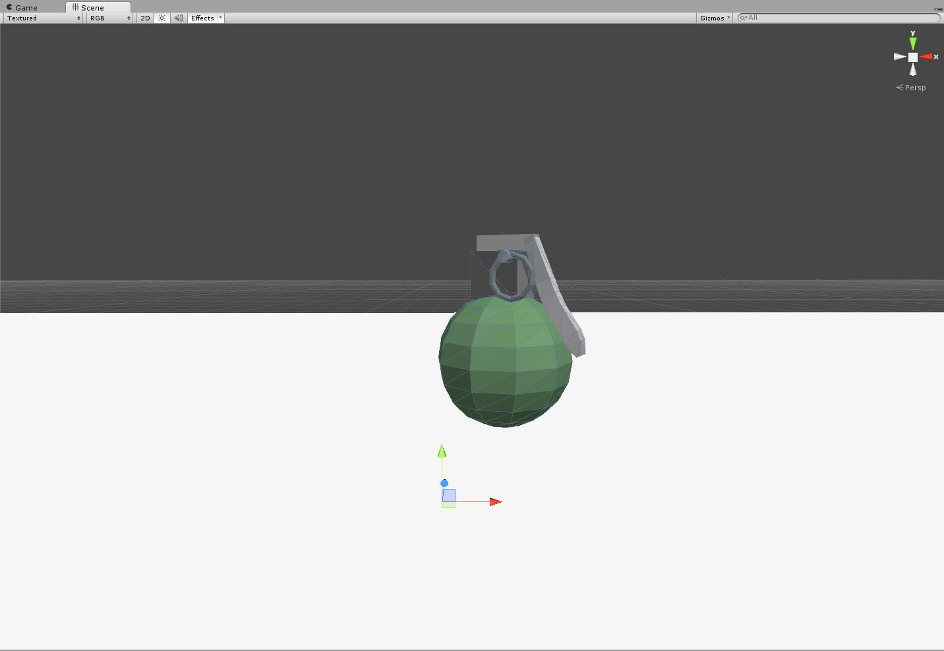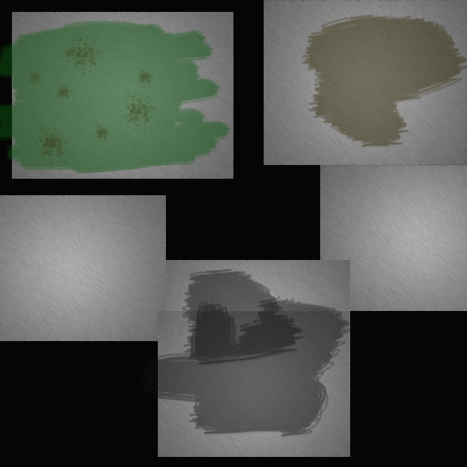

Figure : Grenade from the future – 268 polys

### Guillotine

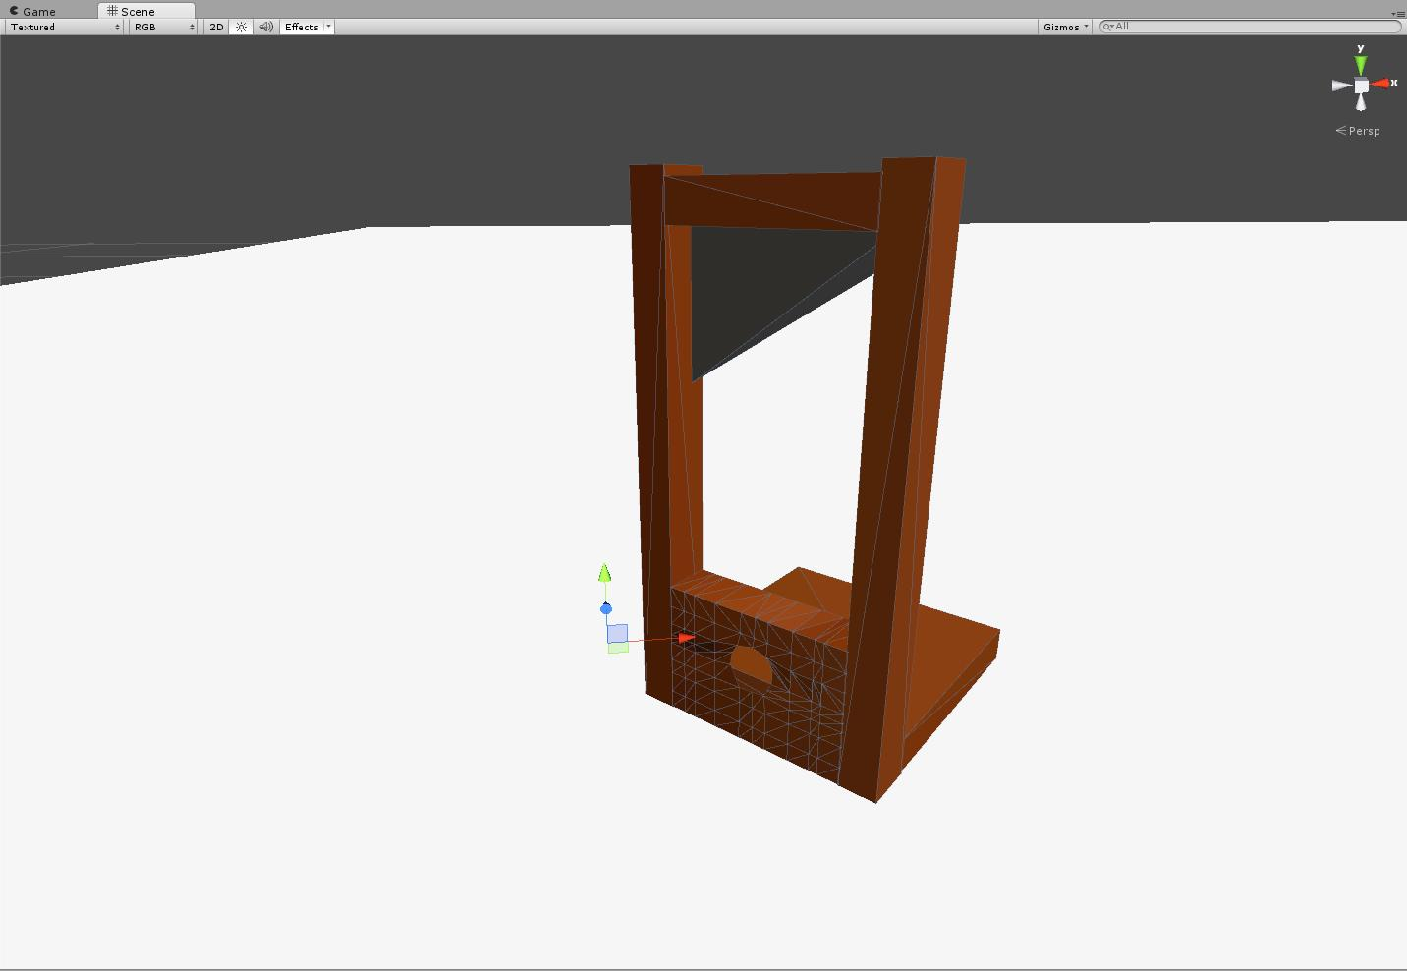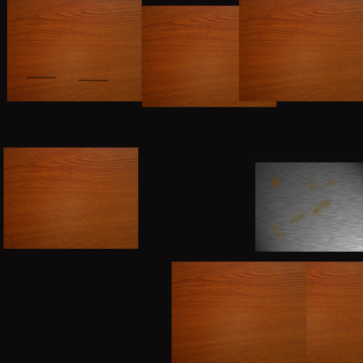

Figure : Guillotine – 196 polys

### Human Female civilian - All variants

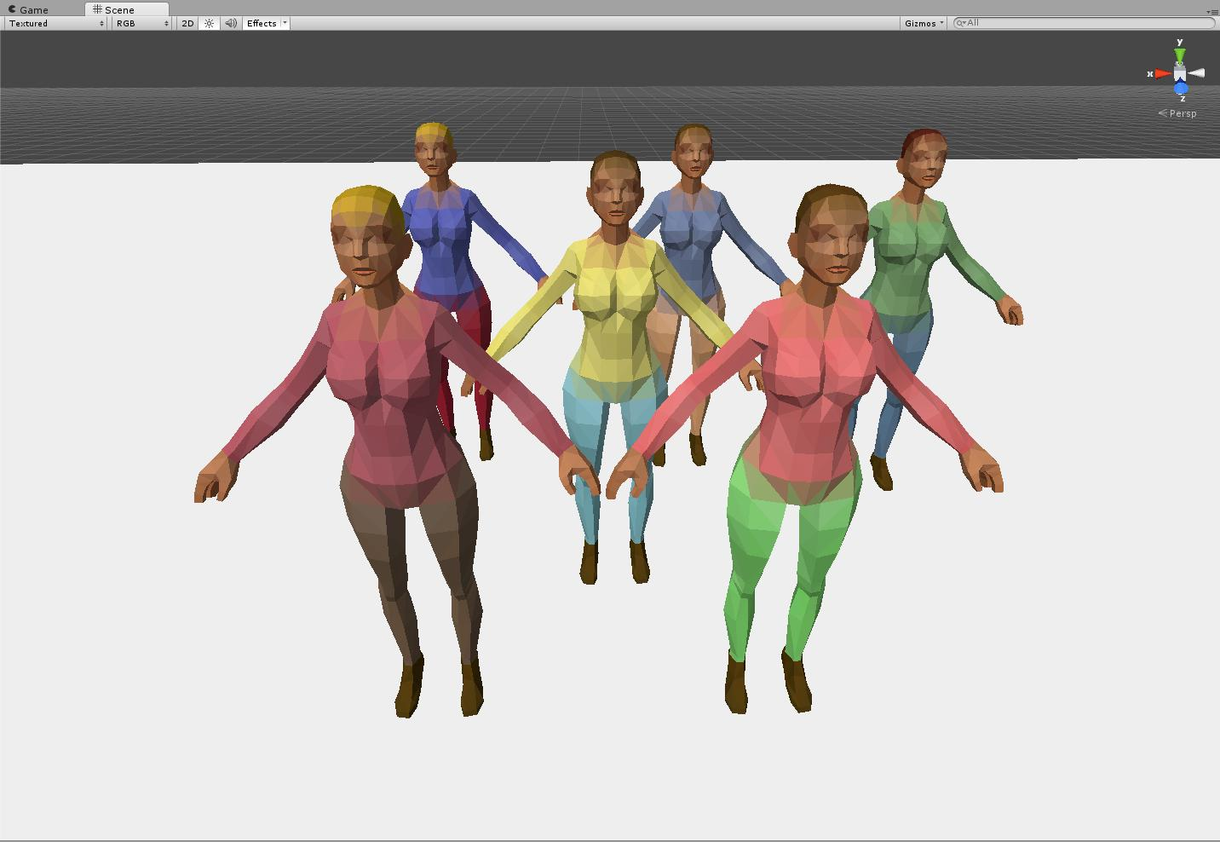

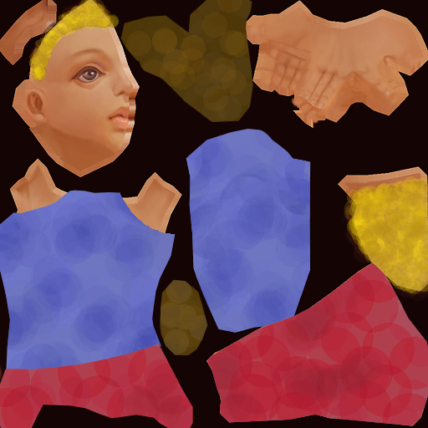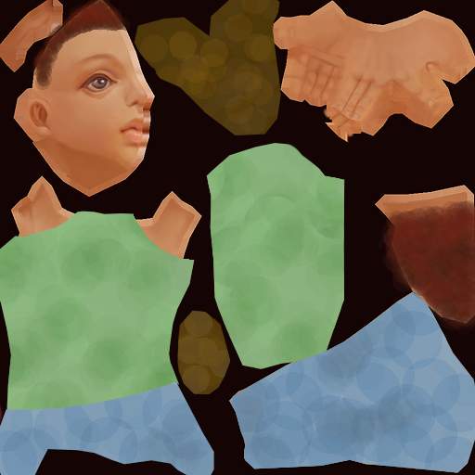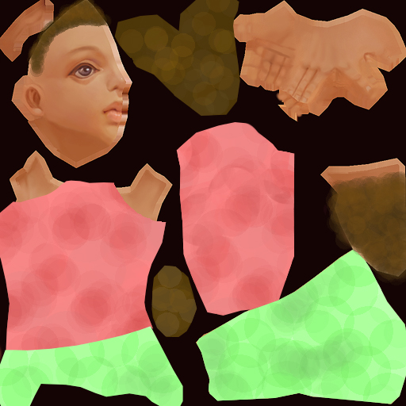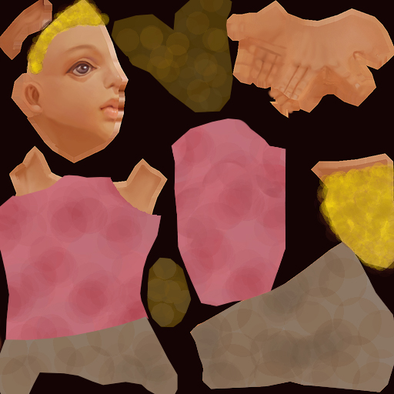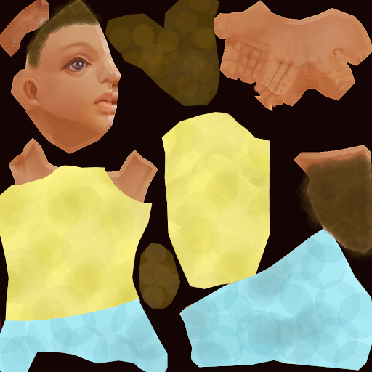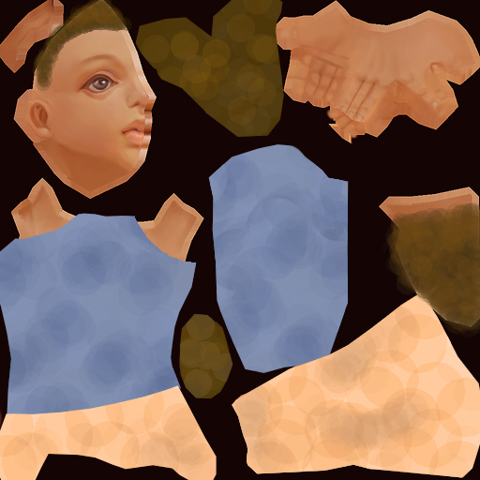

Figure : Female Human civilian - All variants – 660 polys each

### Human Male Civilian - All variants

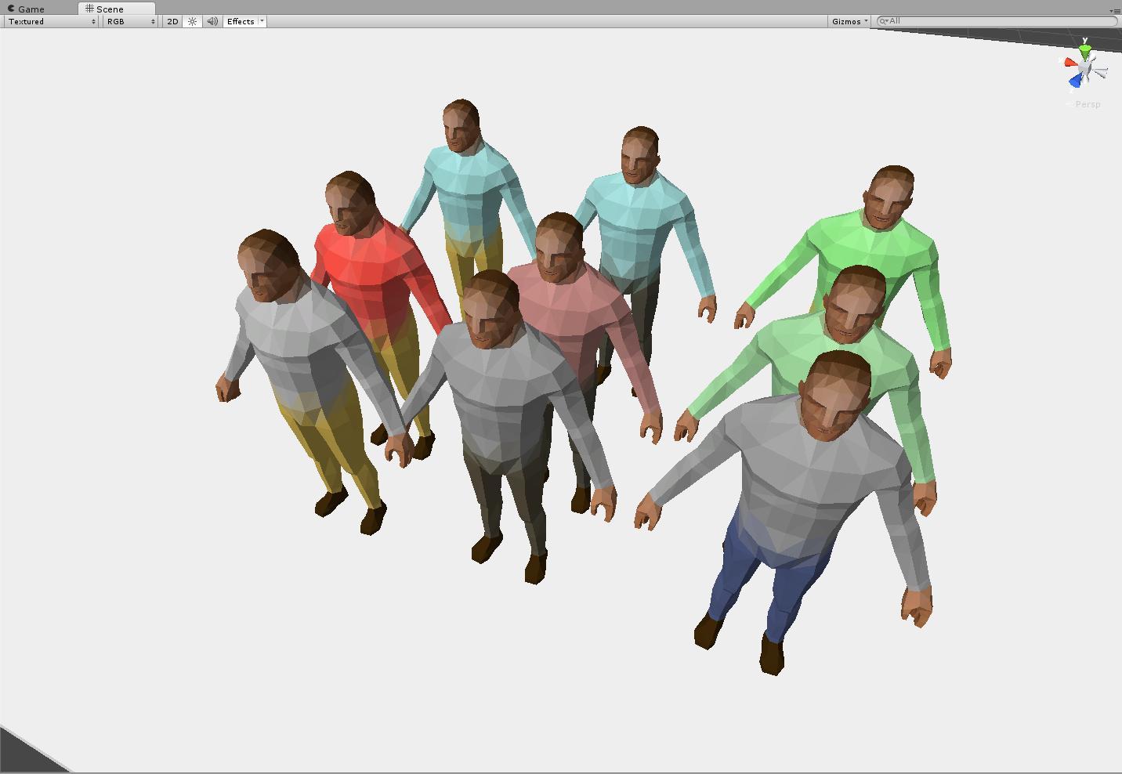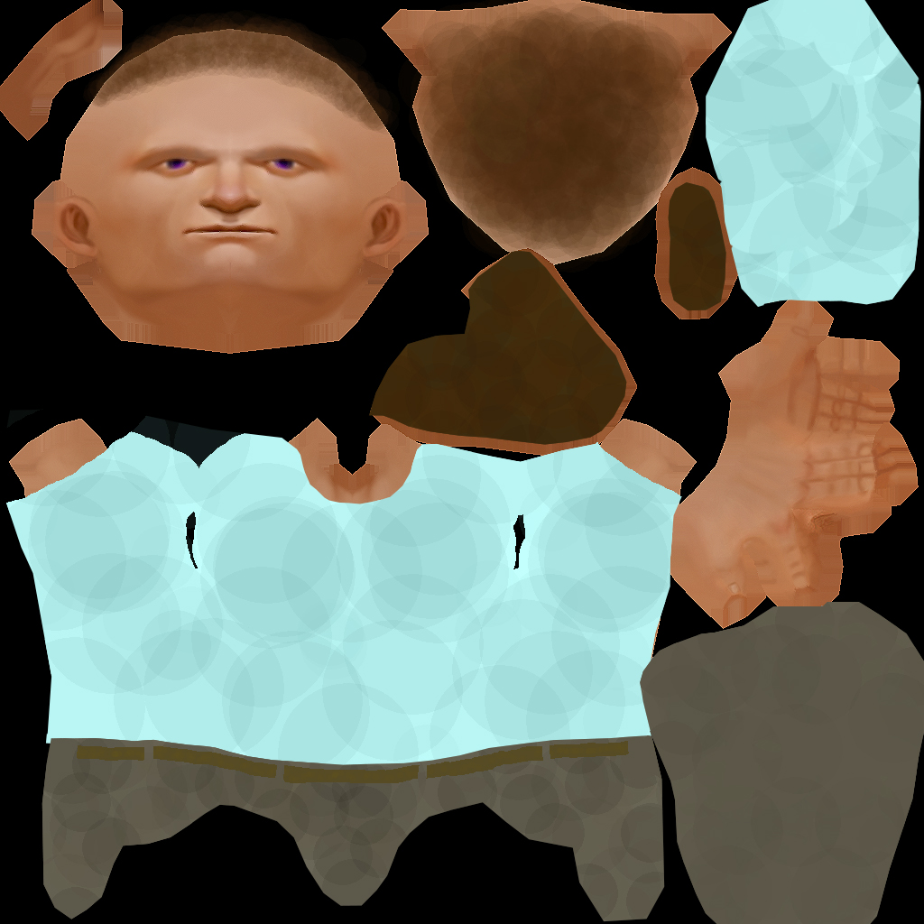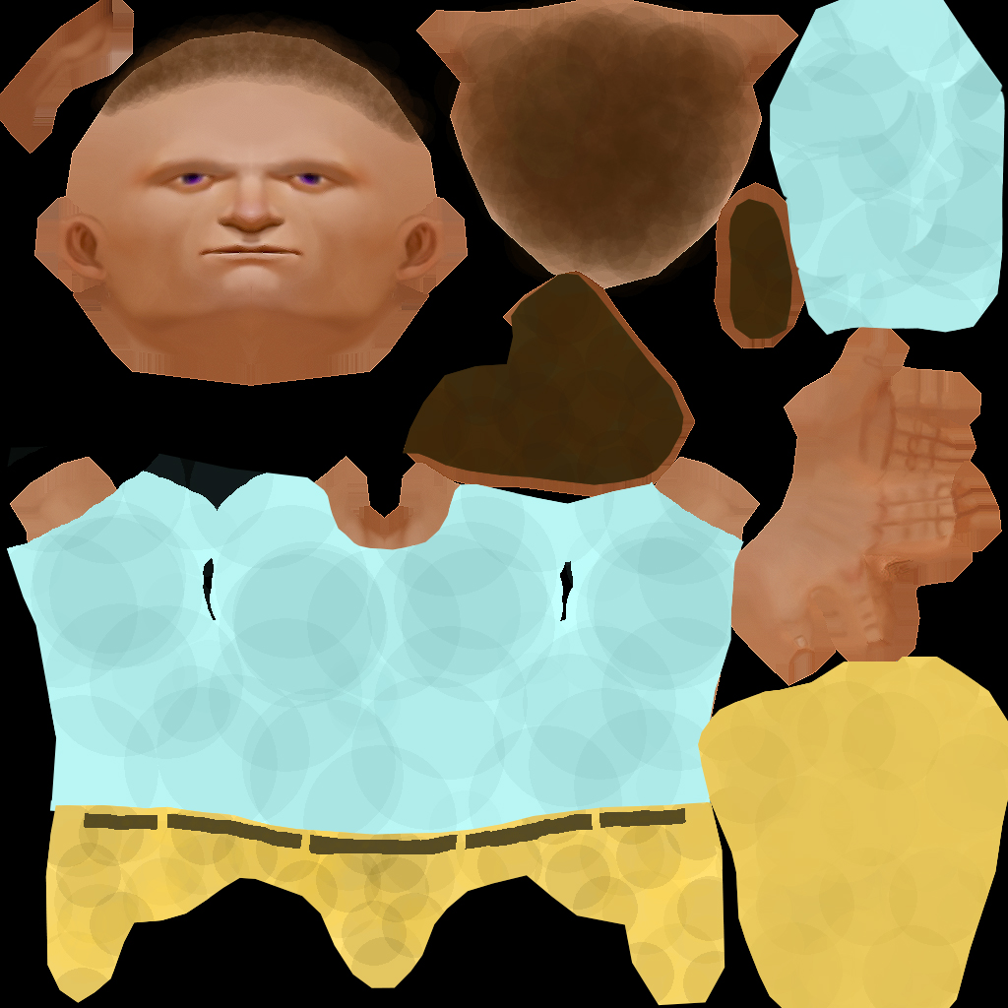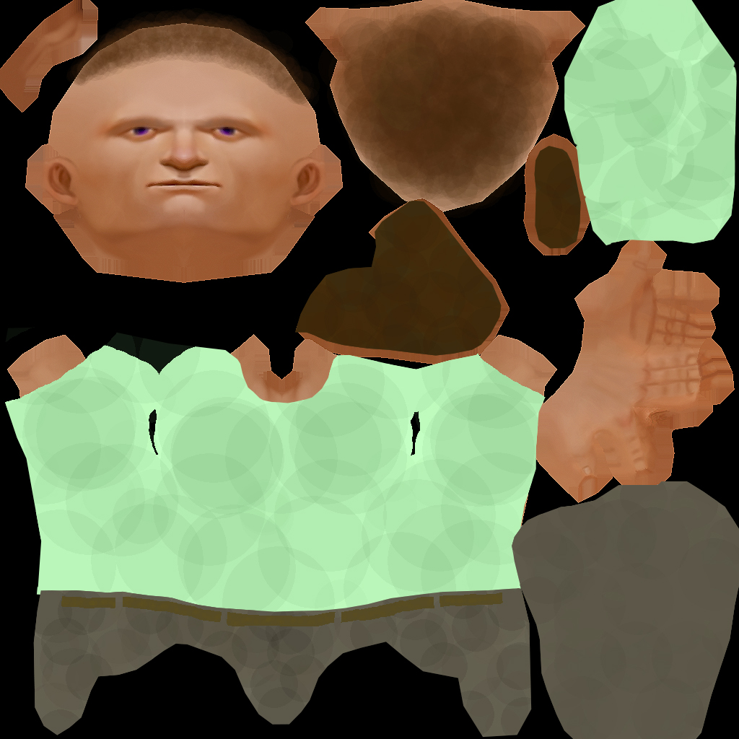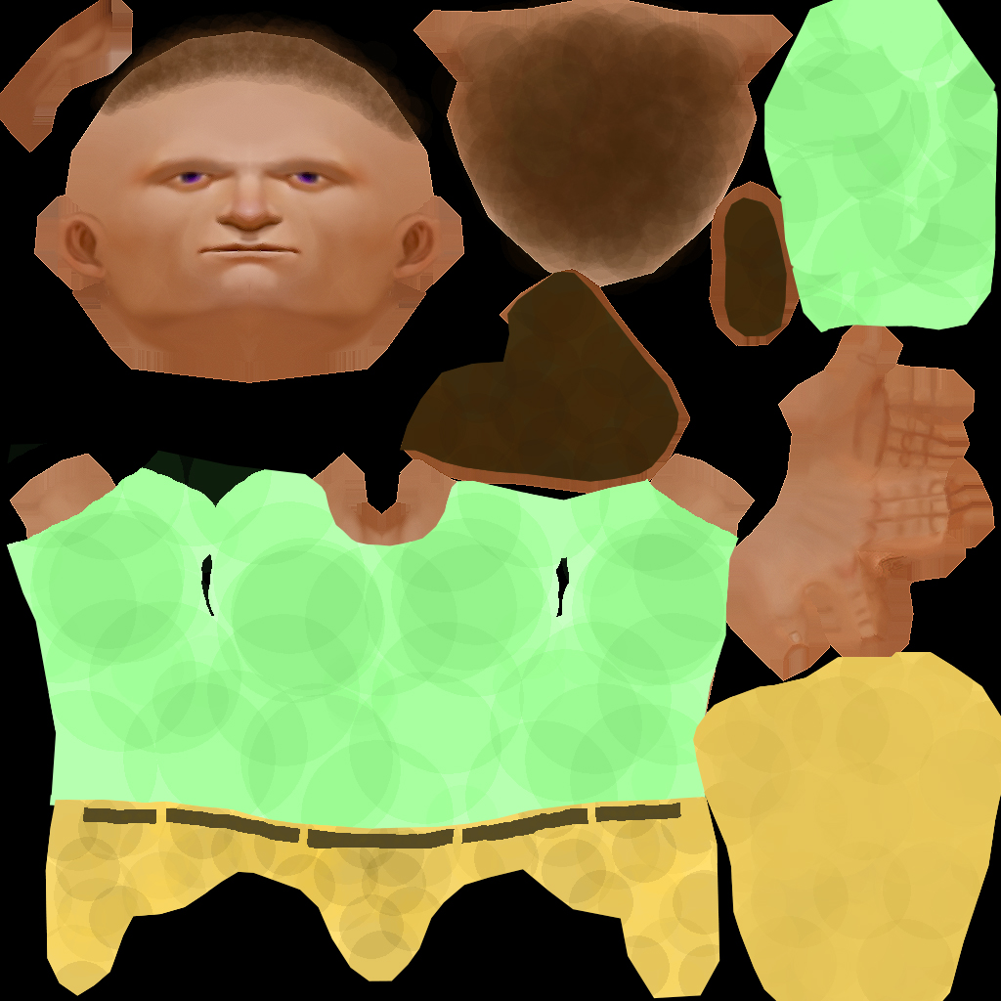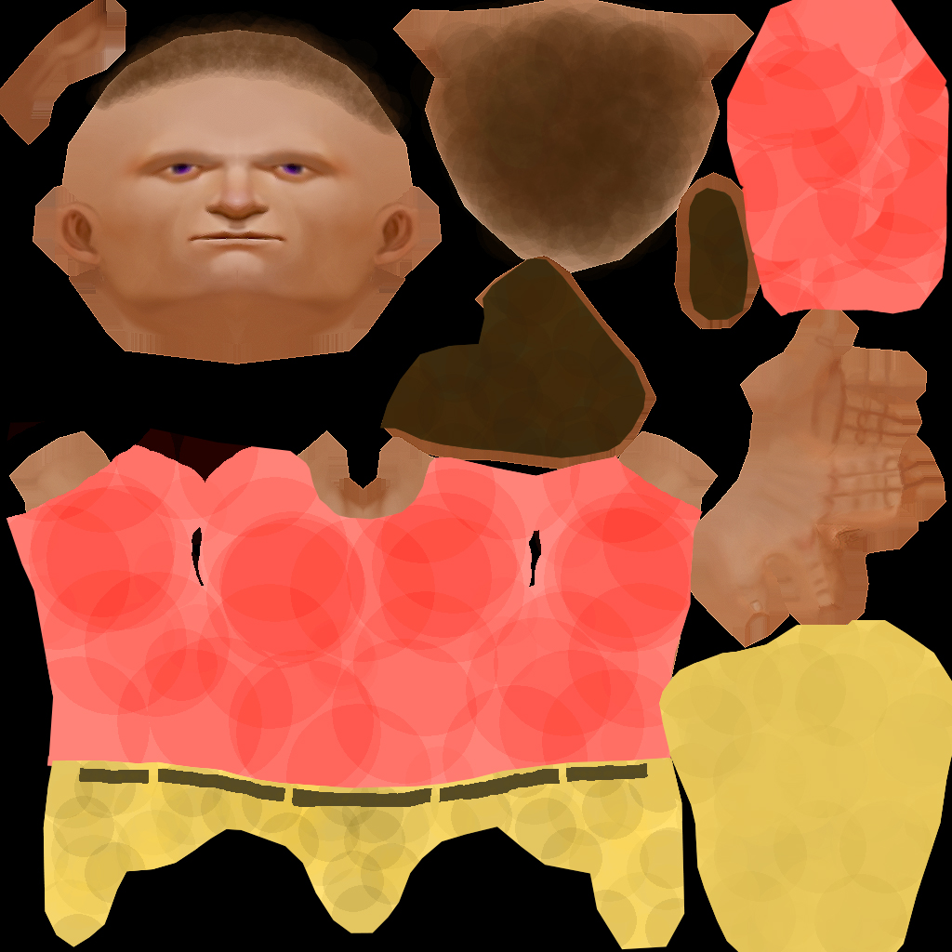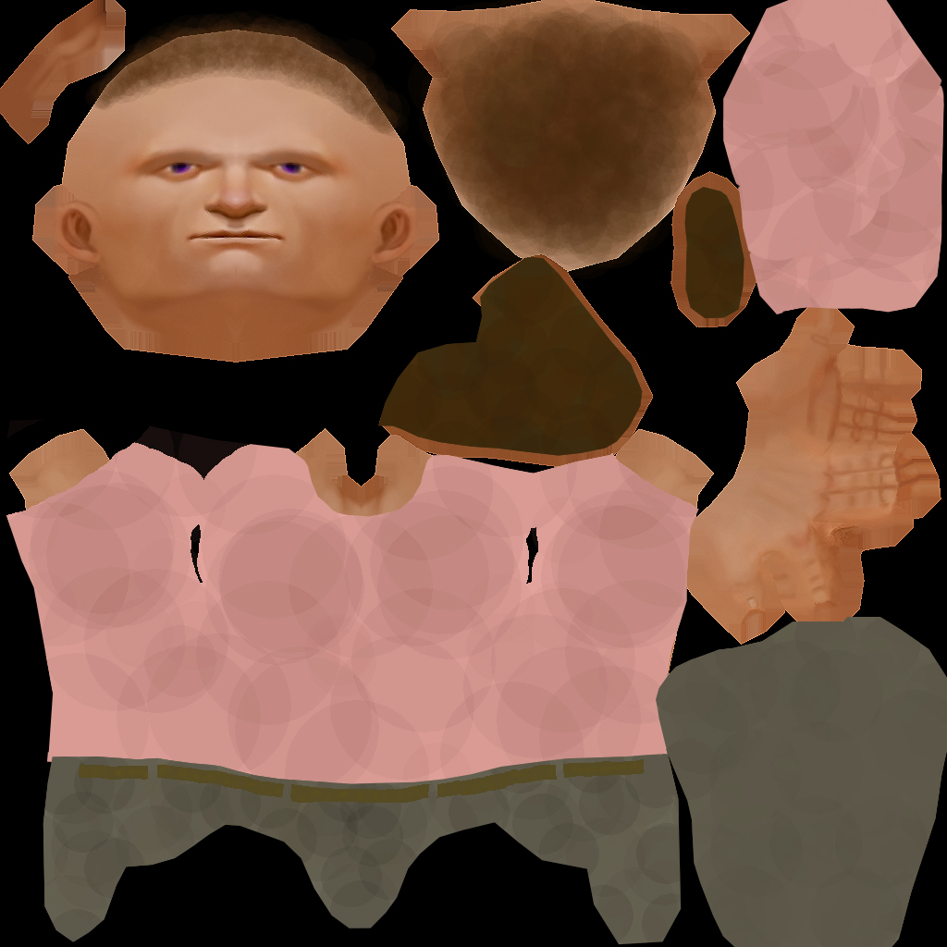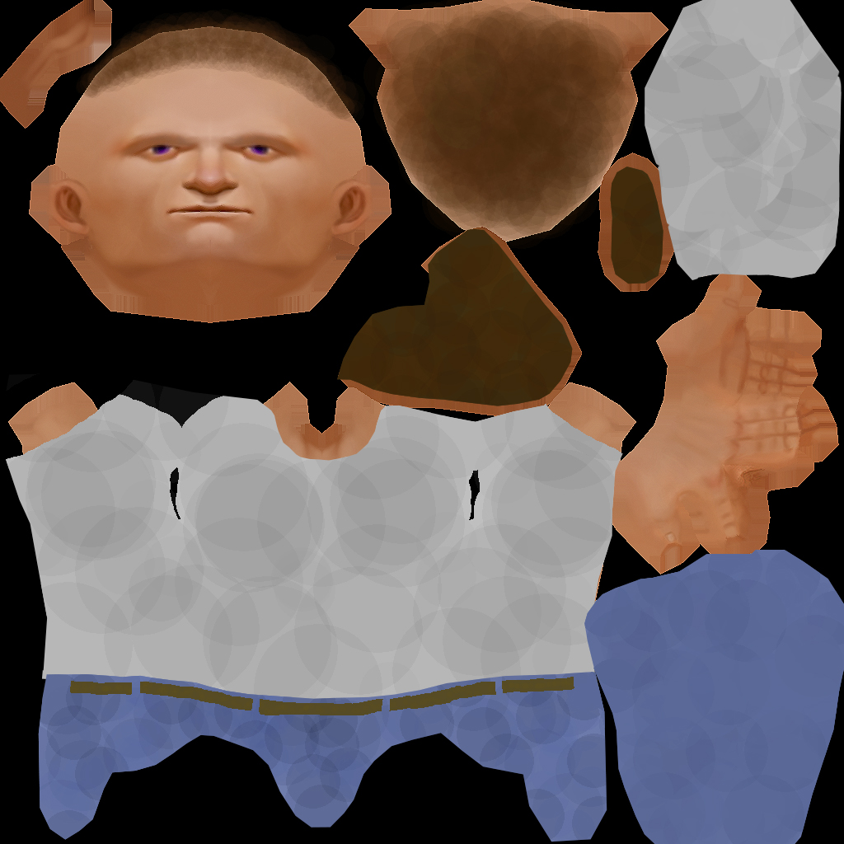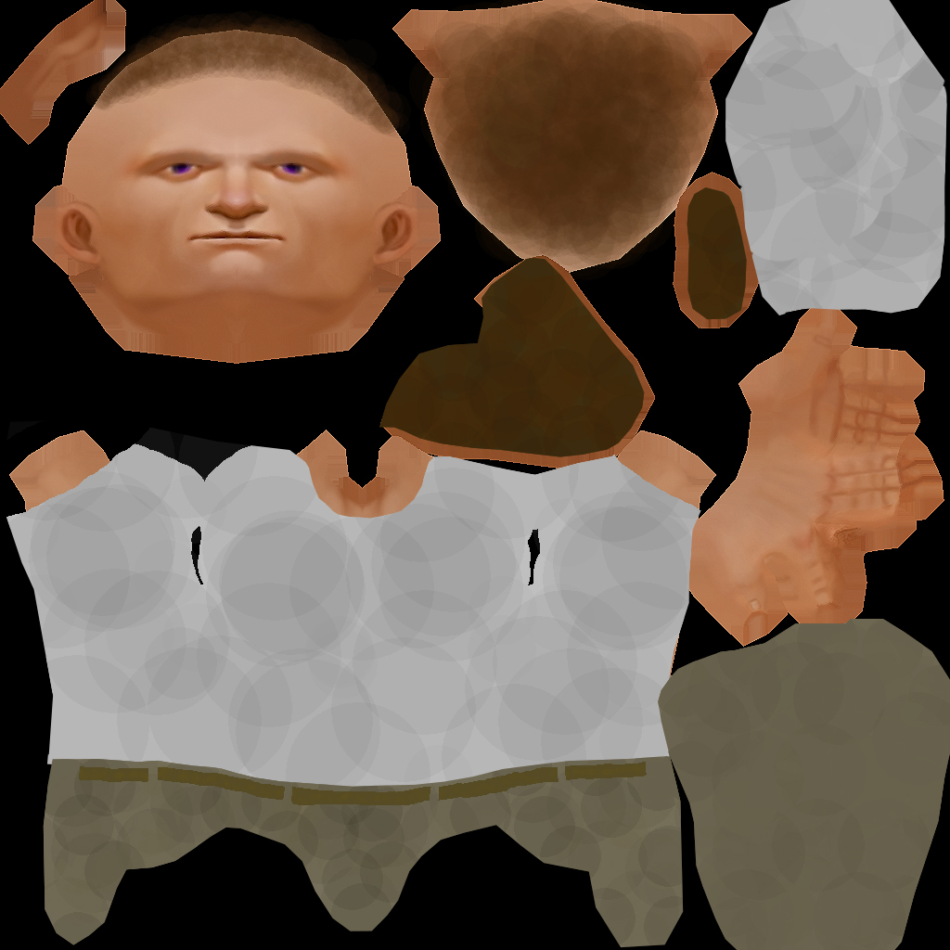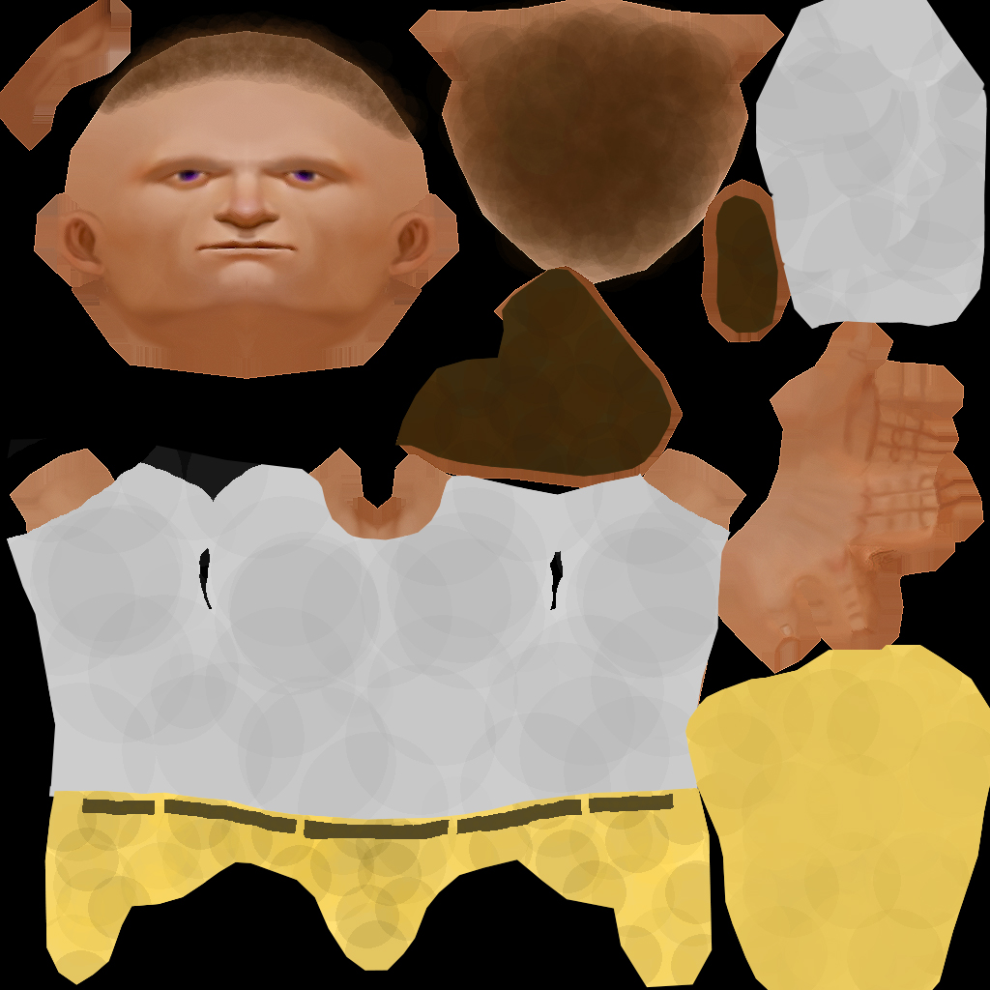

Figure : Human Male Civilian - All variants - 642 polys each

### Jet engine

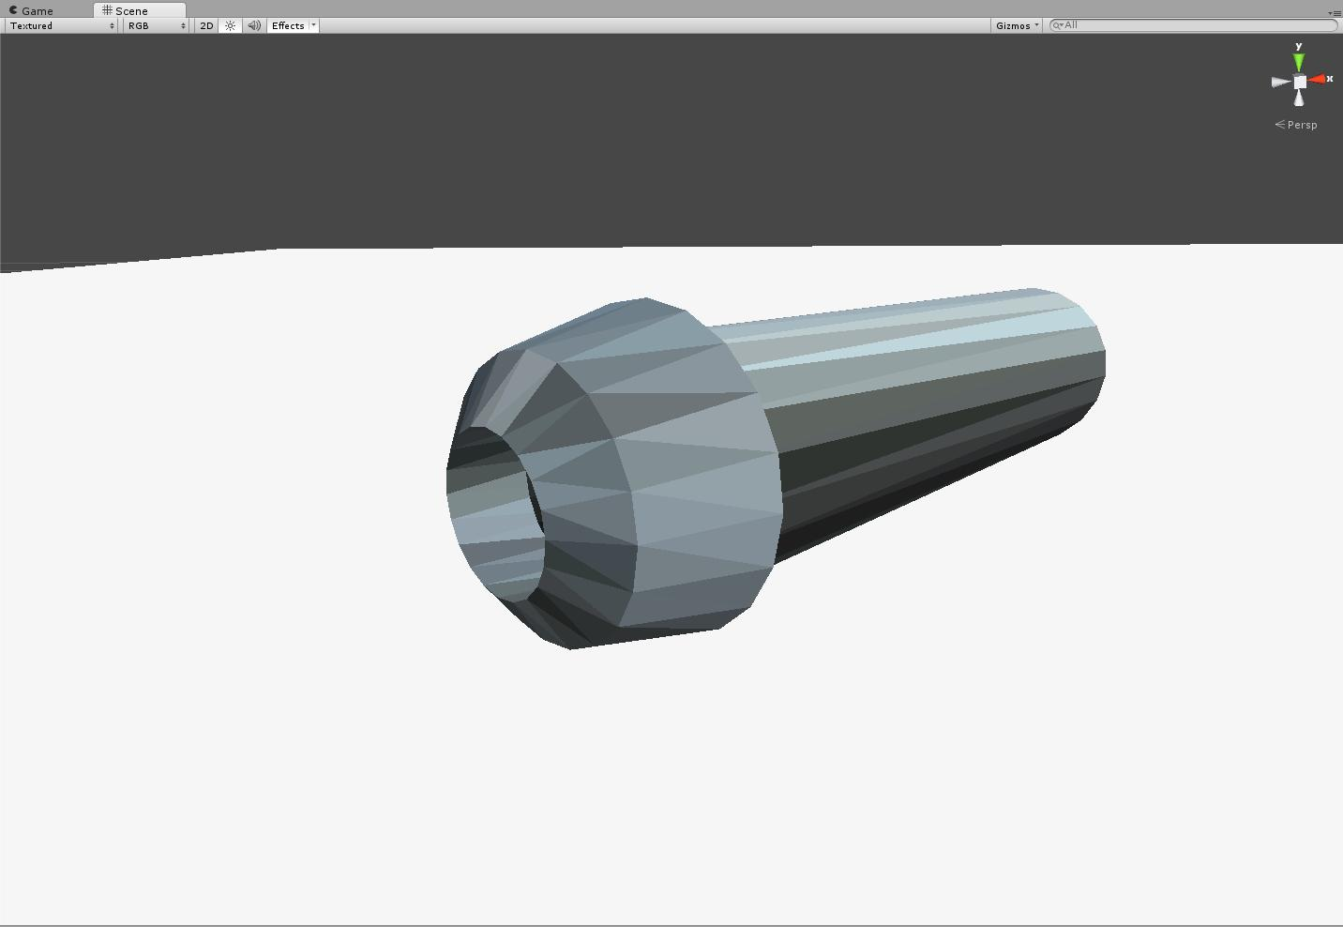

Figure : Jet engine – 140 polys

### Jousting lance

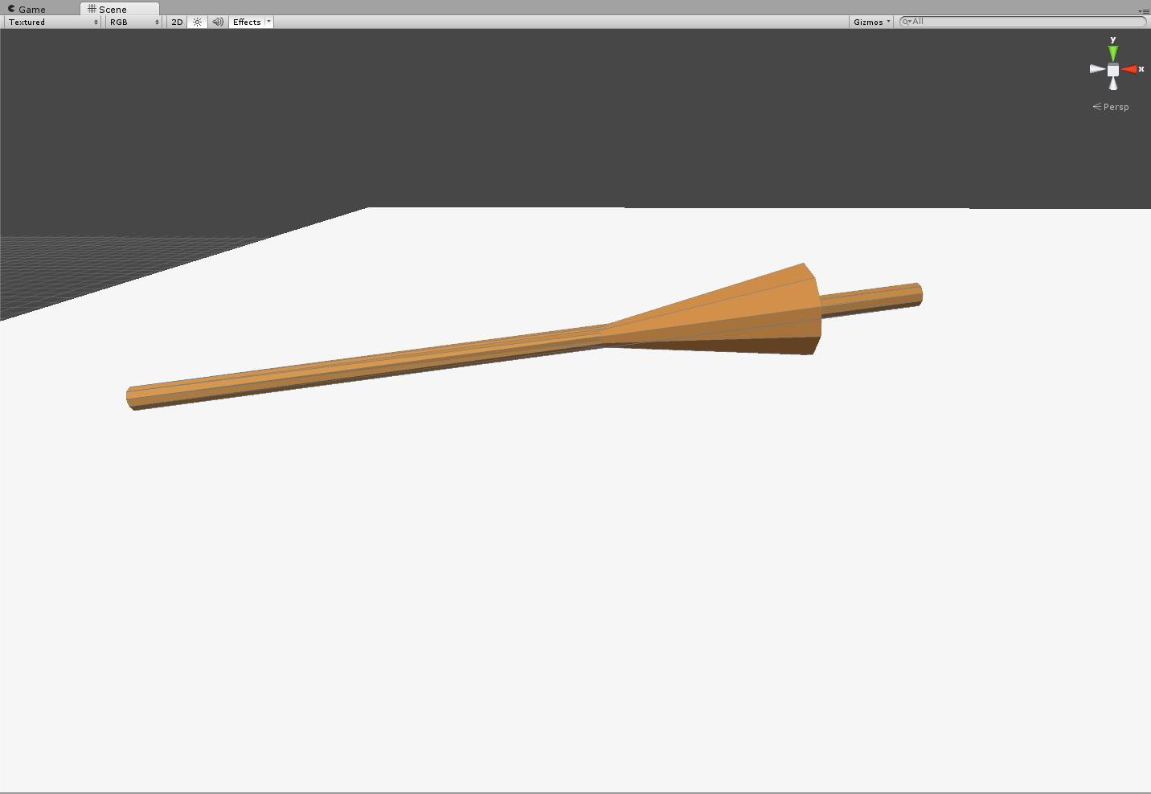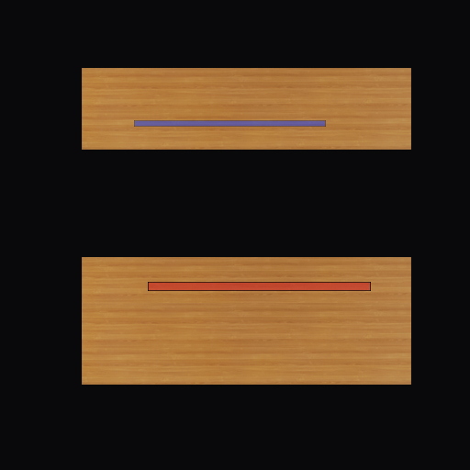

Figure : Jousting lance – 41 polys

### Kesh

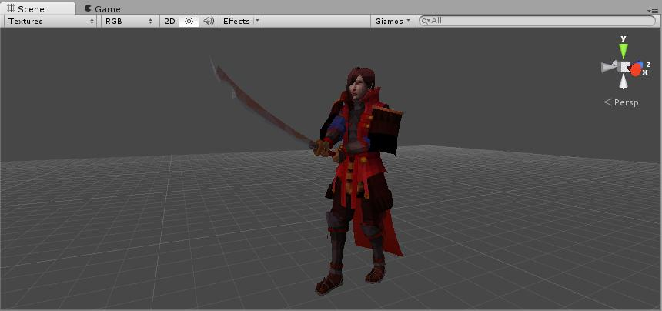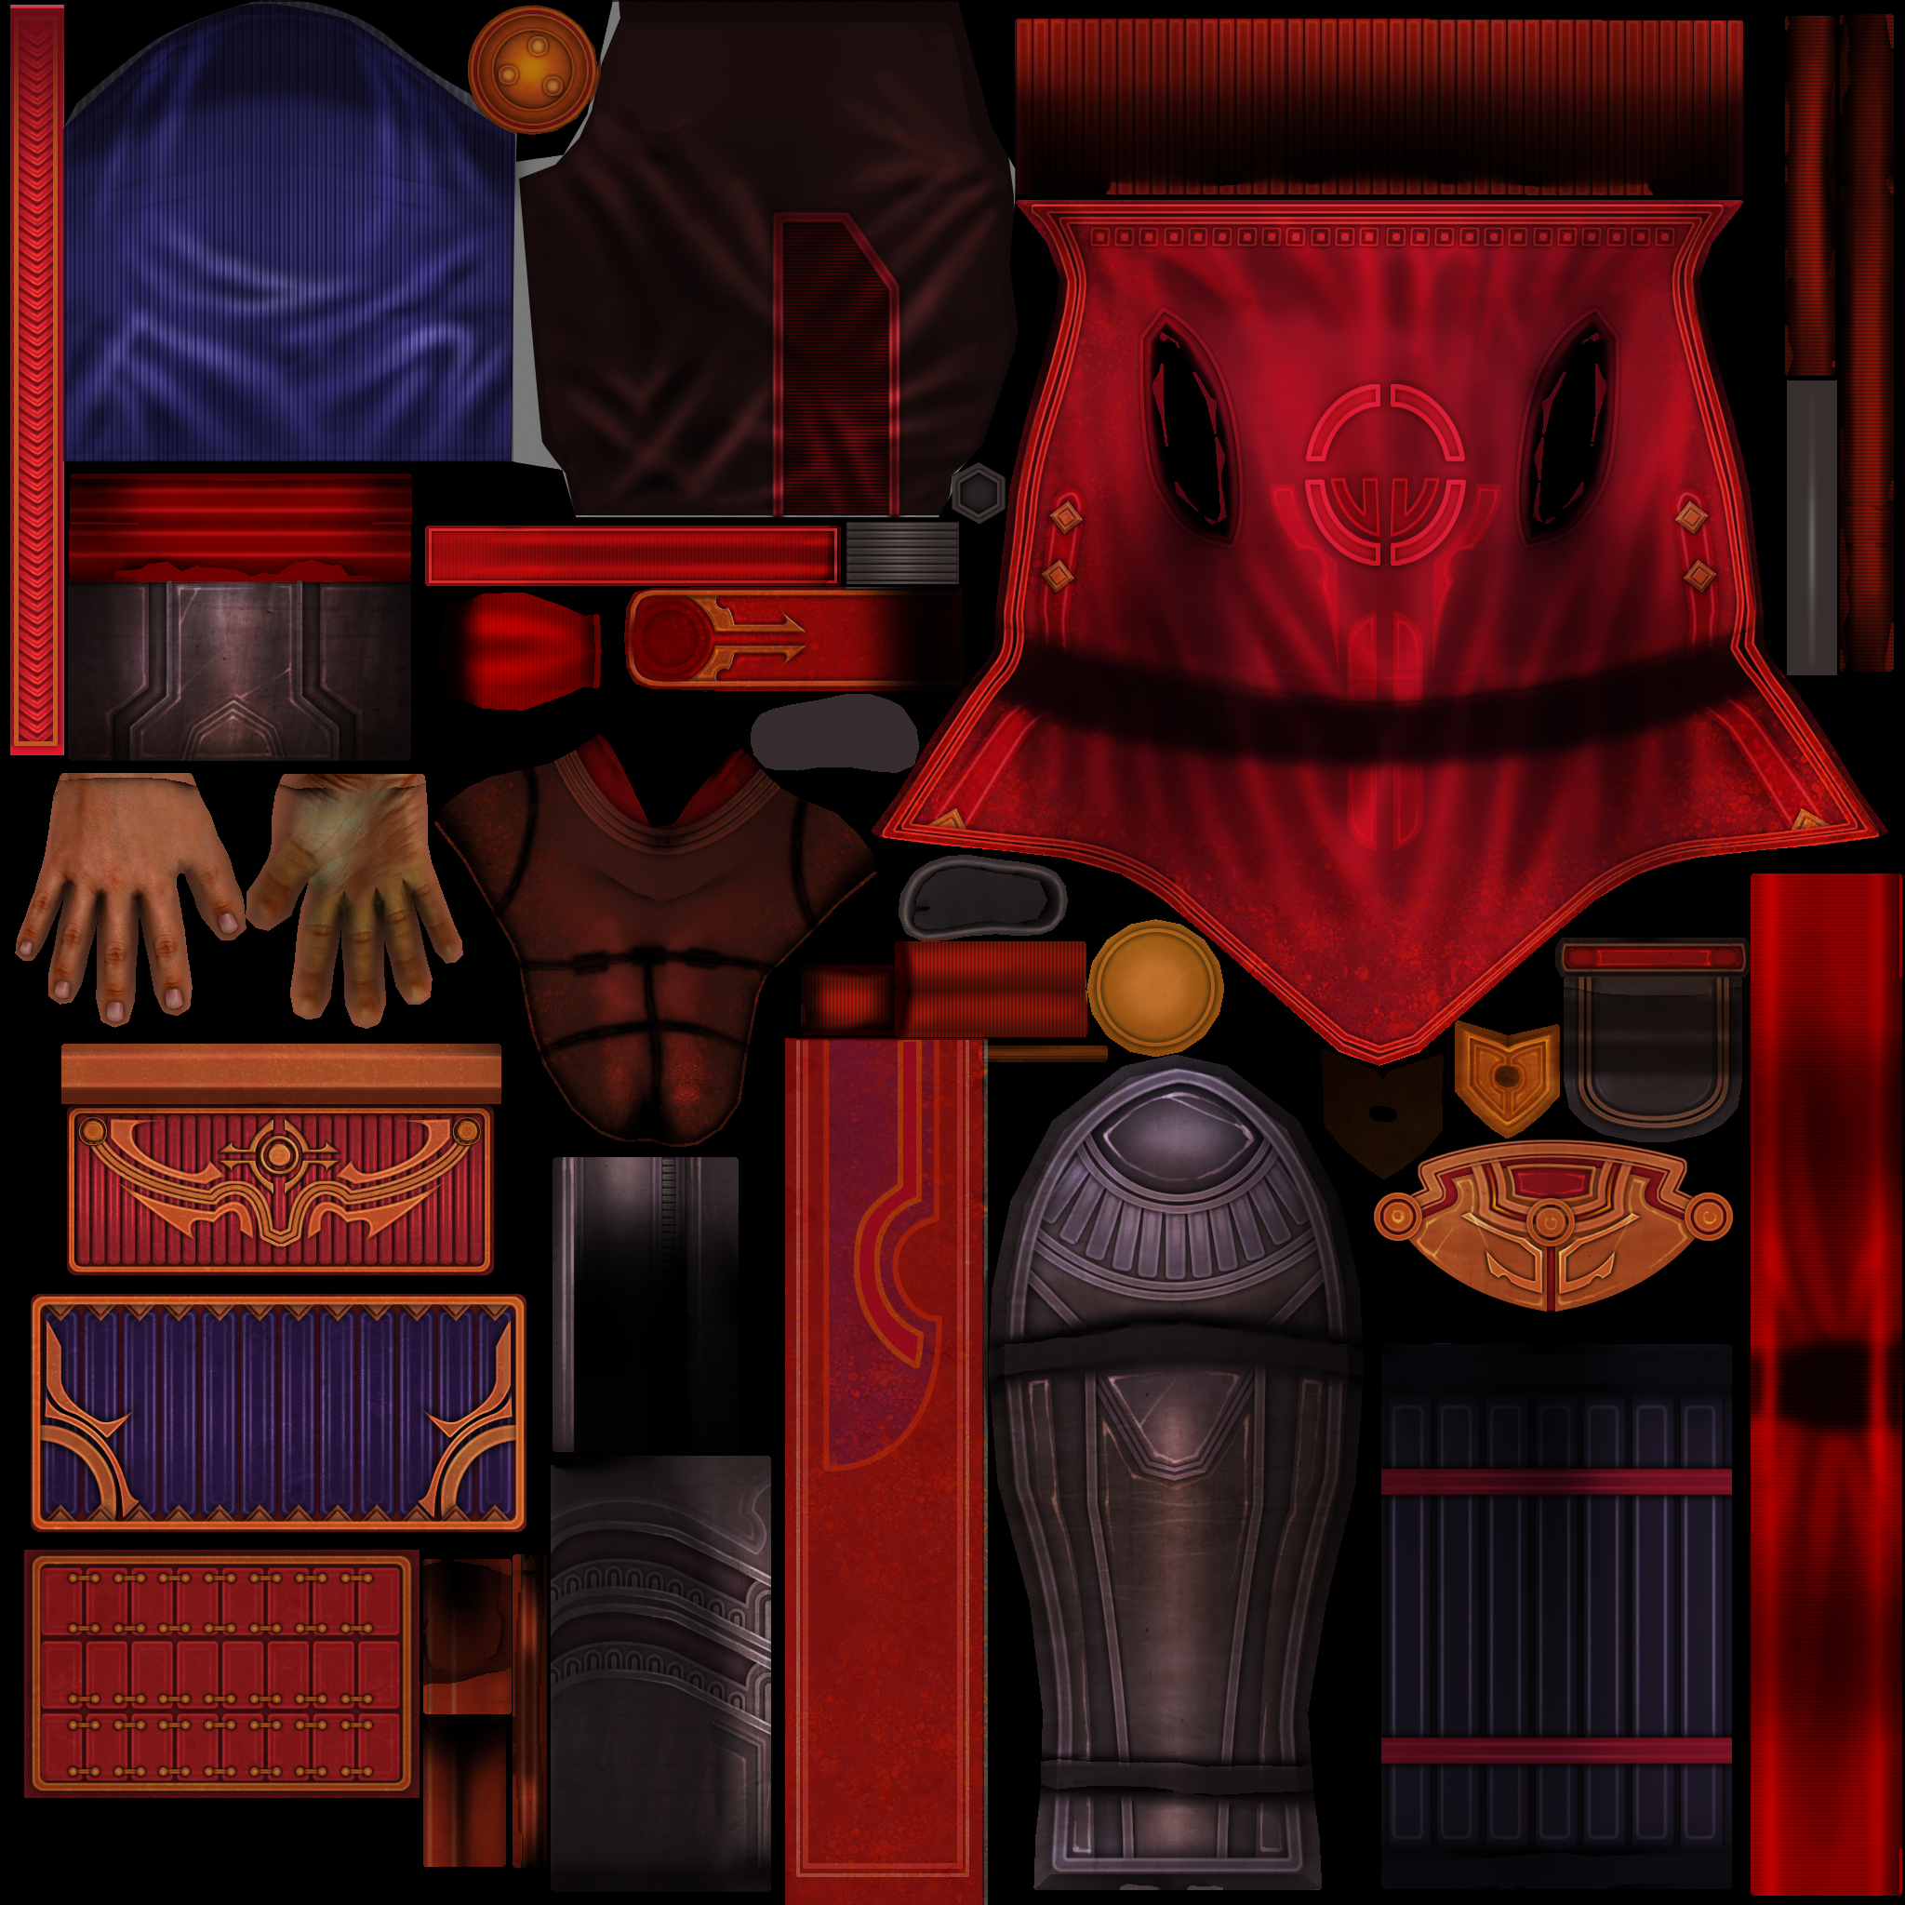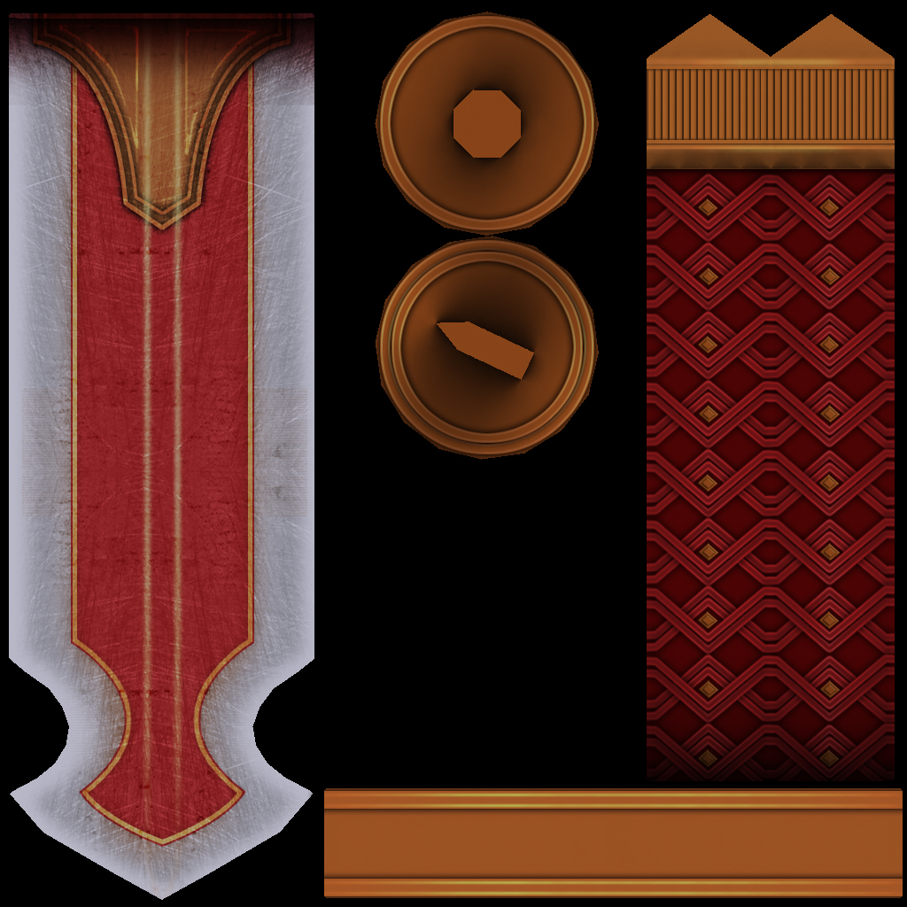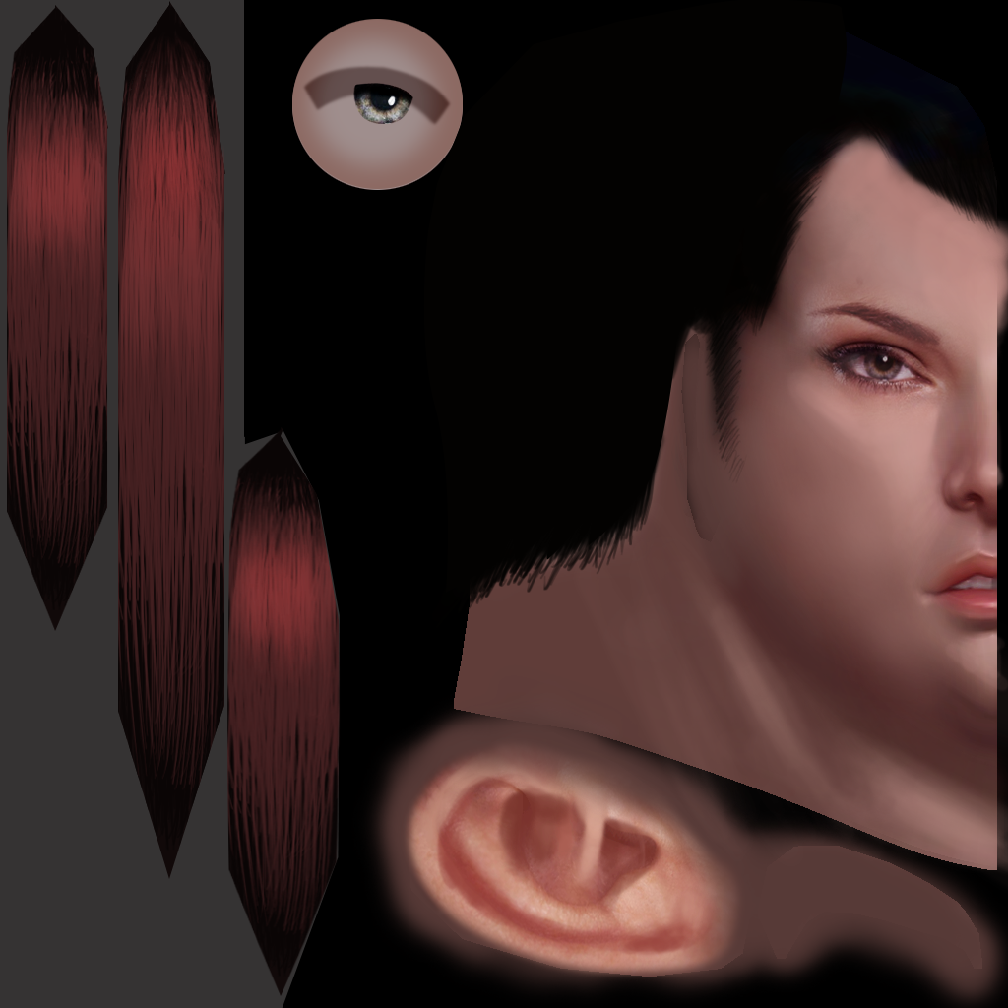

Figure : Kesh - 11271 Polys

### Kesh exhibit left

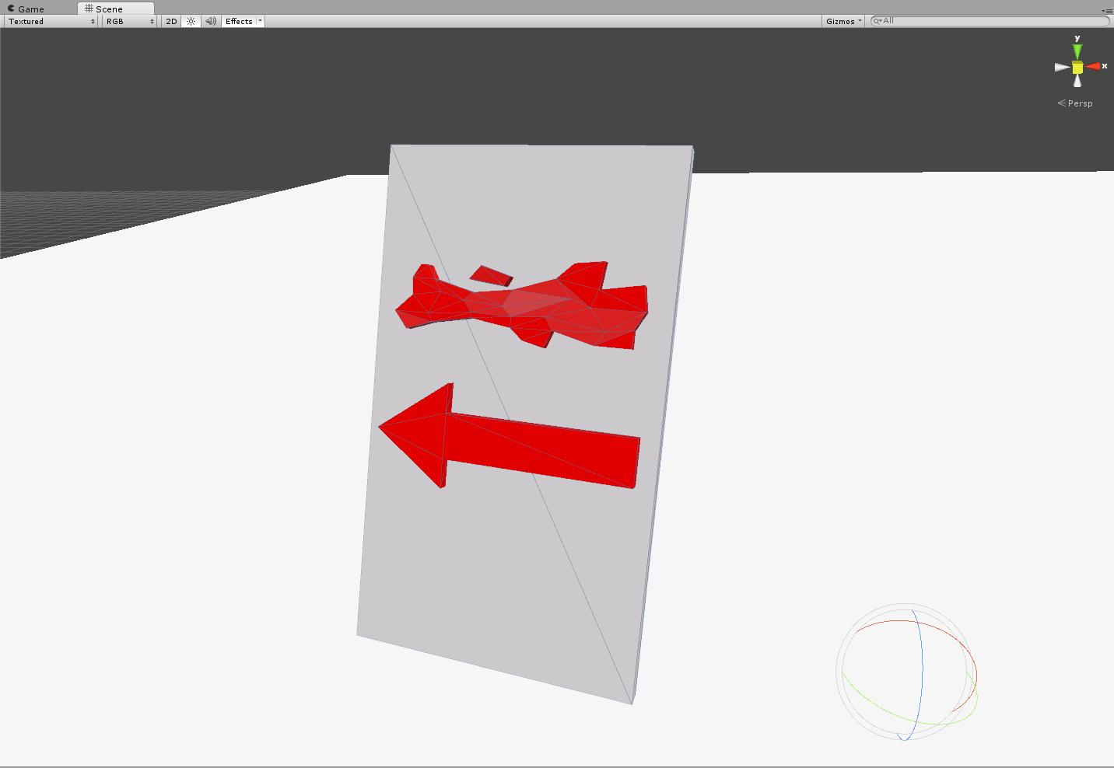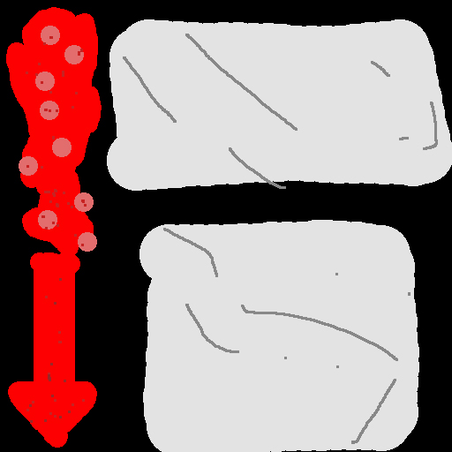

Figure : Kesh exhibit left – 99 polys

### Kesh's exhibit forward

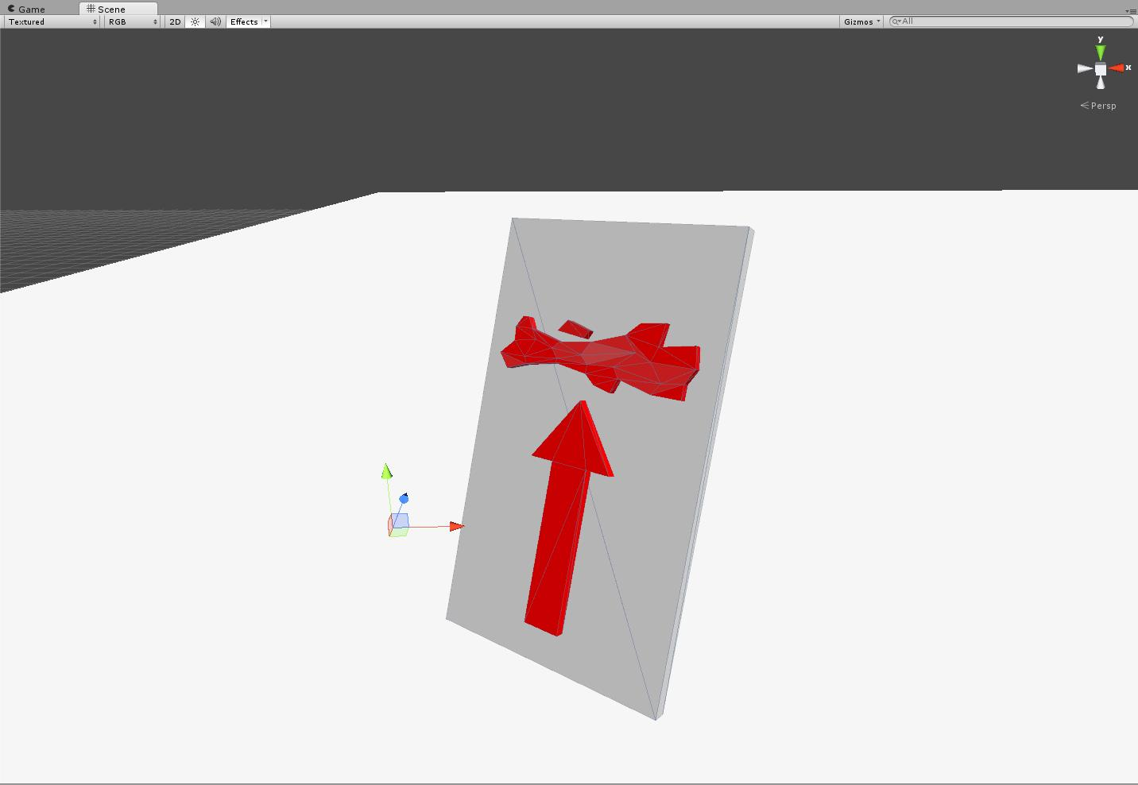

Figure : Kesh's exhibit forward – 99 polys

### Kesh's exhibit Right

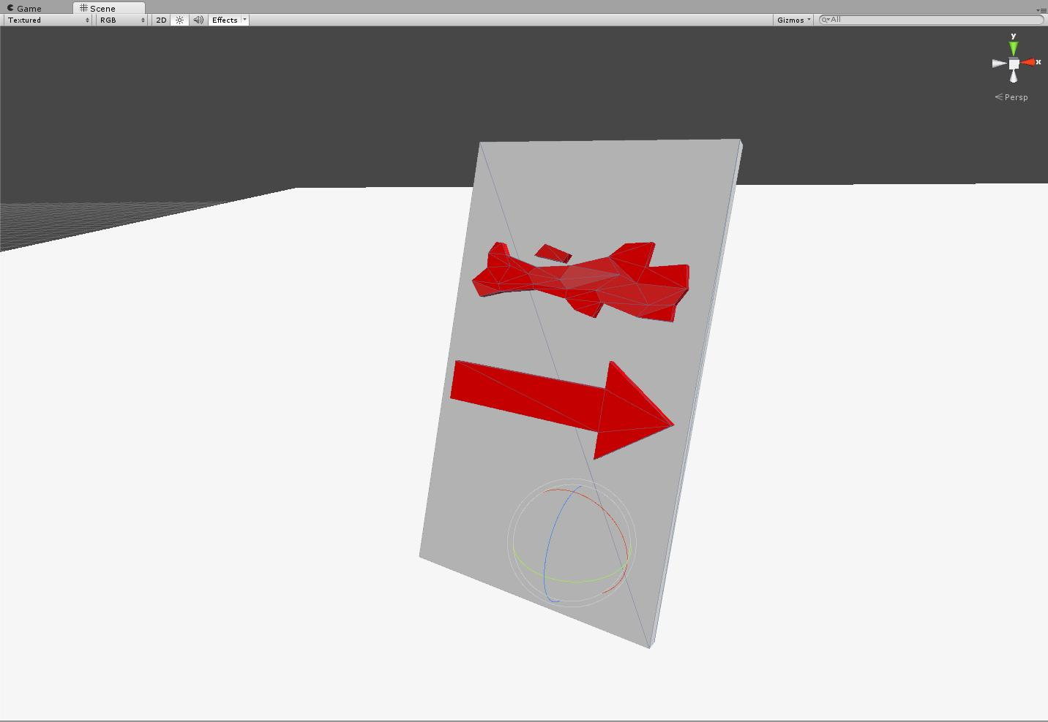

Figure : Kesh's exhibit right – 99 polys

### Kesh's mace

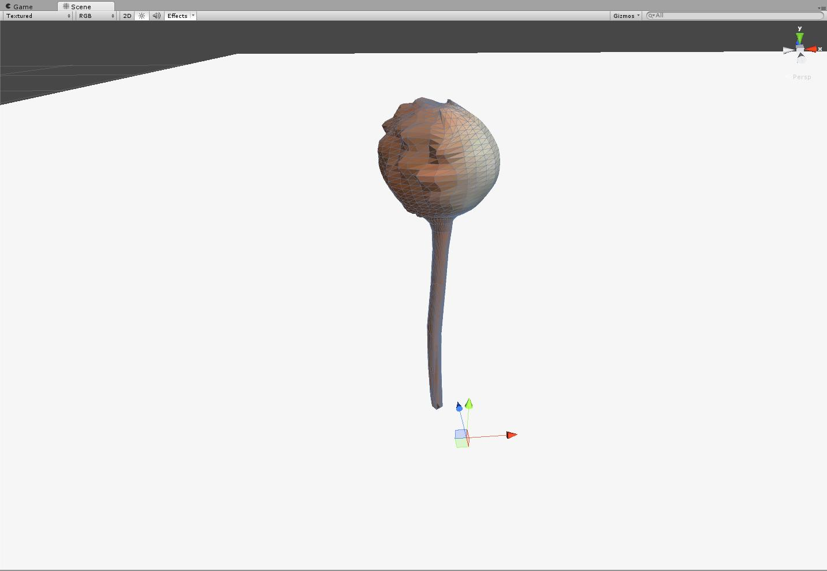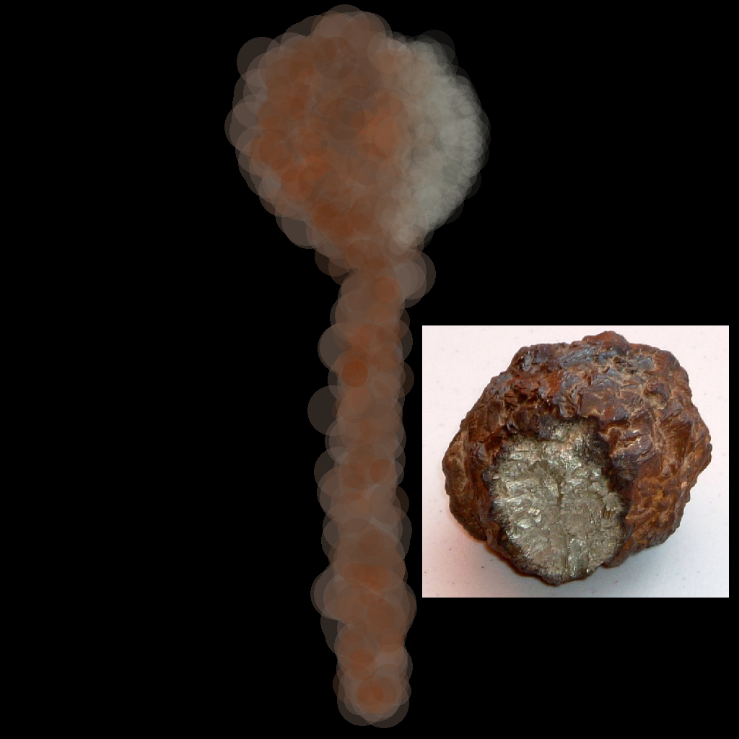

Figure : Kesh's mace – 1435 polys

### Kesh's staff

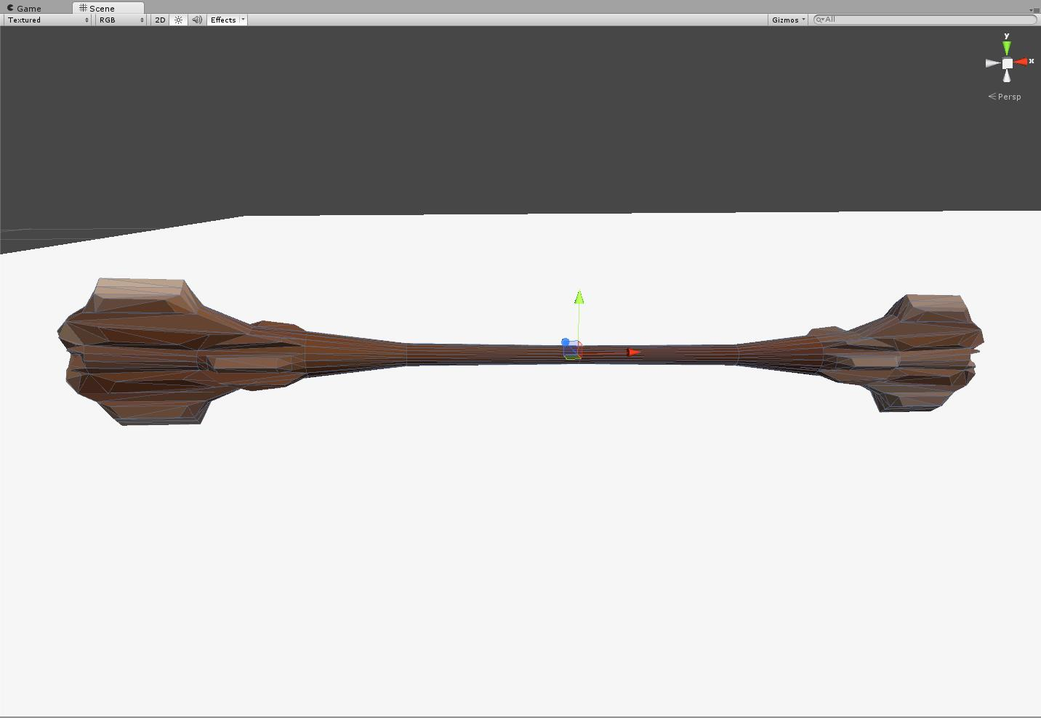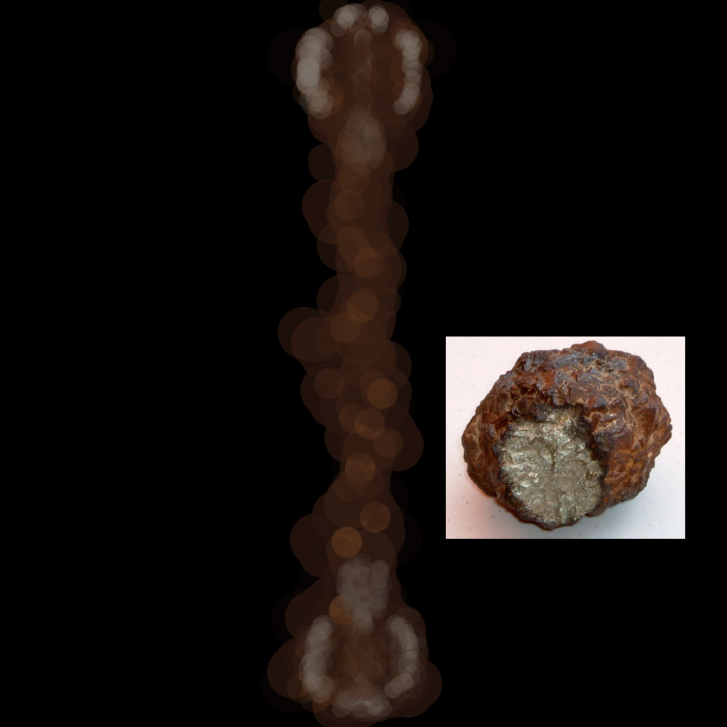

Figure : Kesh's staff – 496 polys

### Kesh's sword

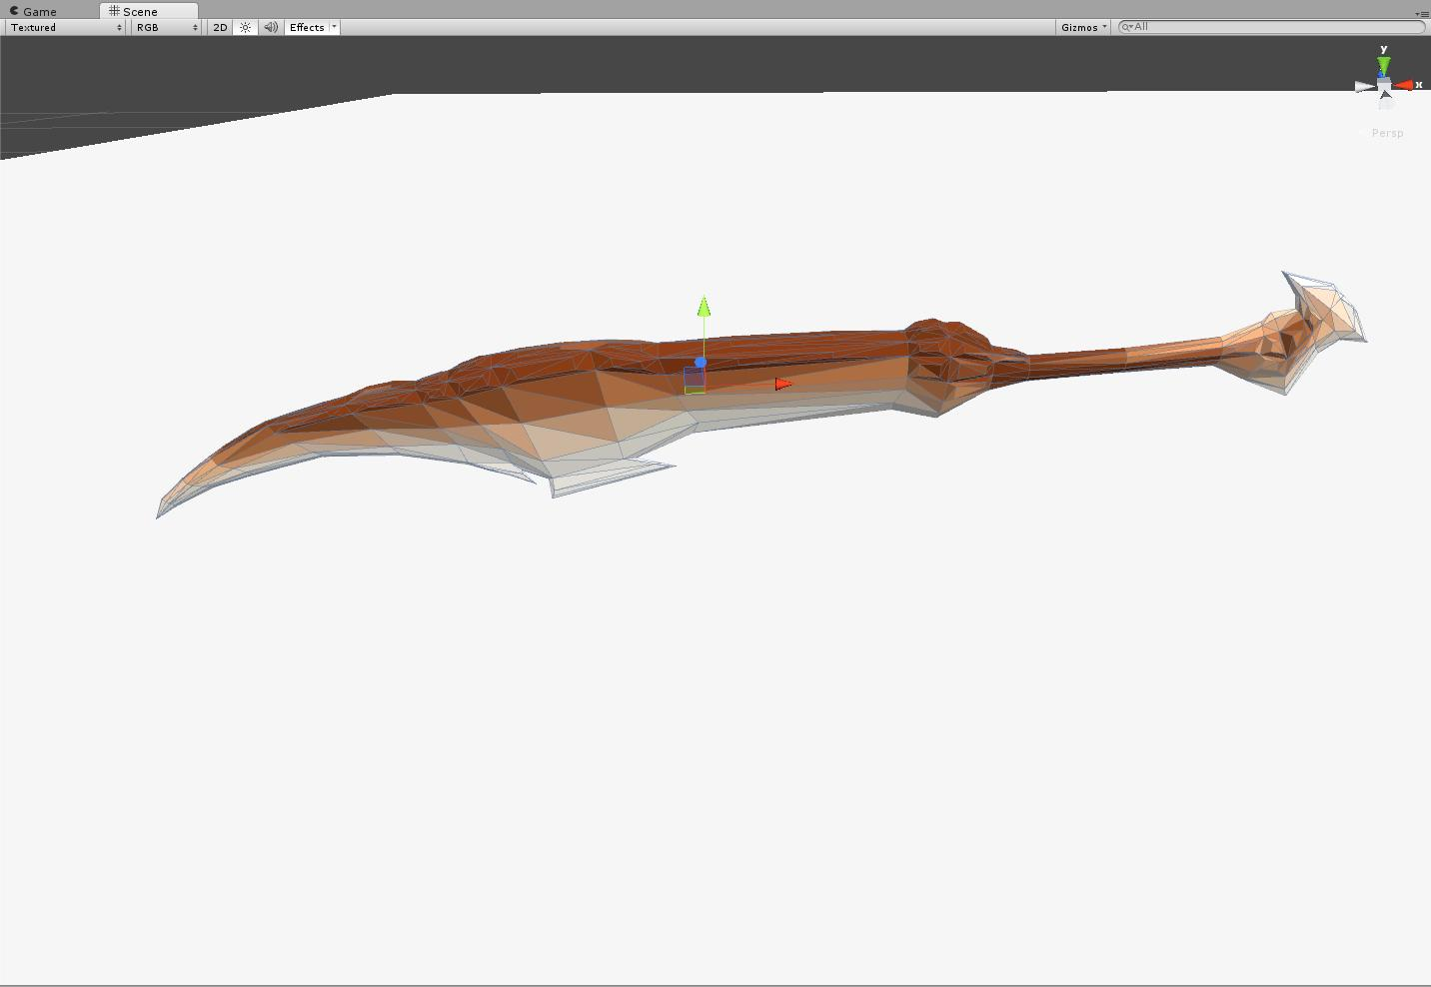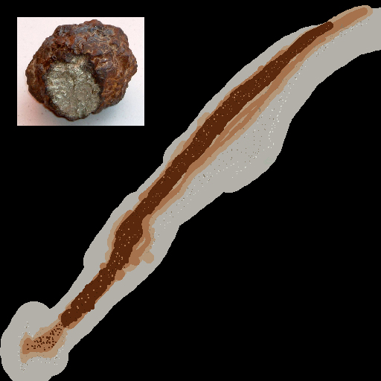

Figure : Kesh's sword – 544 polys

### Lab table

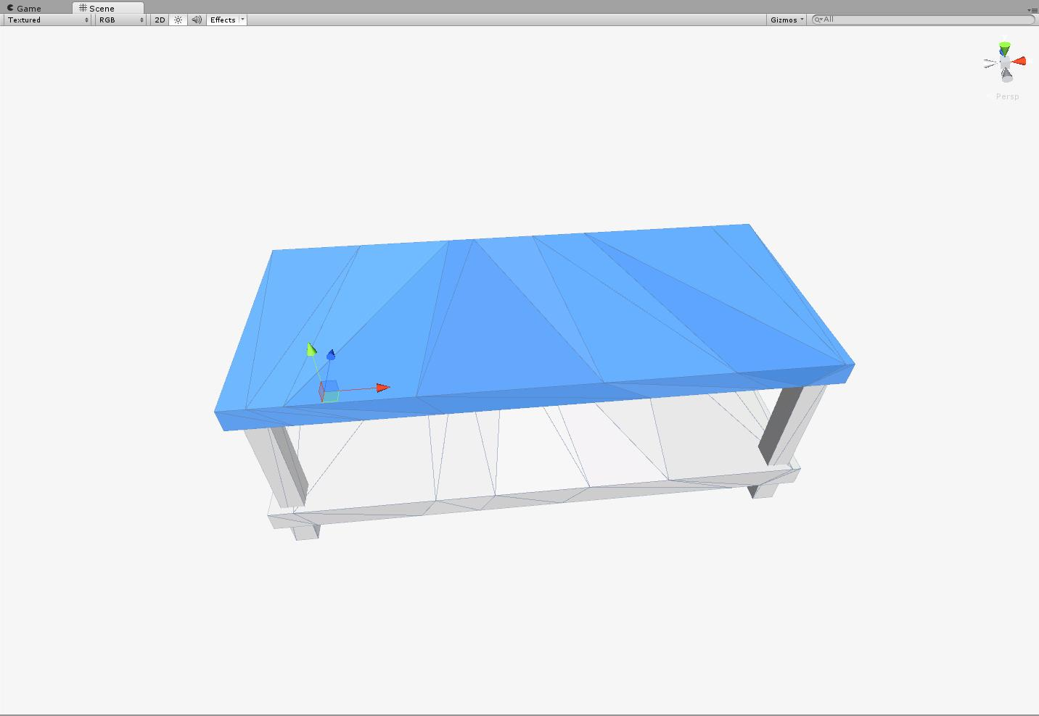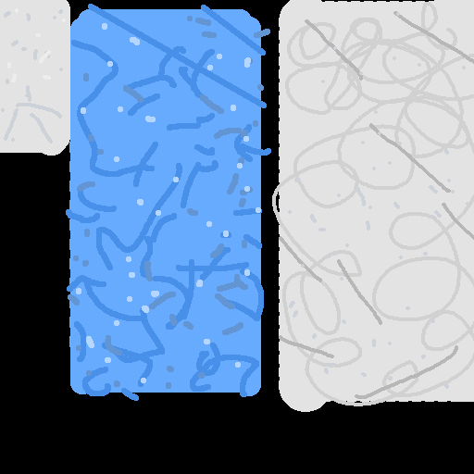

Figure : Lab table – 62 polys

### Large pot – Blue

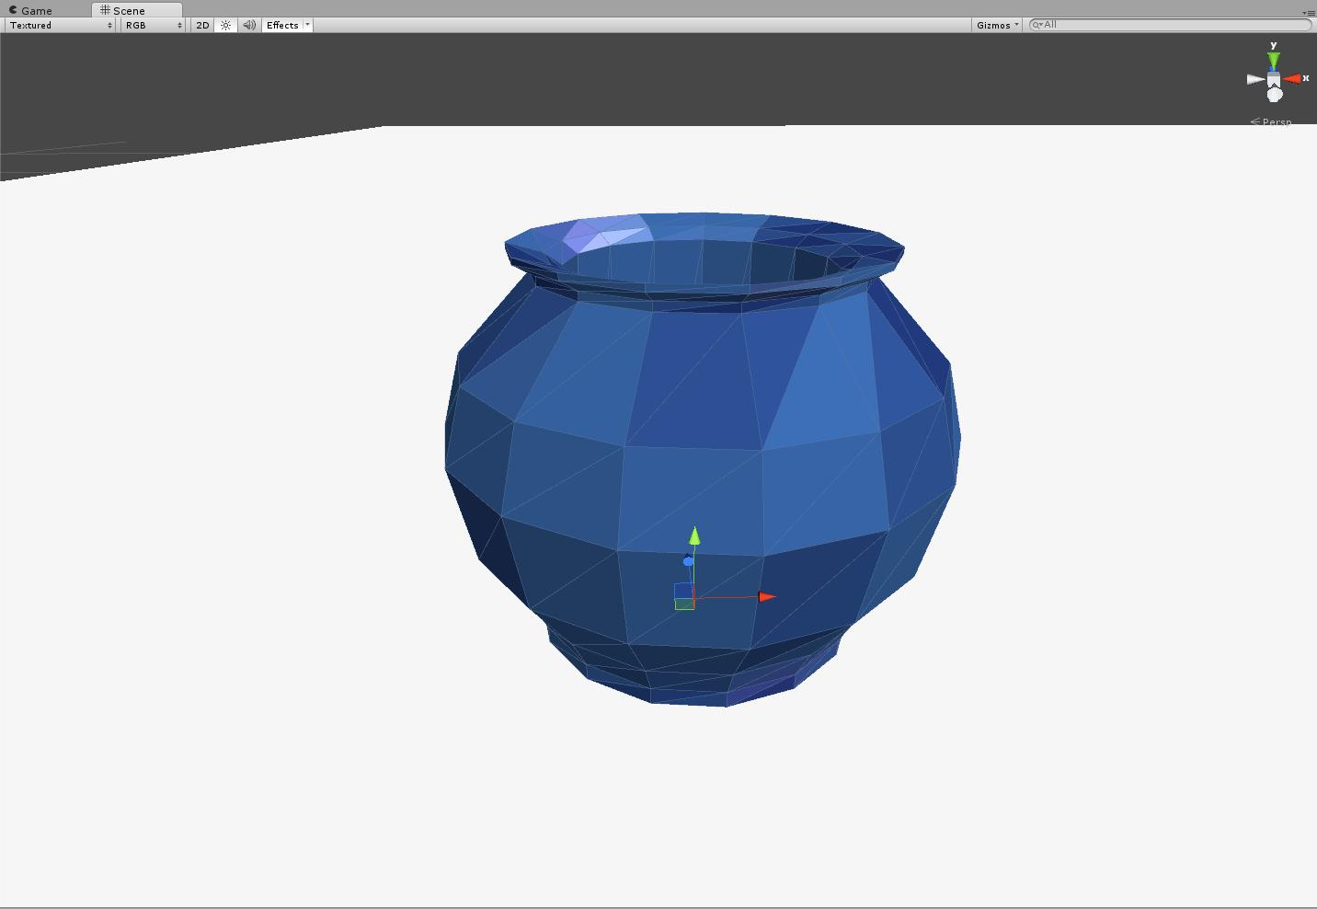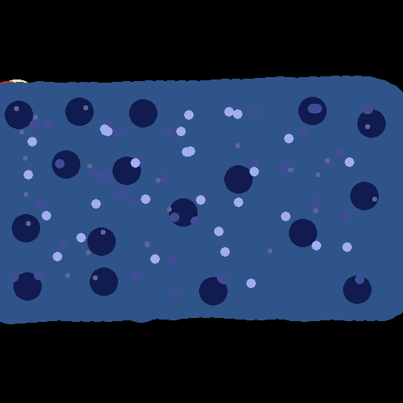

Figure : Large pot – Blue – 210 polys

### Large pot – Green

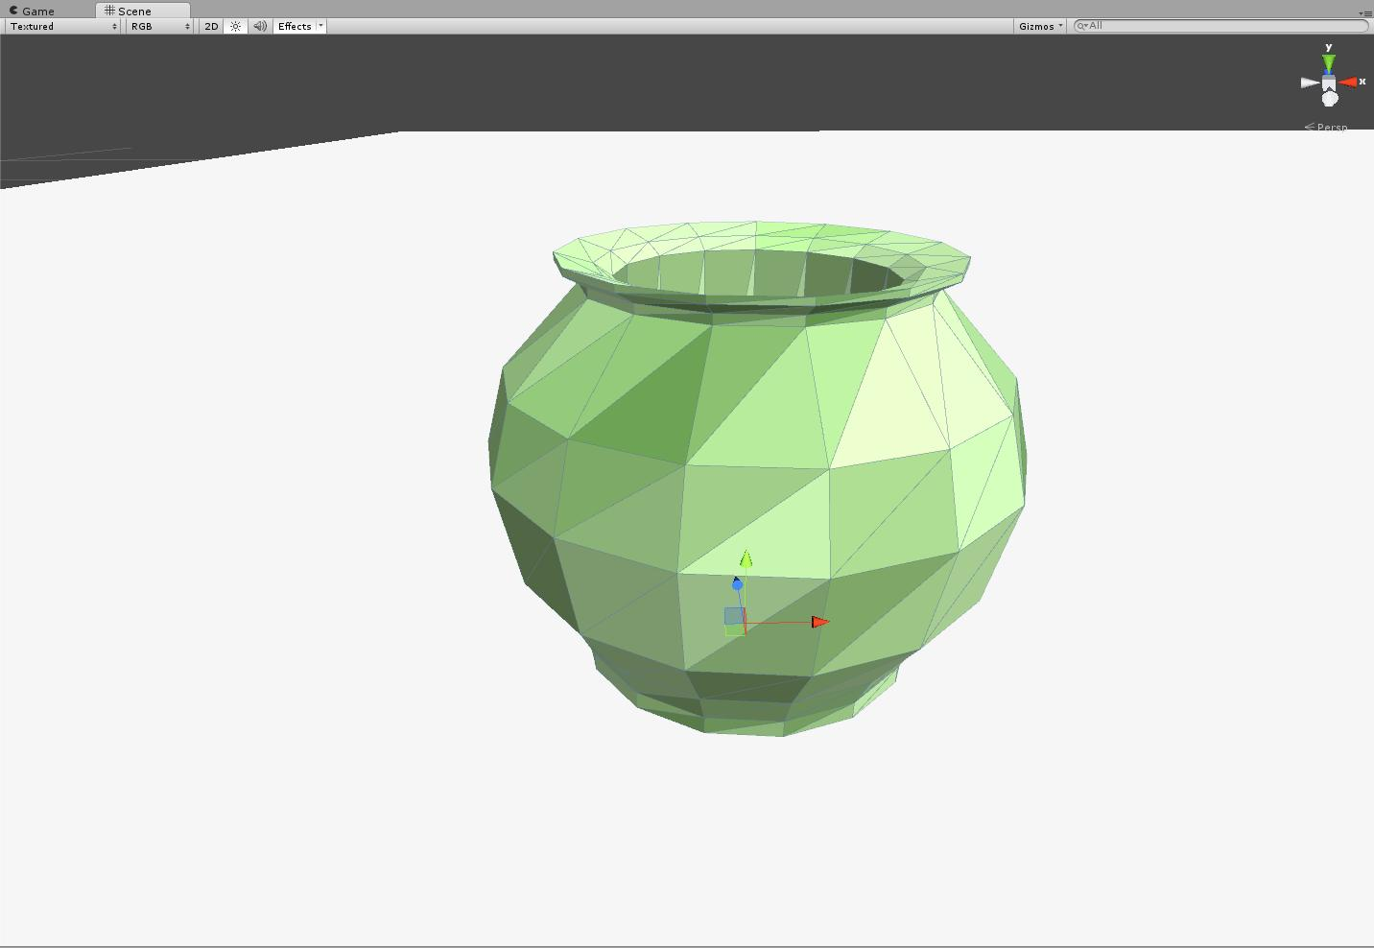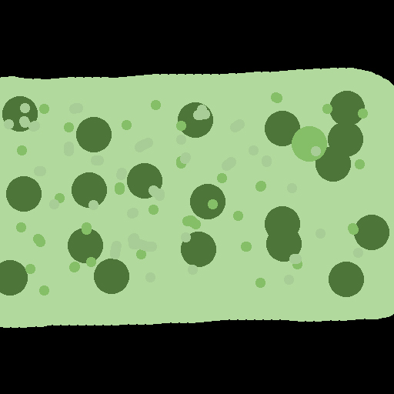

Figure : Large pot – Green – 210 polys

### Large pot – Red

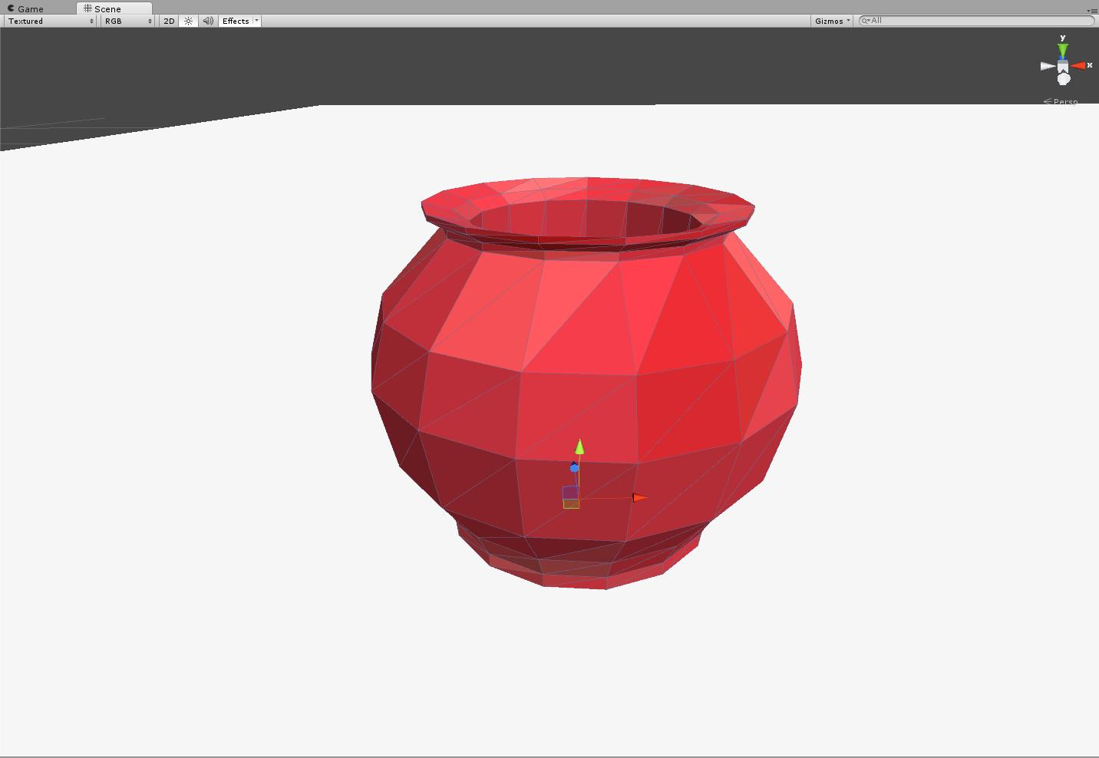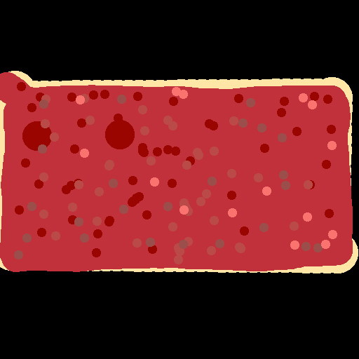

Figure : Large pot – Red – 210 polys

### Lobby desk

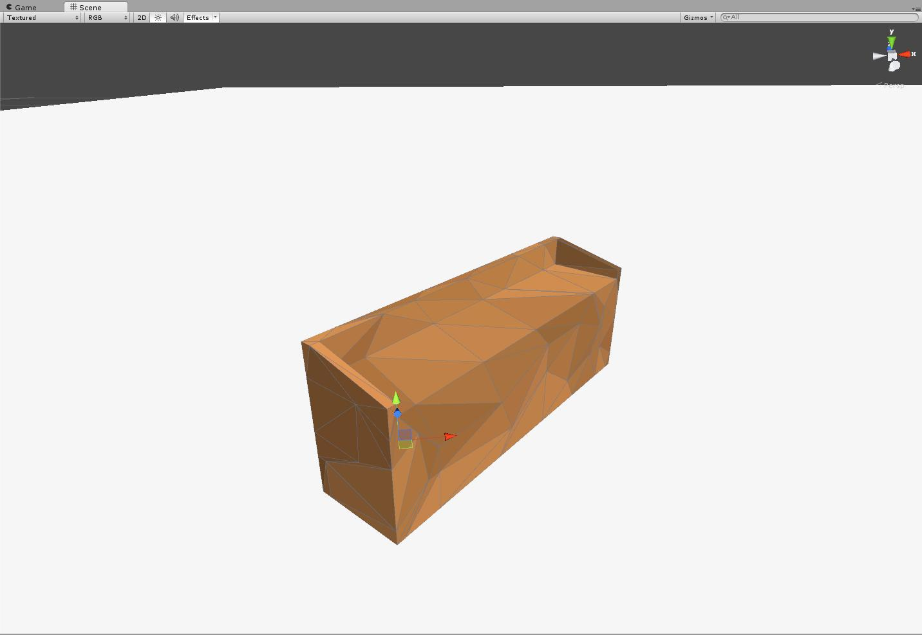

Figure : Lobby desk – 98 polys

### Long display case

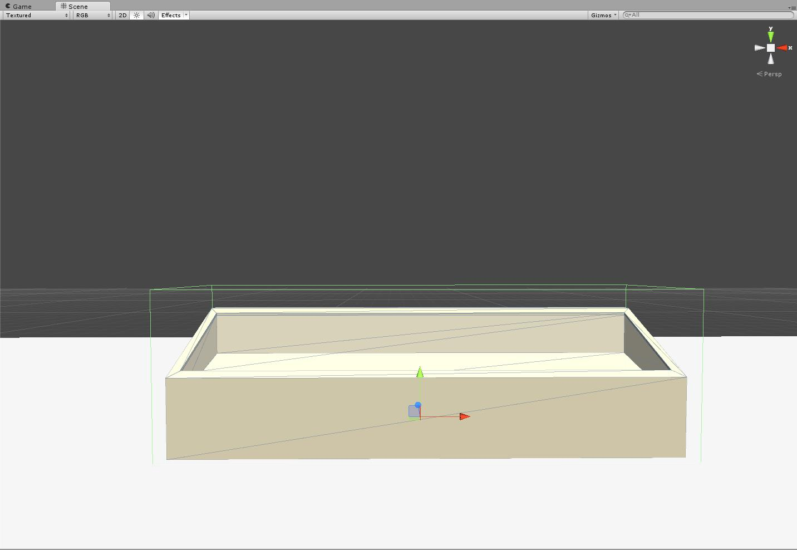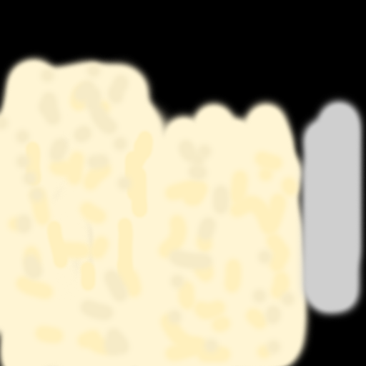

Figure : Long display case – 22 polys

### Medical tool table

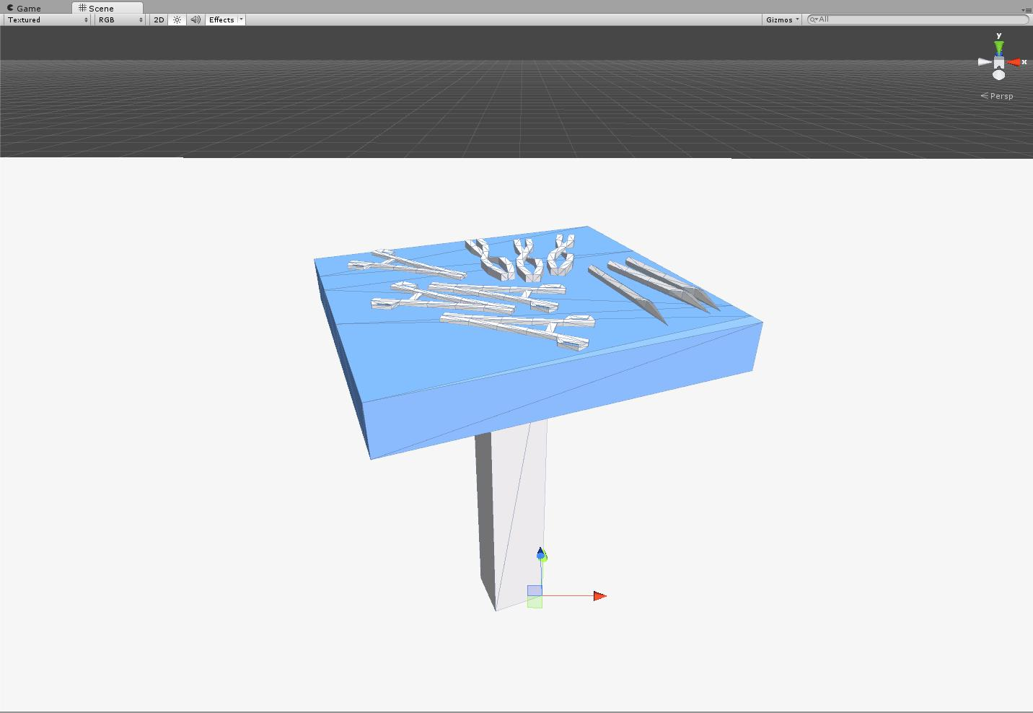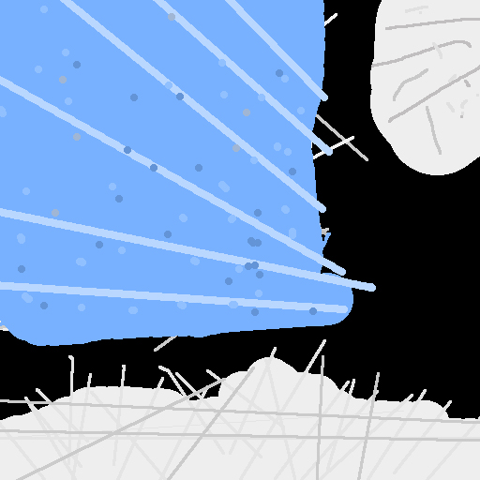

Figure : Medical tool table – 440 polys

### MG-32

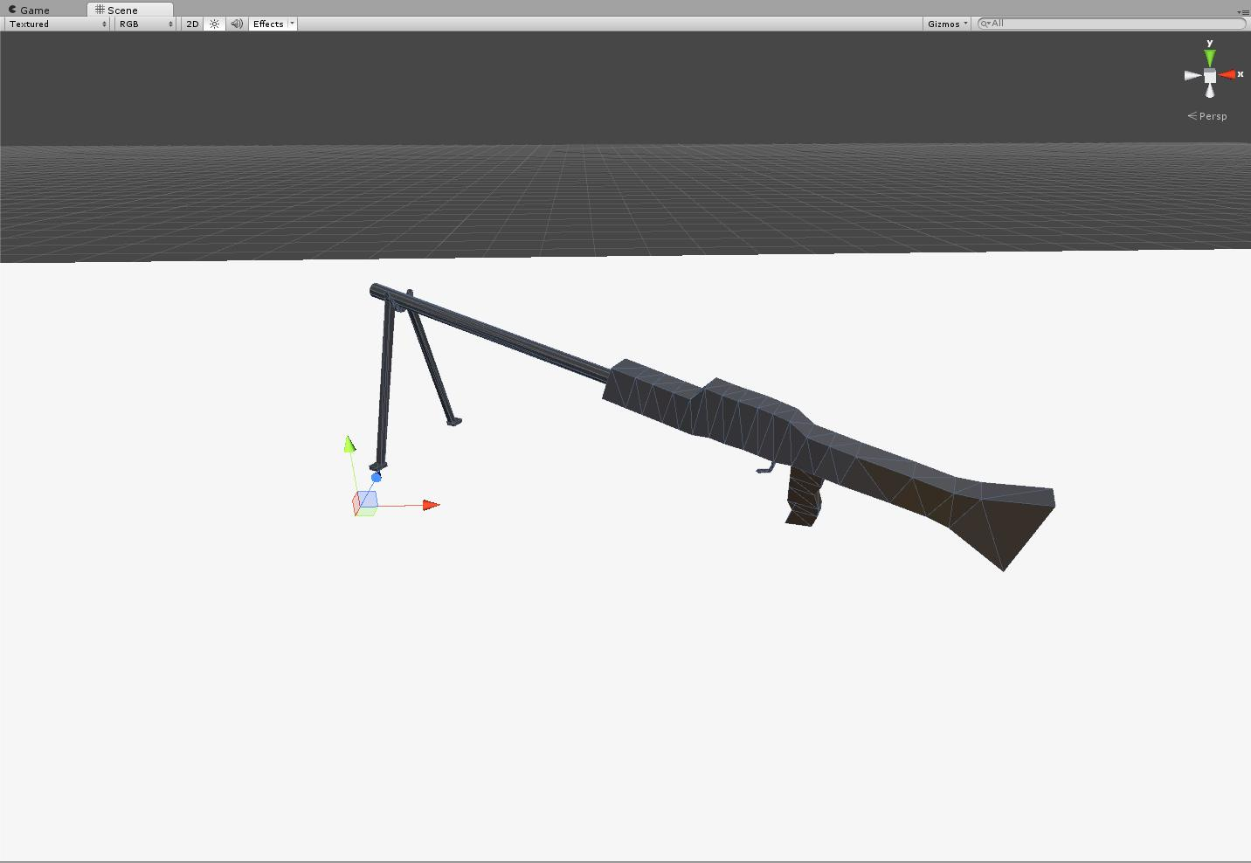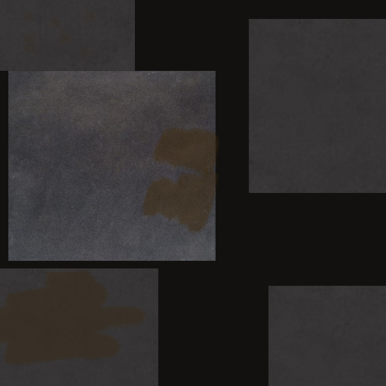

Figure : MG-32 – 230 polys

### Modern art - windows – blue

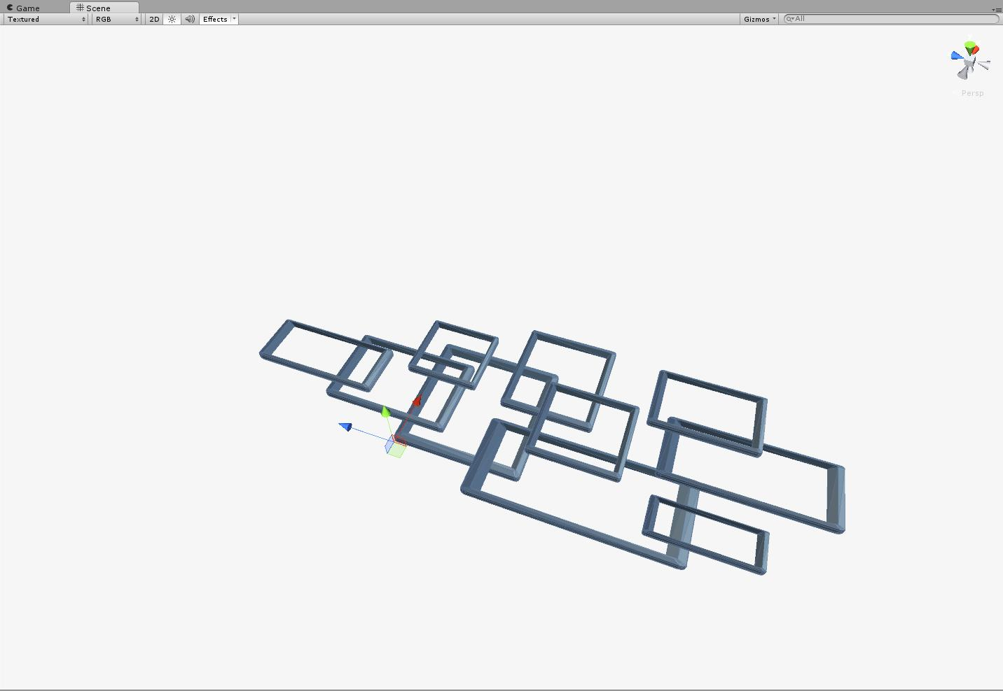

Figure : Modern art - windows – blue - 960 polys

### Modern art - windows – brown

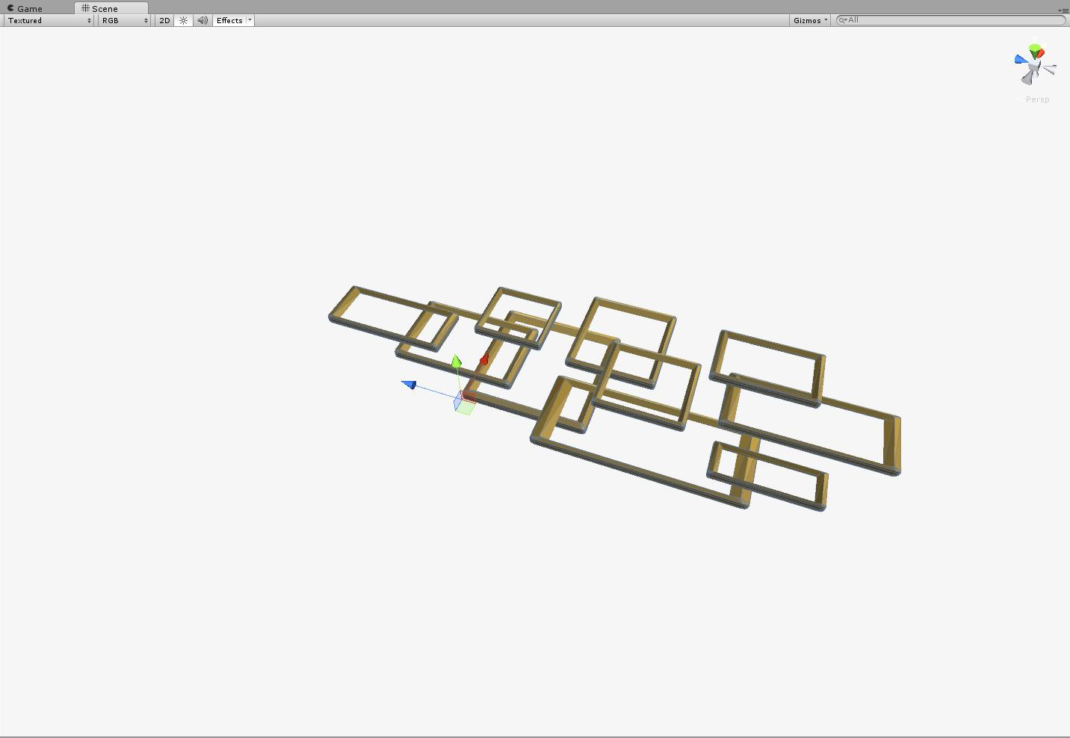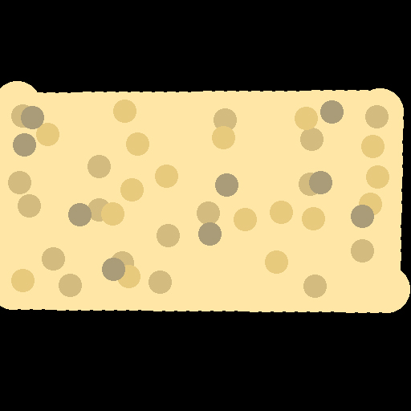

Figure : Modern art - windows – brown – 960 polys

### Modern art - windows – green

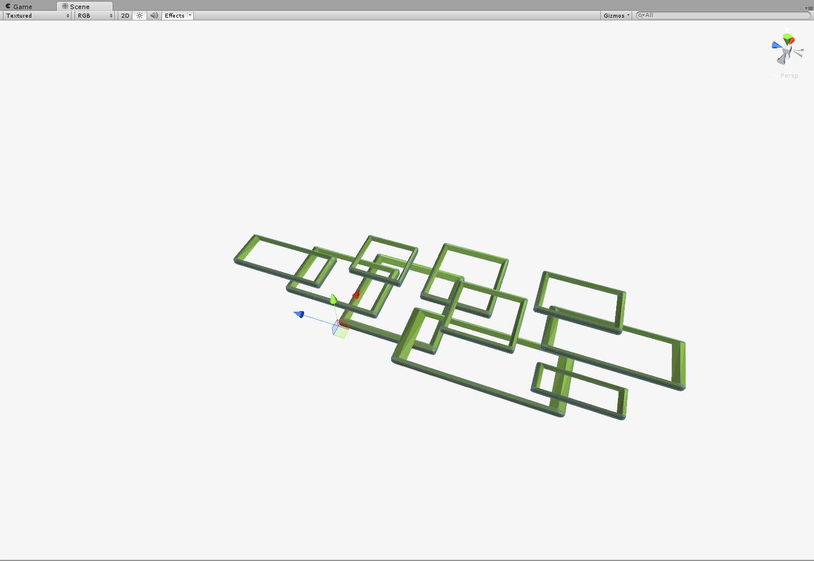

Figure : Modern art - windows – green – 960 polys

### Modern art - windows – pink

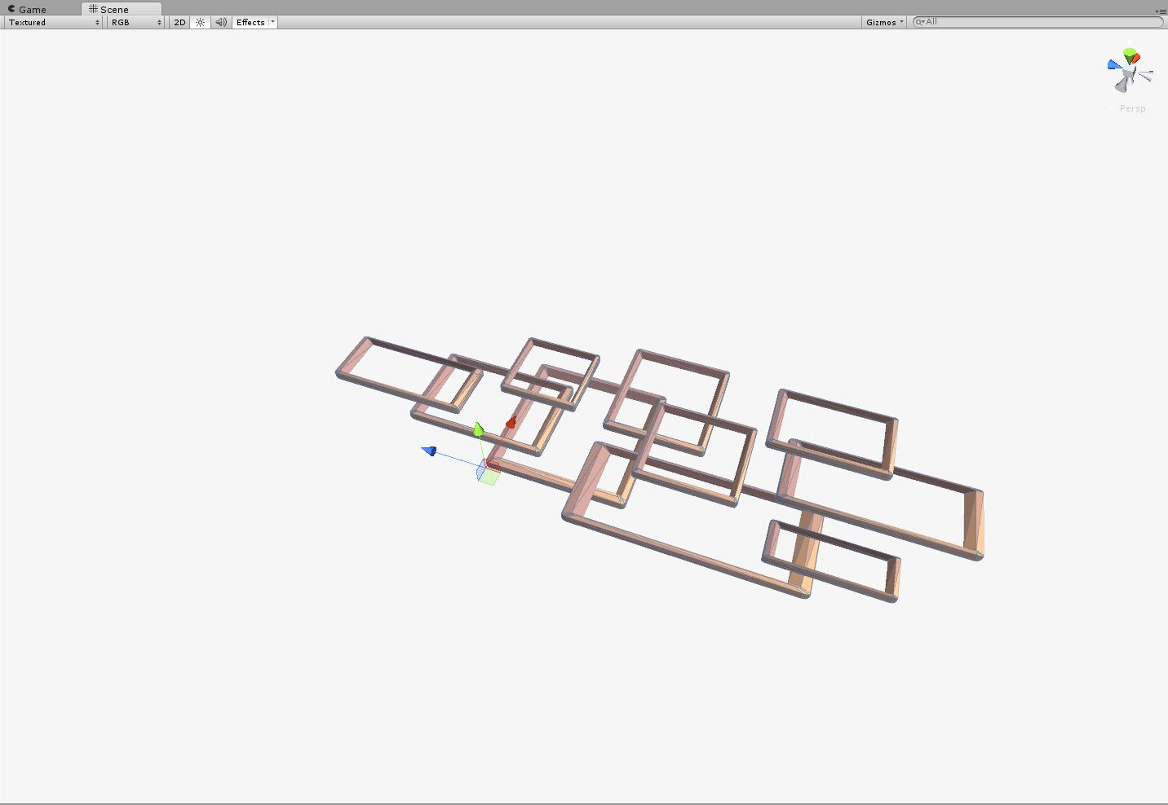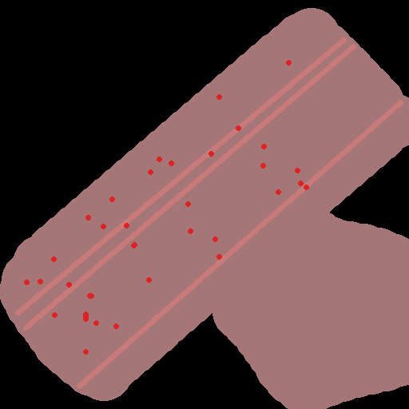

Figure : Modern art - windows – pink – 960 polys

### Modern art - windows – purple

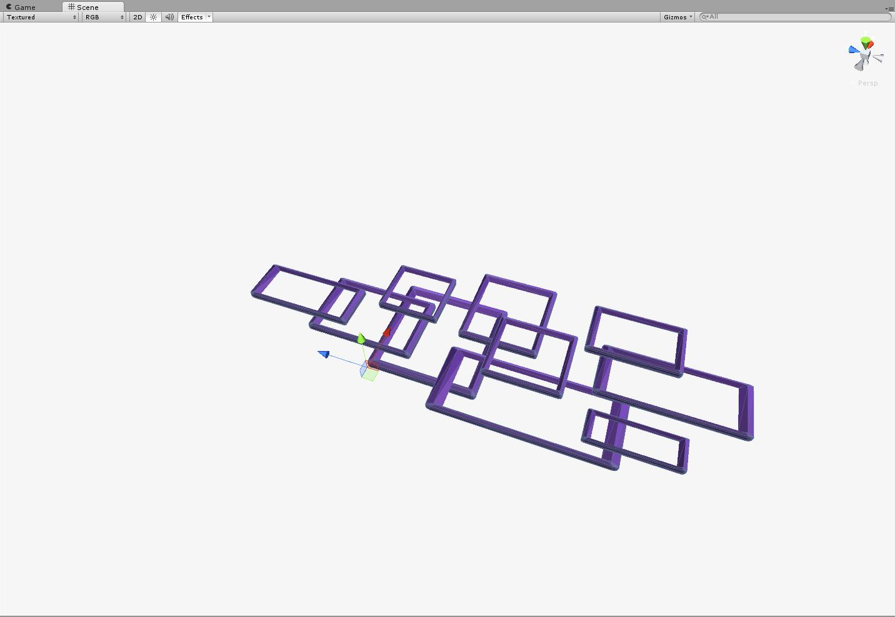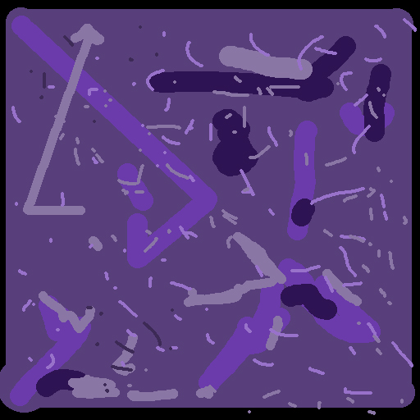

Figure : Modern art - windows – purple – 960 polys

### Modern art – boxes

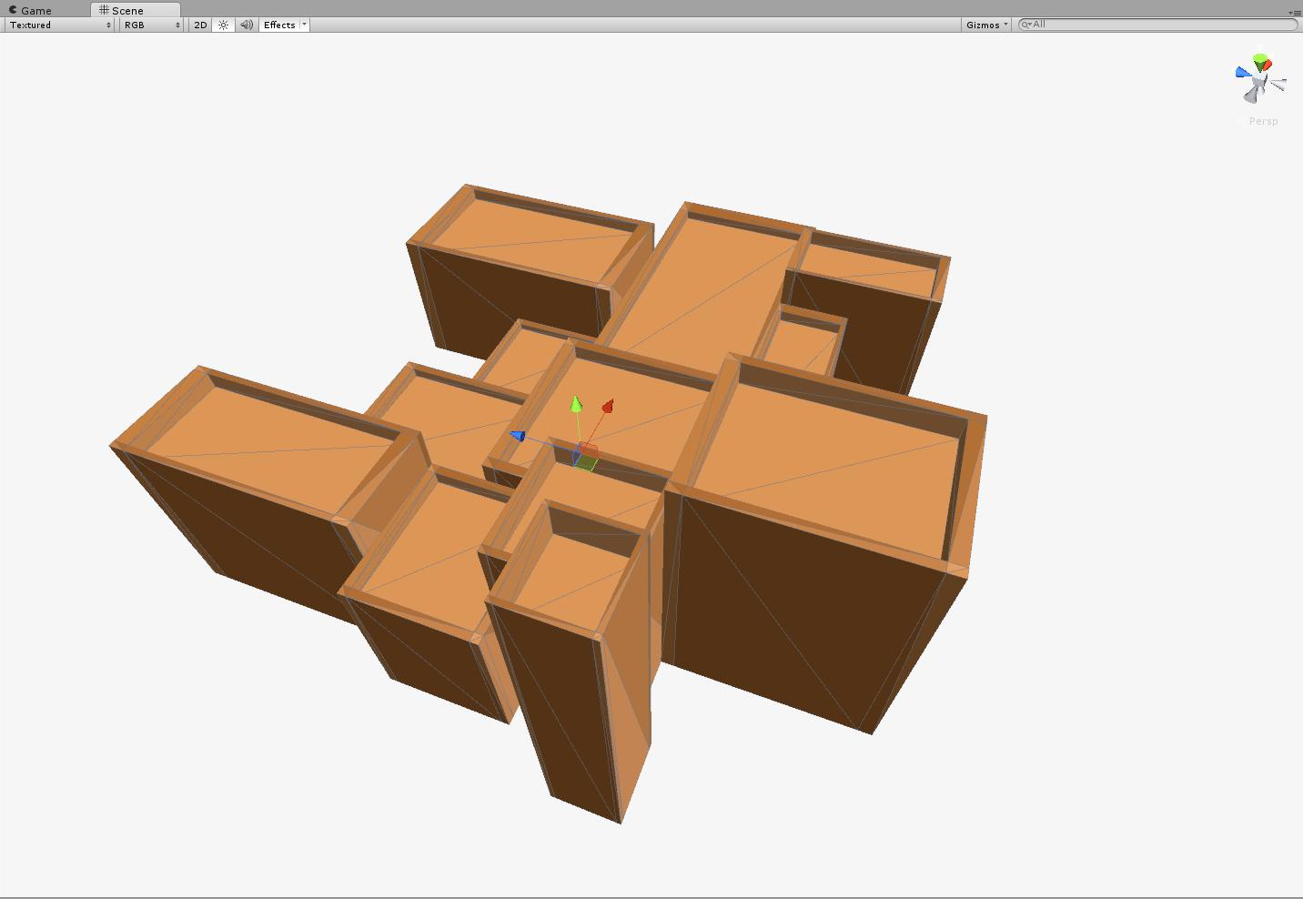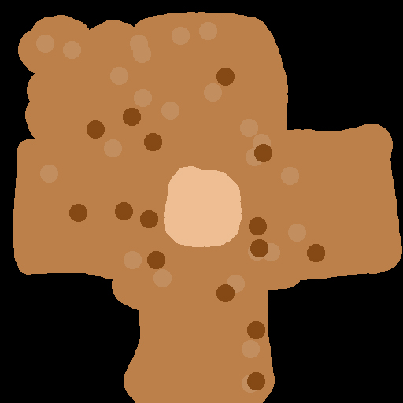

Figure : Modern art – boxes – 408 polys

### Morning star

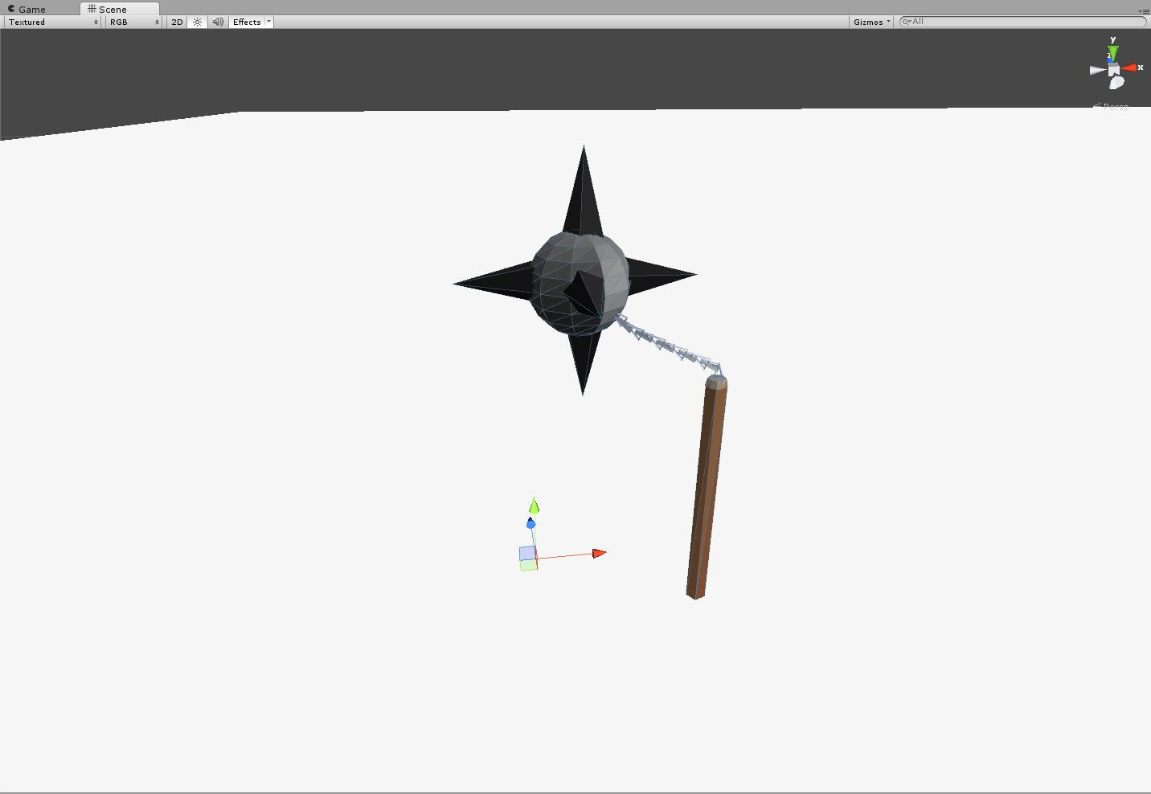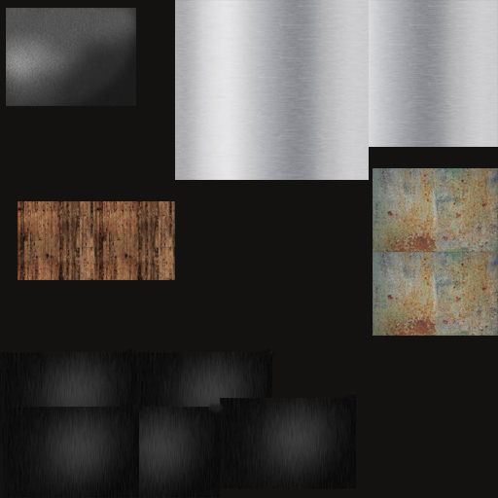

Figure : Morning star – 289 polys

### Mural – blue

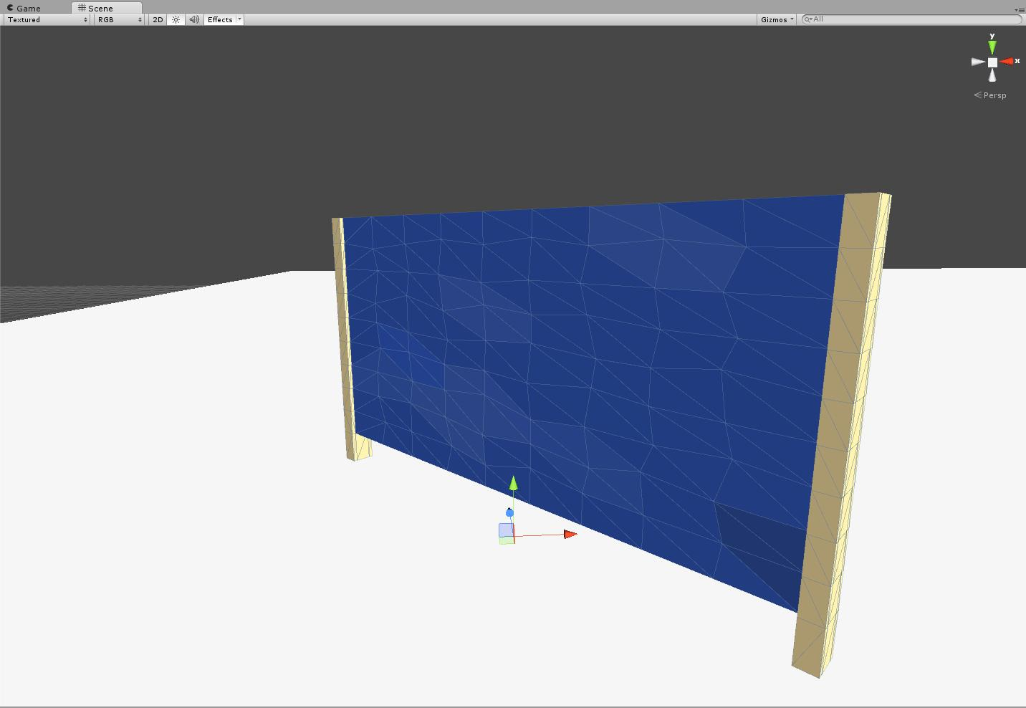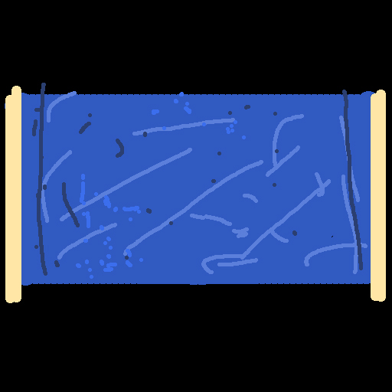

Figure : Mural – blue – 350 polys

### Mural – green

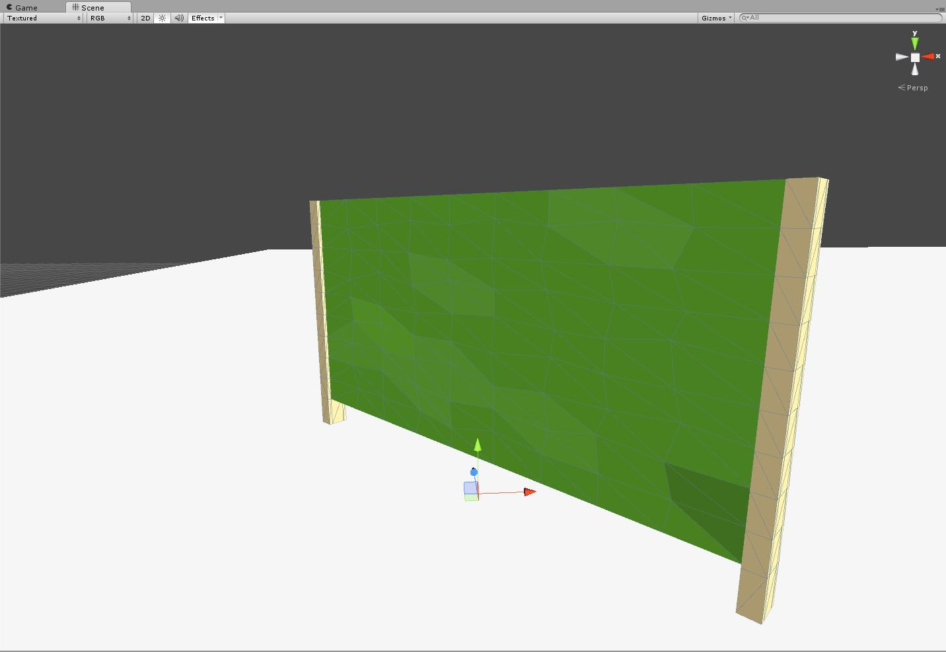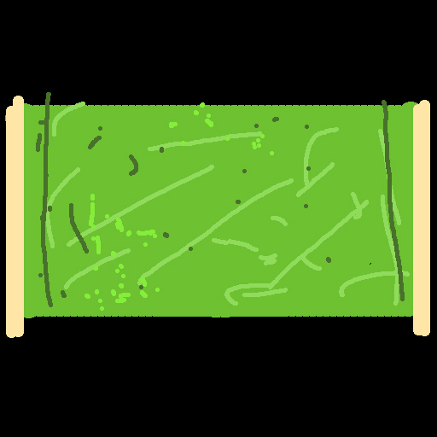

Figure : Mural – green – 350 polys

### Mural – red

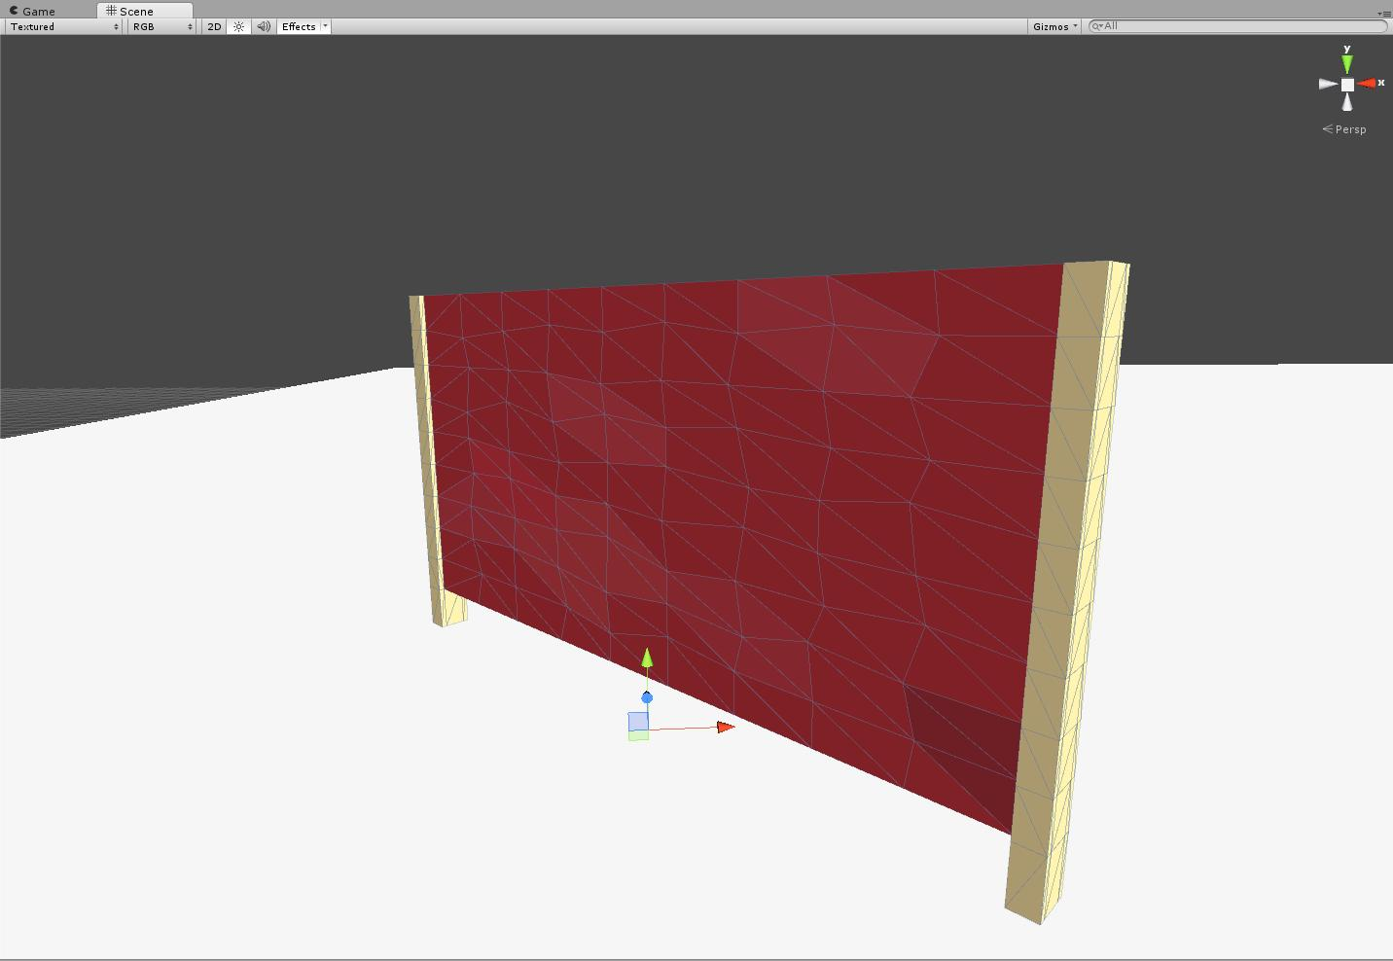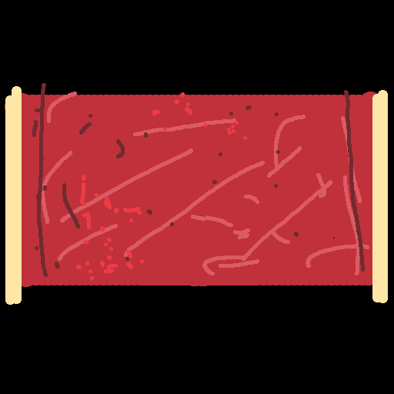

Figure : Mural – red – 350 polys

### Obelisks

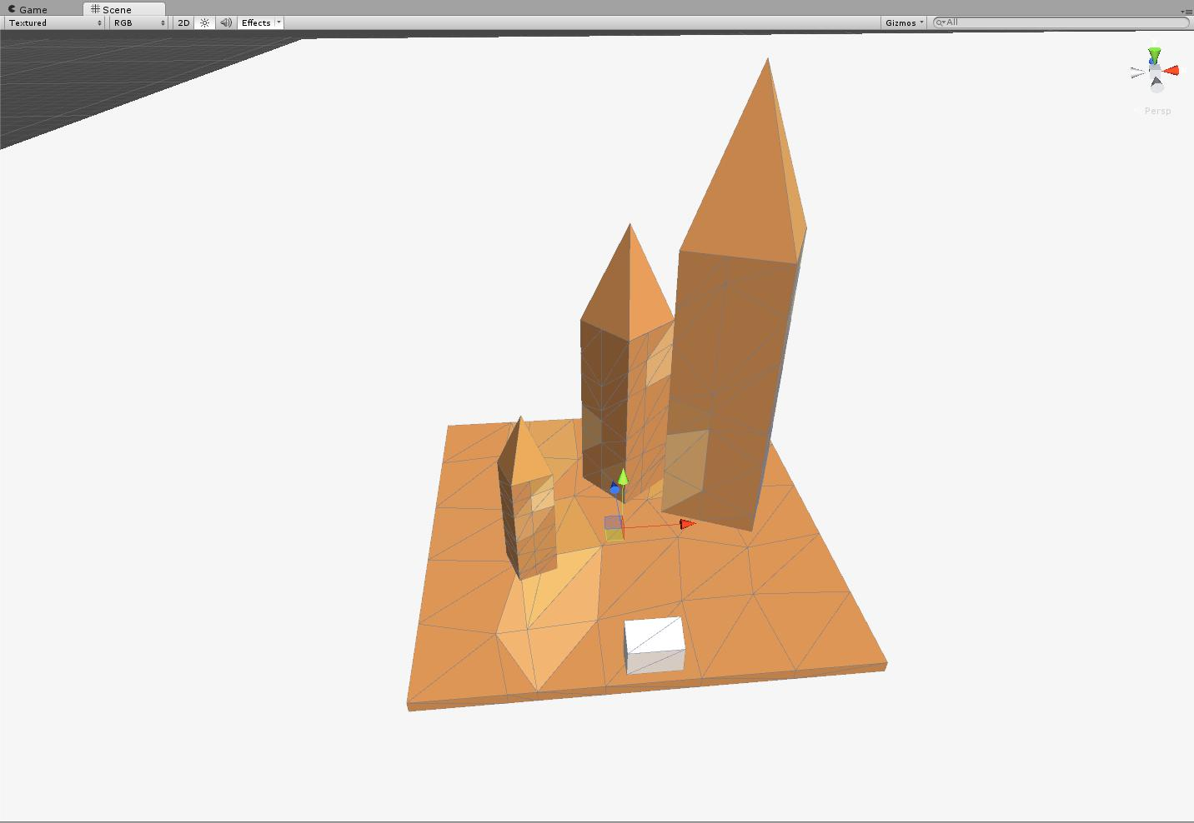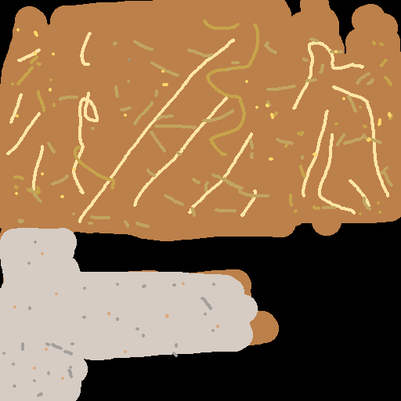

Figure : Obelisks – 242 polys

### Paintings - 10 variations

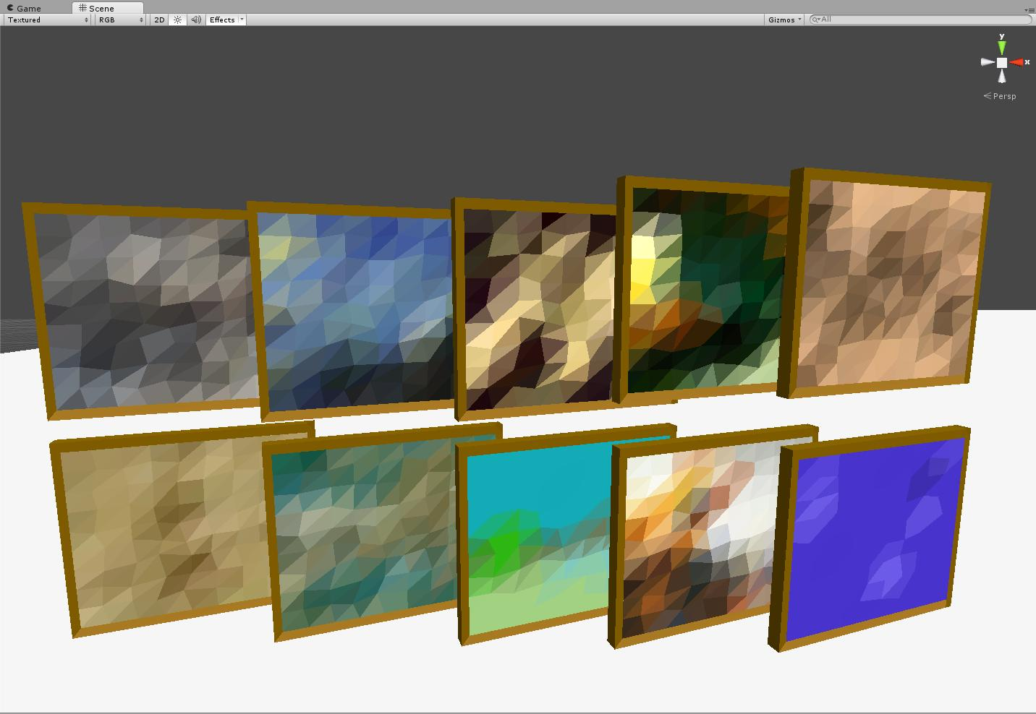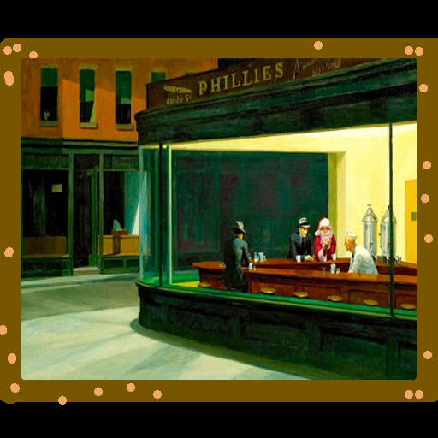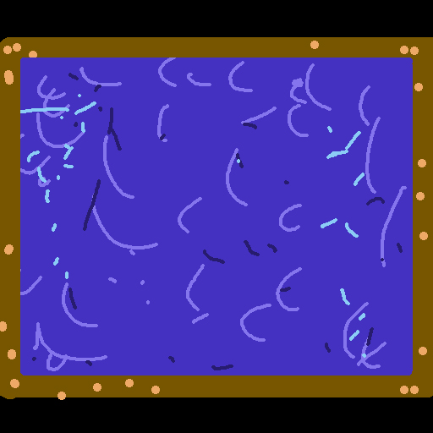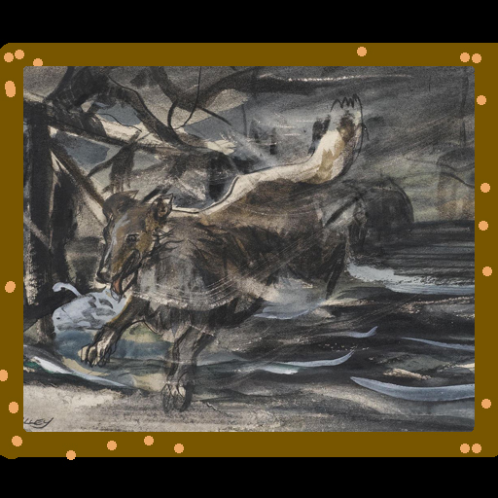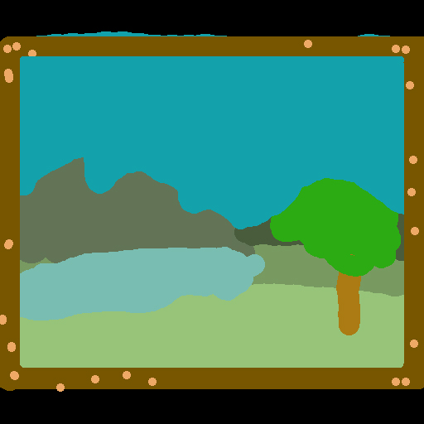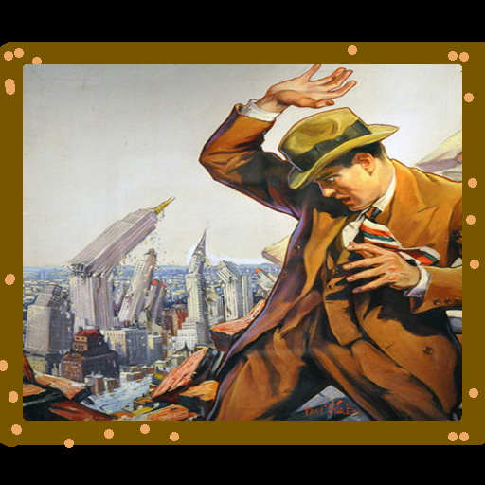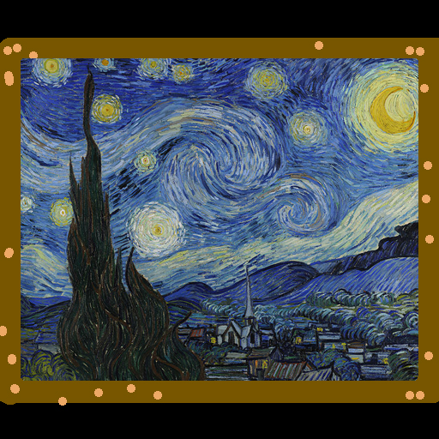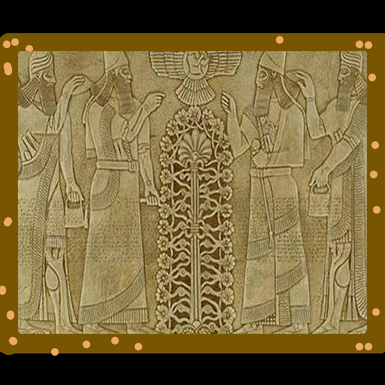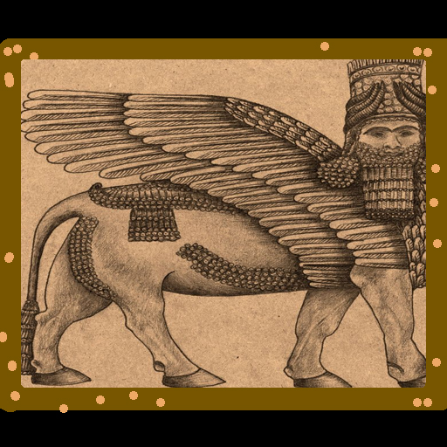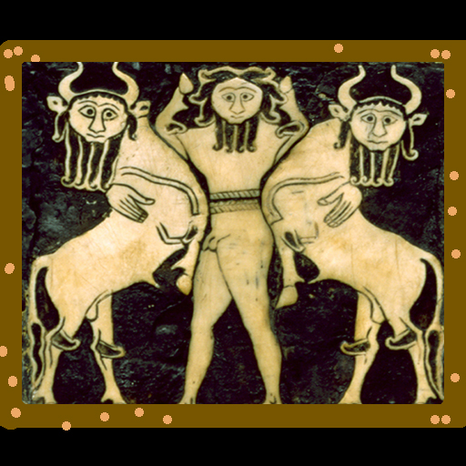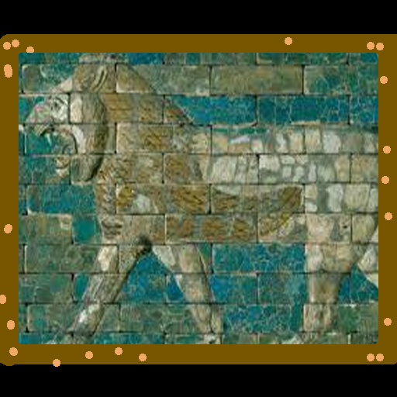

Figure : Paintings - 10 variations – 101 polys each

### Podium

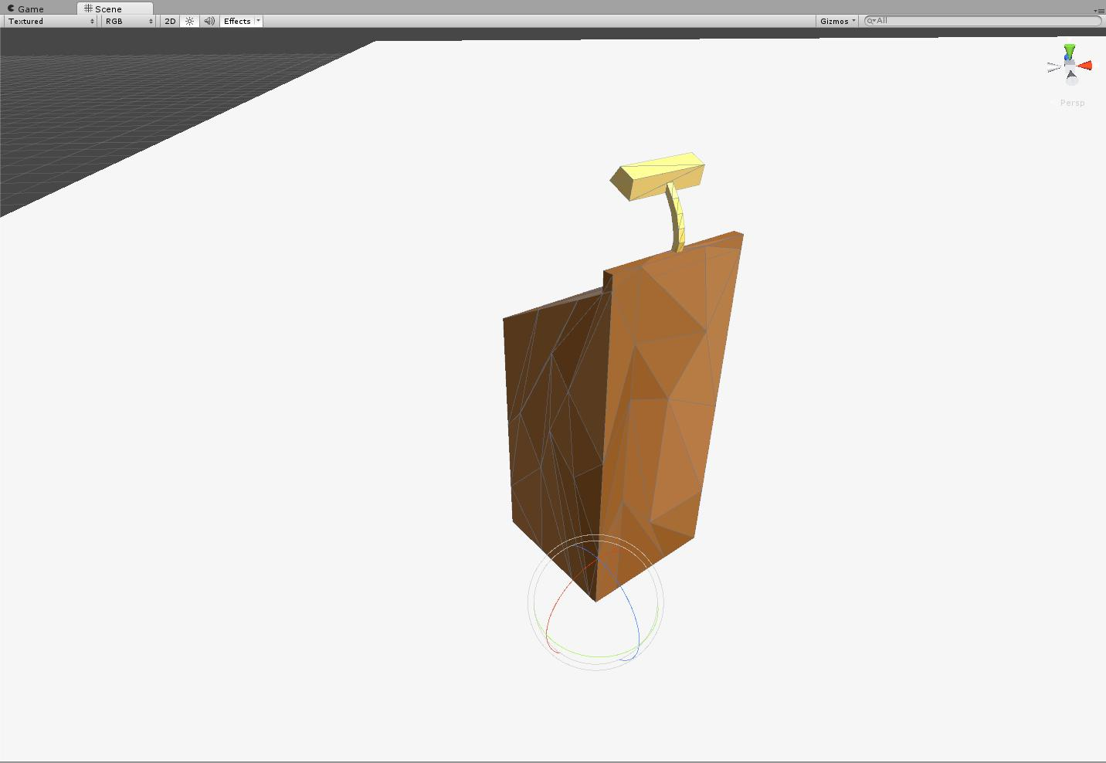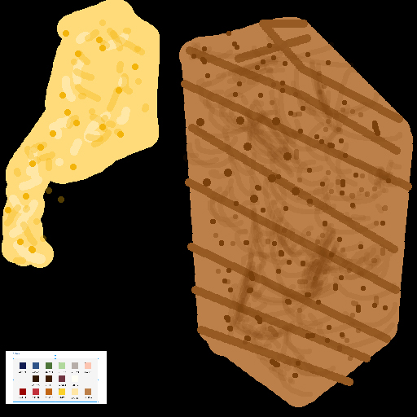

Figure : Podium – 90 polys

### Police barricade

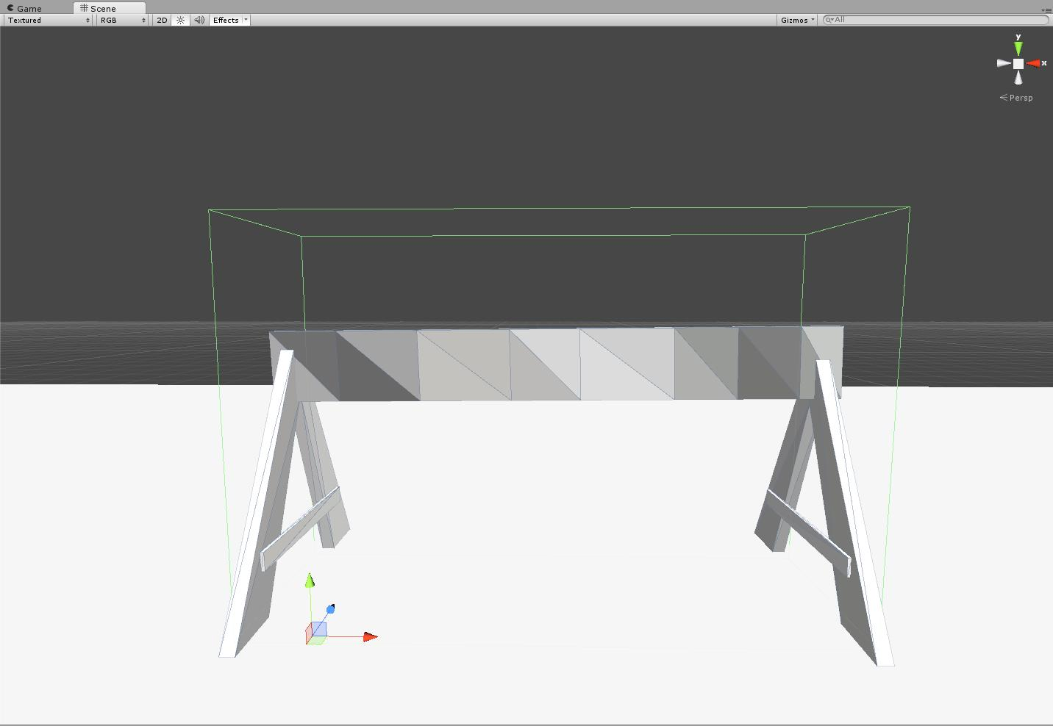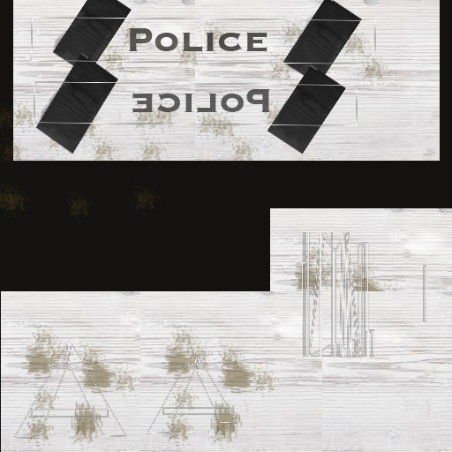

Figure : Police barricade – 70 polys

### Police car

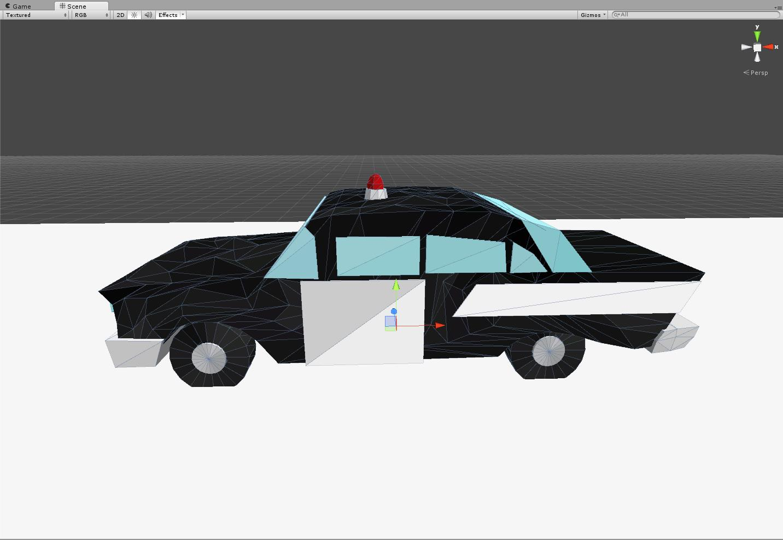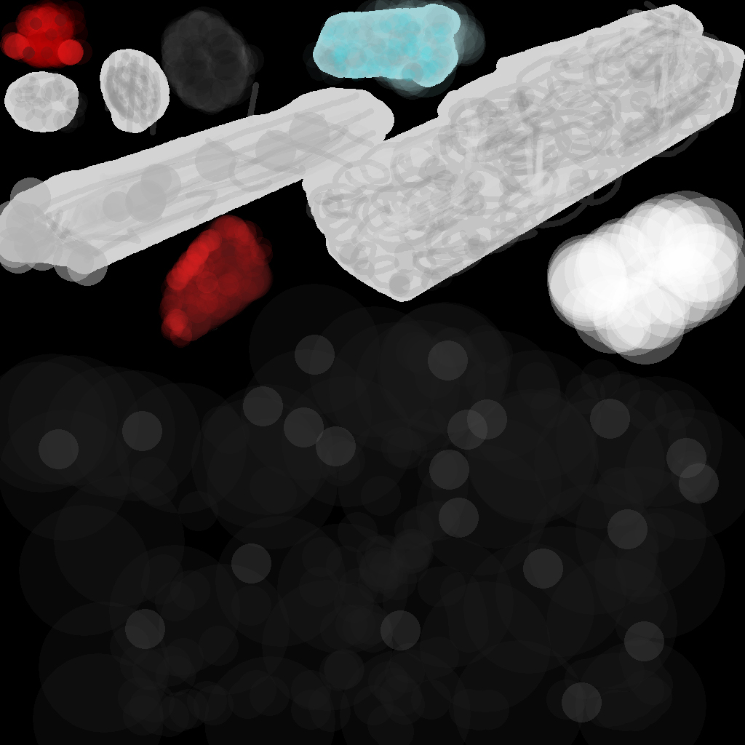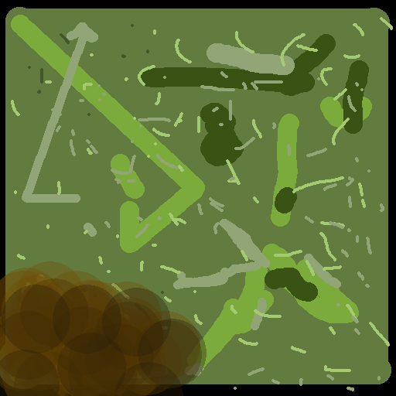

Figure : Police car – 796 polys

### Potted shrub – short

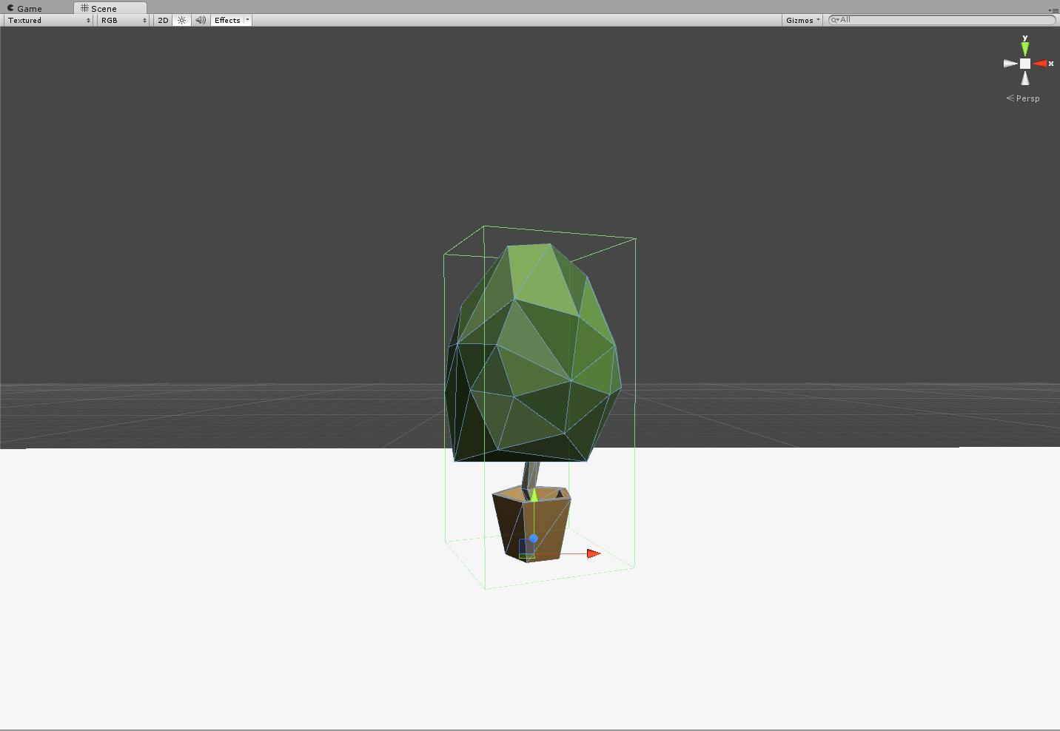

Figure : Potted shrub – short – 122 polys

### Potted shrub – tall

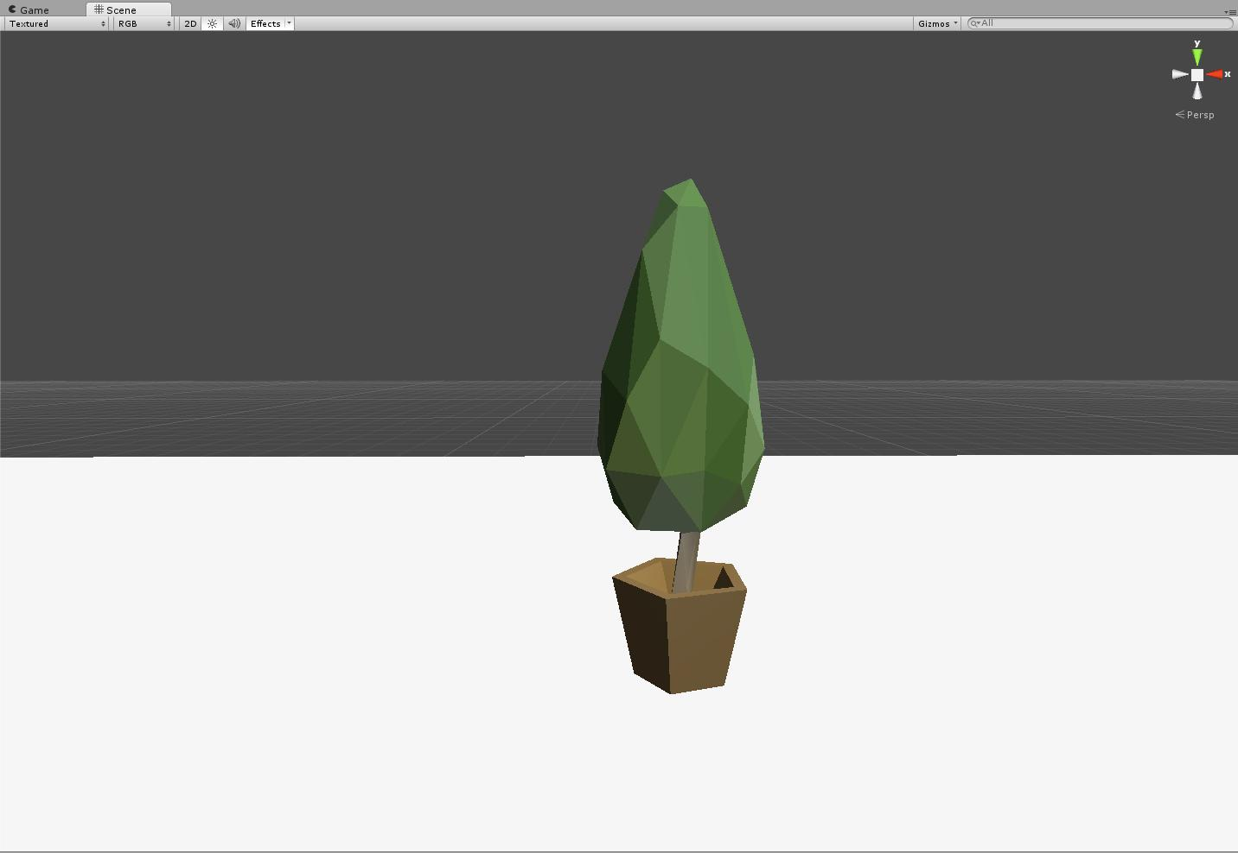

Figure : Potted shrub – tall – 122 polys

### Pyramid – green

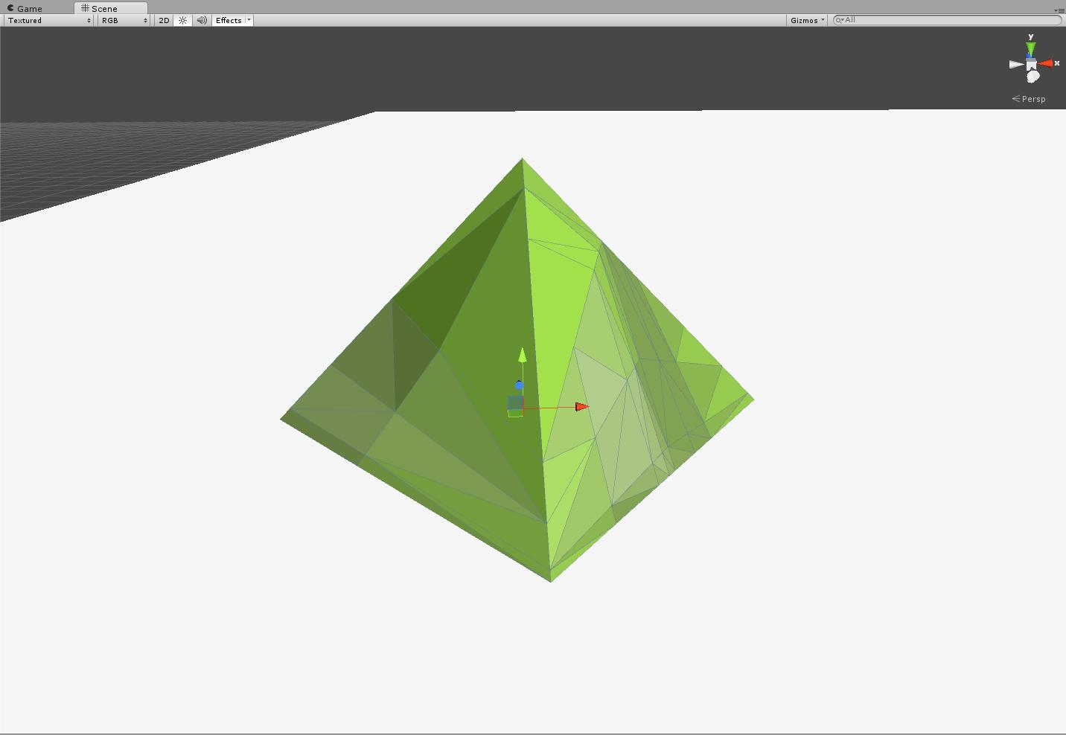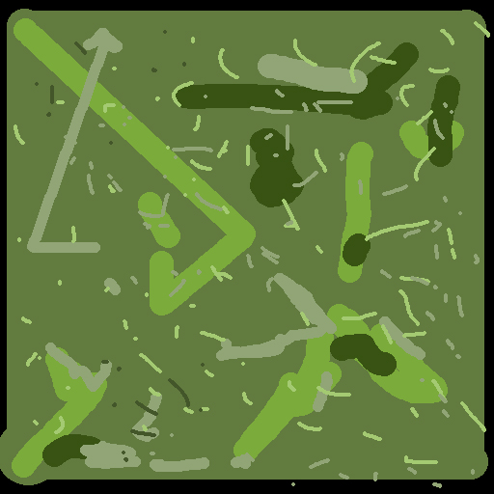

Figure : Pyramid – green – 12 polys

### Pyramid – purple

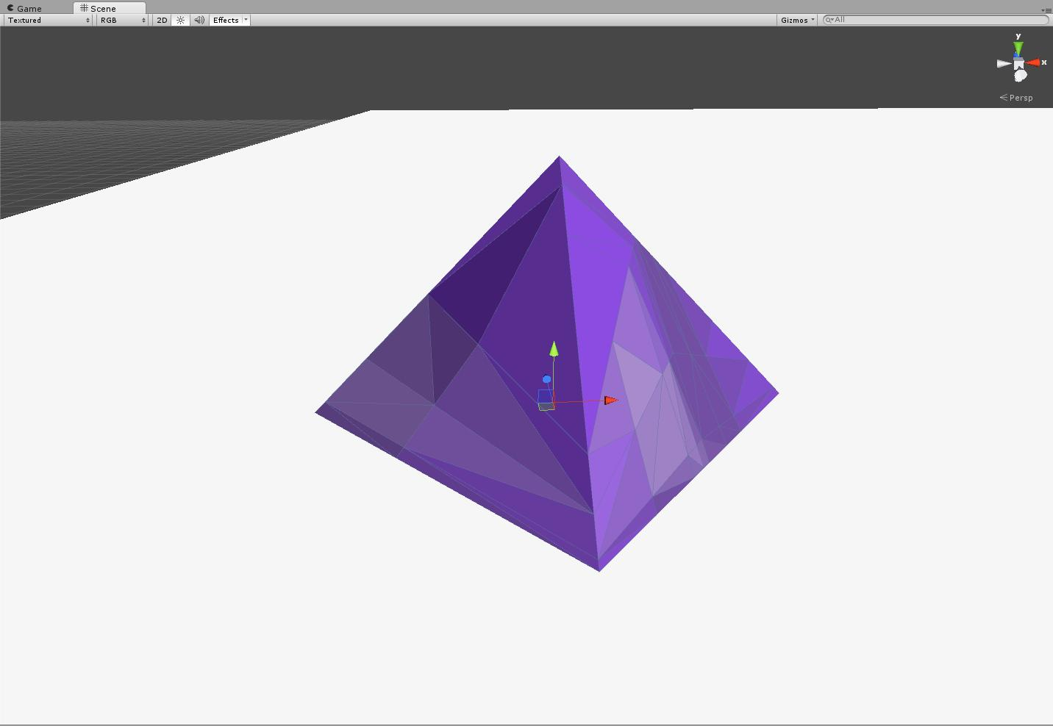

Figure : Pyramid – purple – 12 polys

### Pyramid – tan

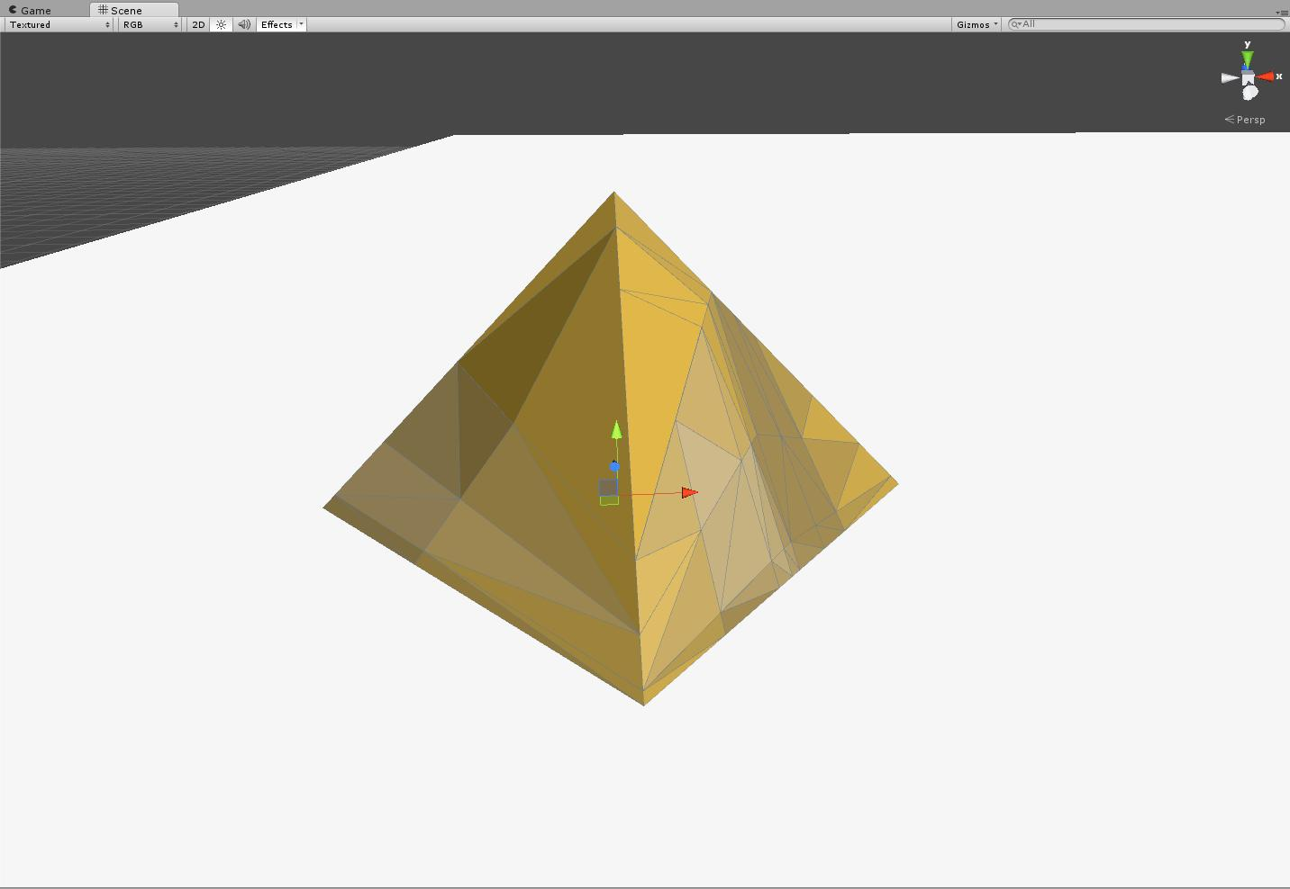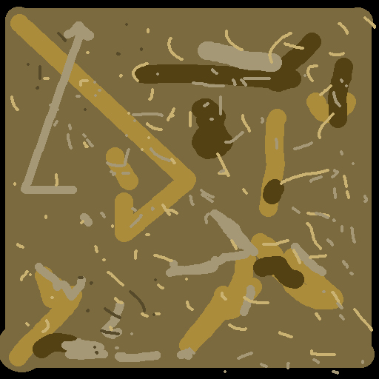

Figure : Pyramid – tan – 12 polys

### Revolver

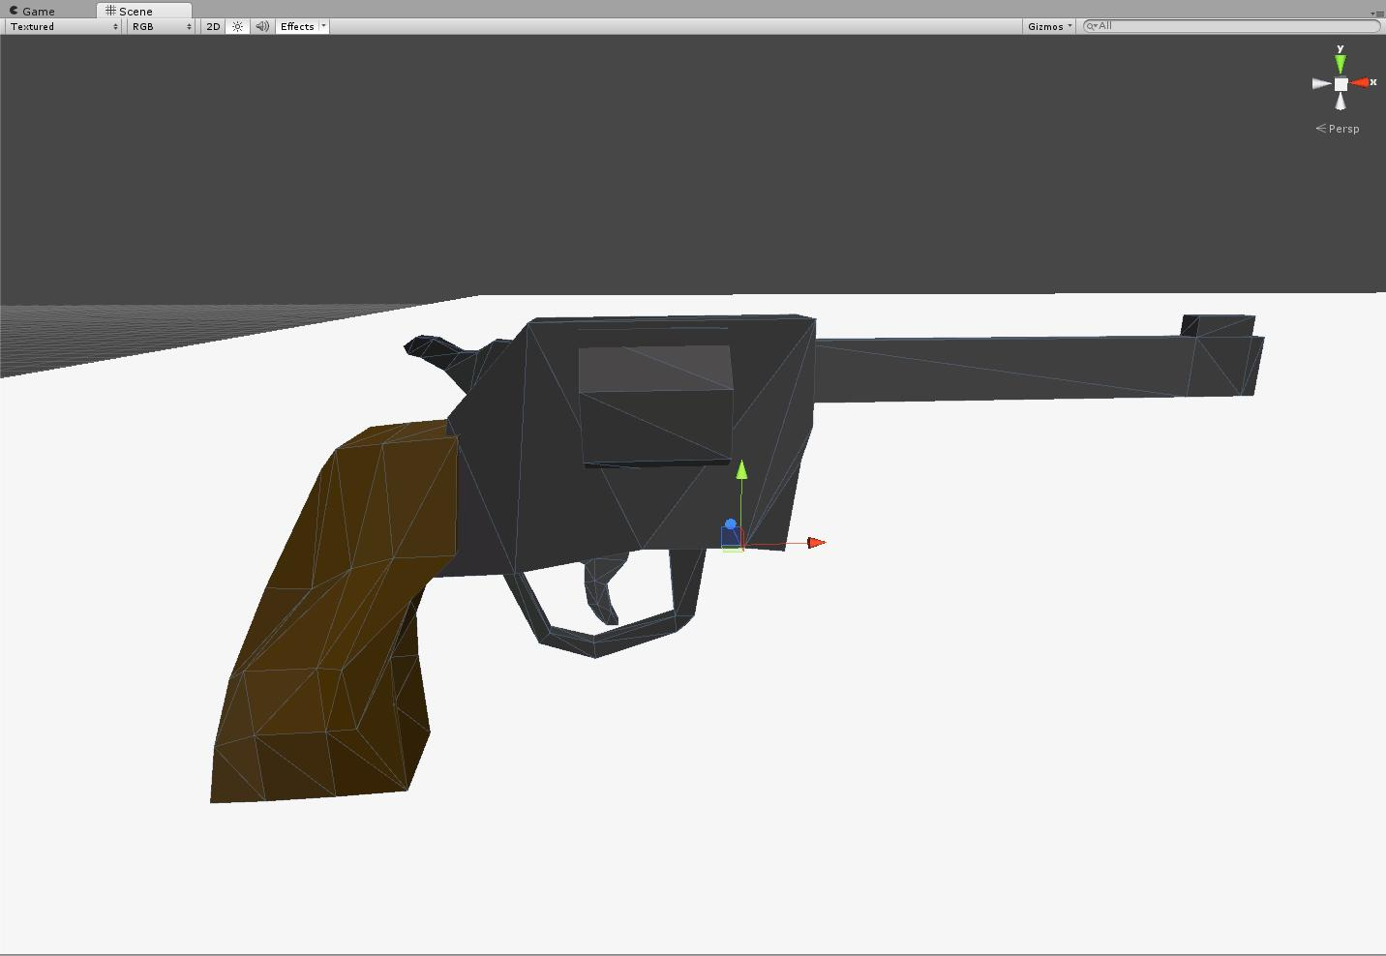

Figure : Revolver – 177 polys

### Rocket

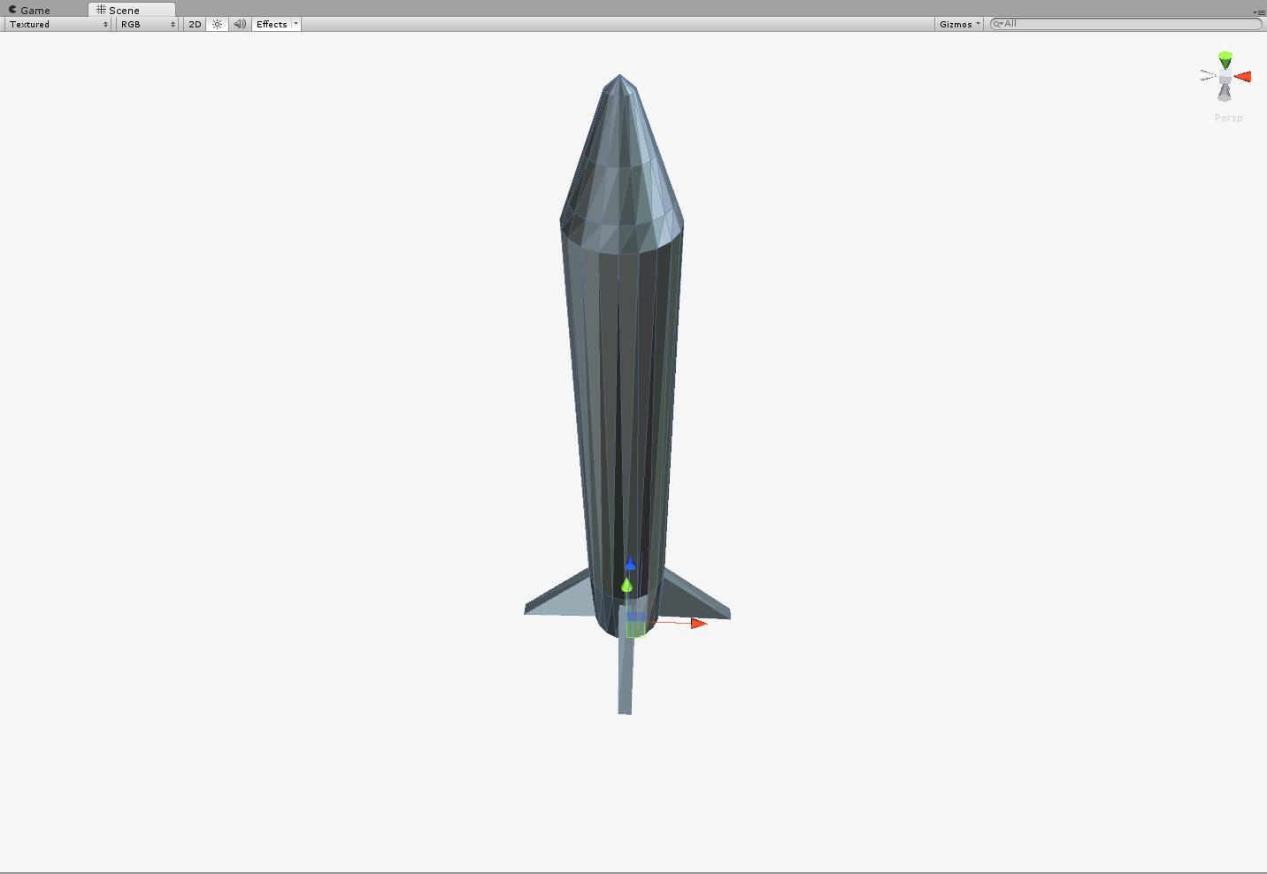

Figure : Rocket – 188 polys

### Round shield

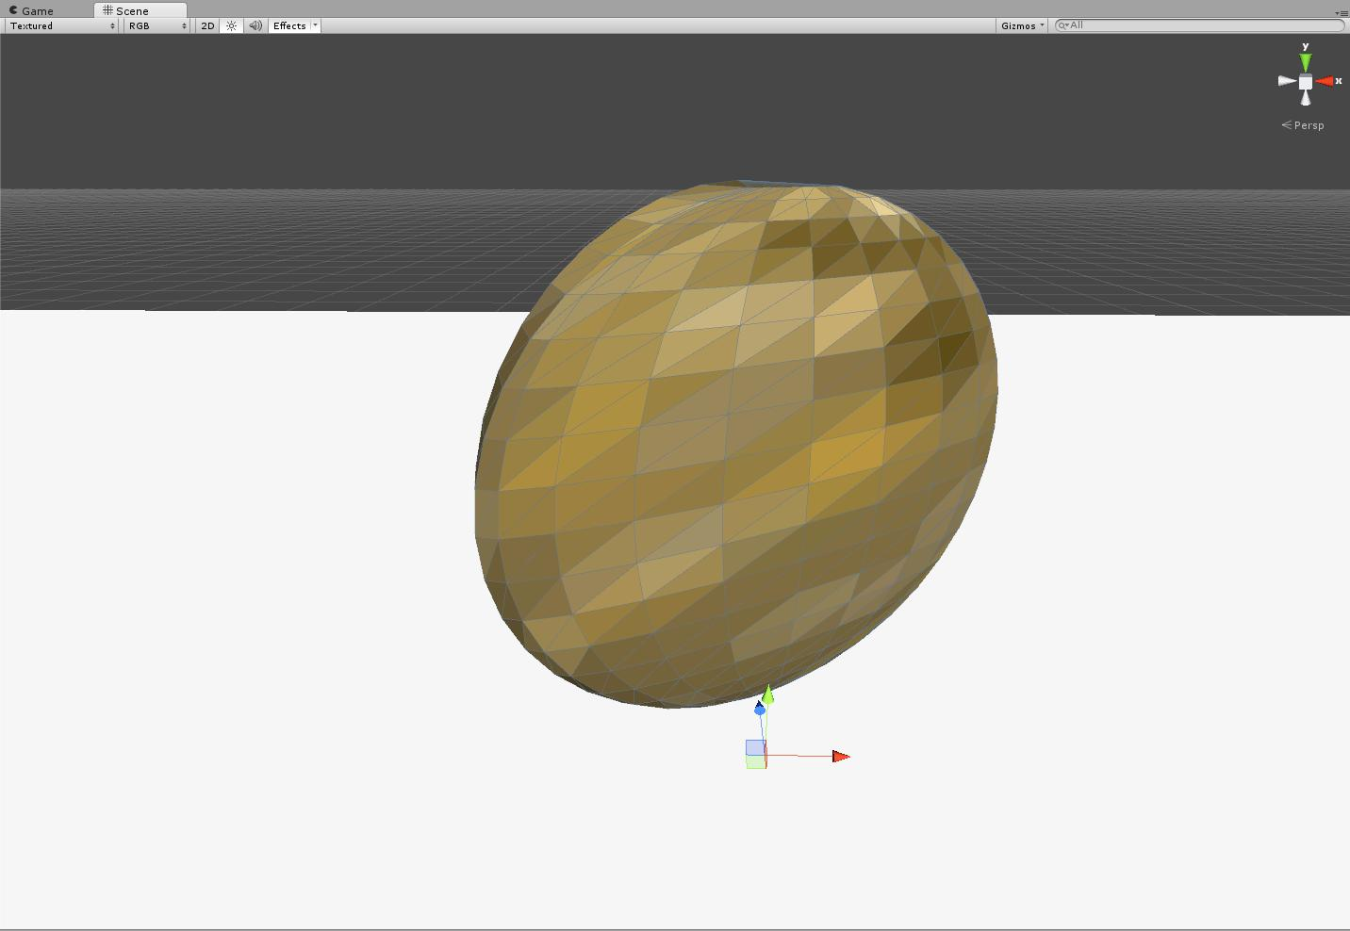

Figure : Round shield – 480 polys

### Satellite

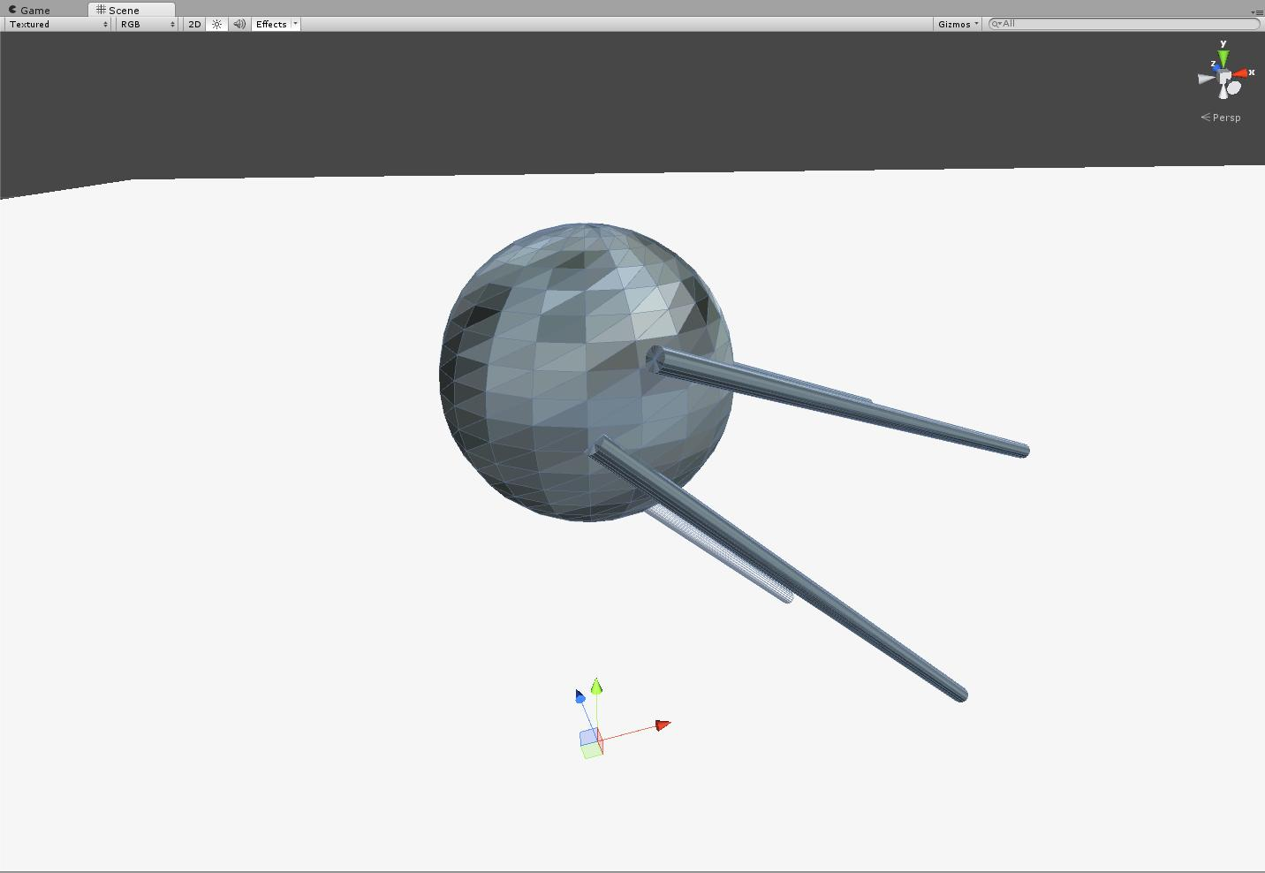

Figure : Satellite – 284 polys

### Scientist

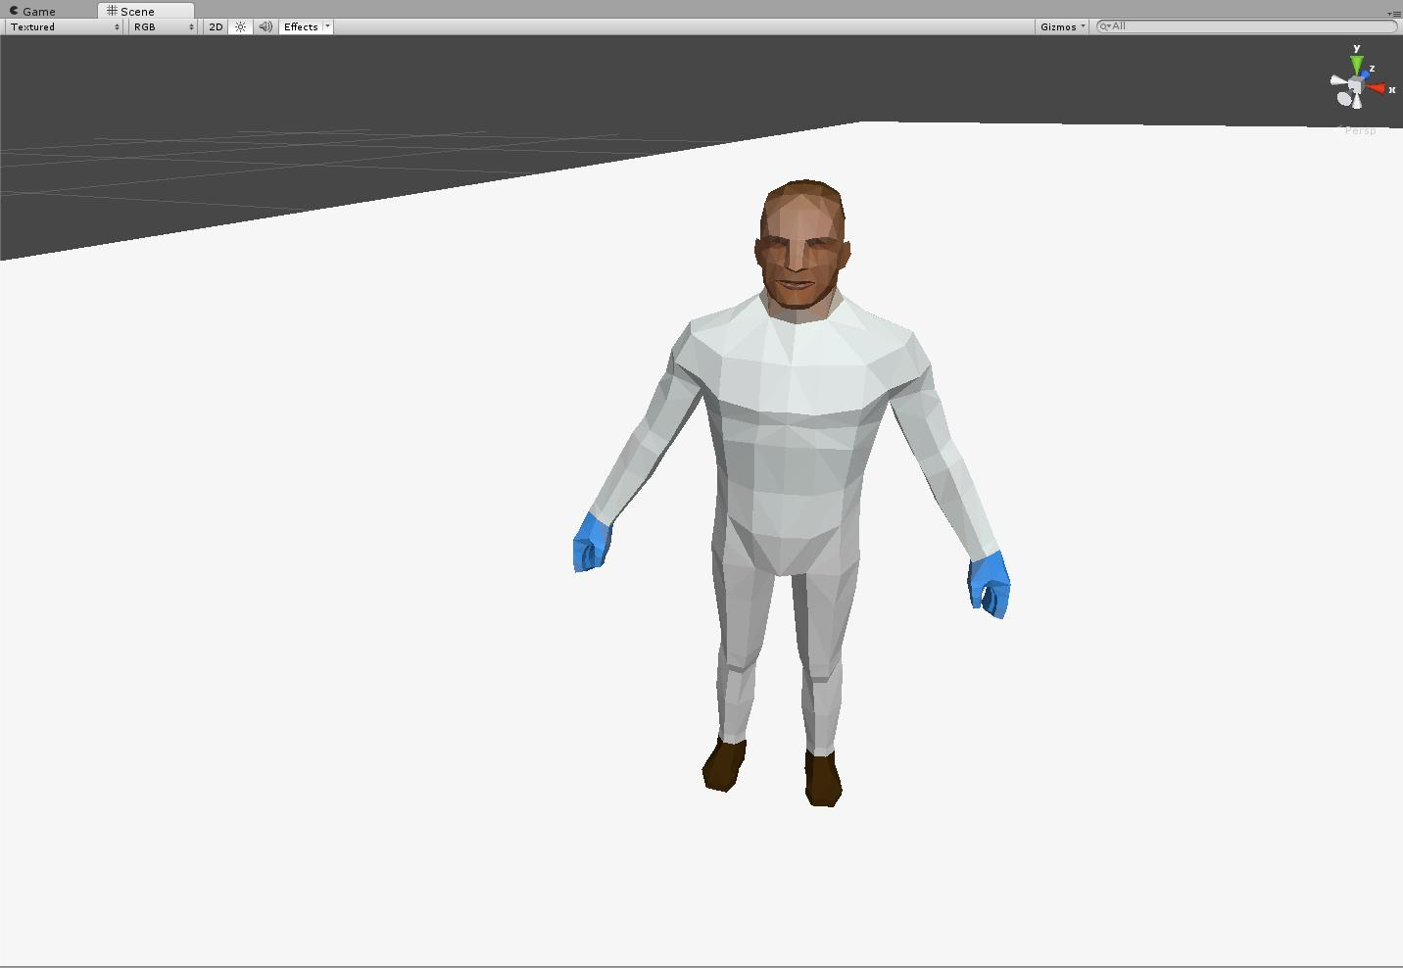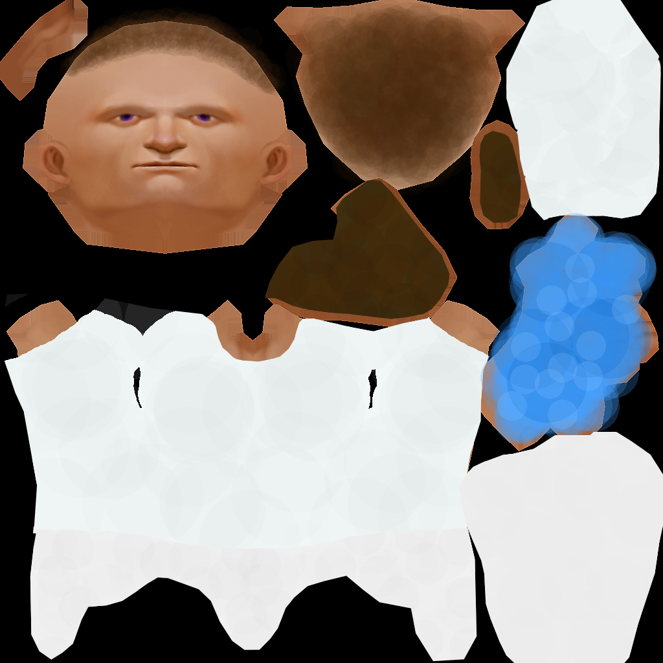

Figure : Scientist – 642 polys

### Seal

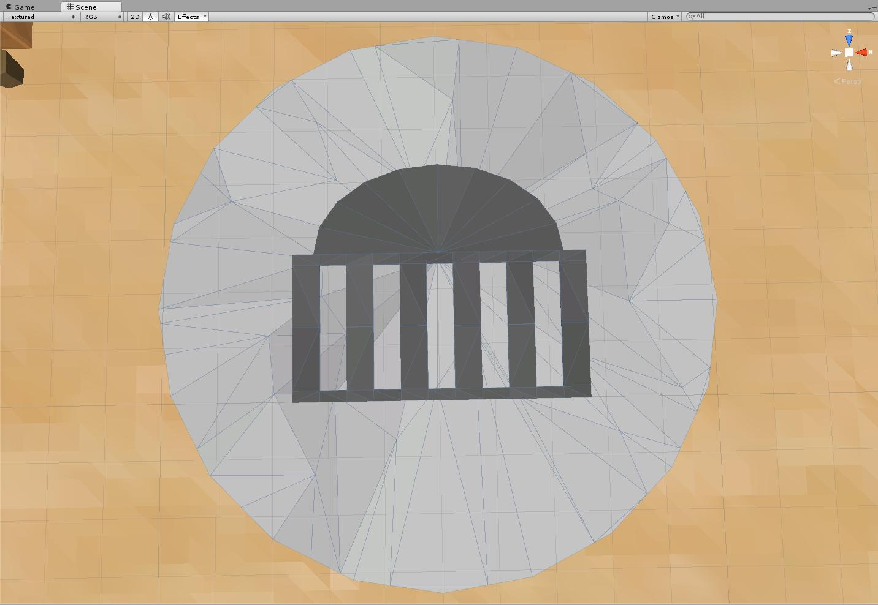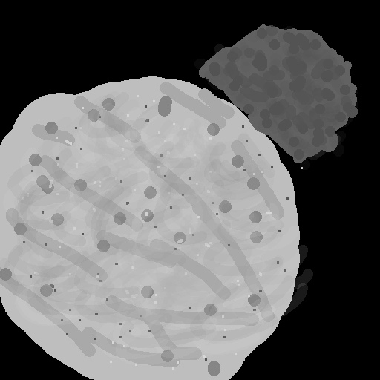

Figure : Seal - 262 polys

### Sickle

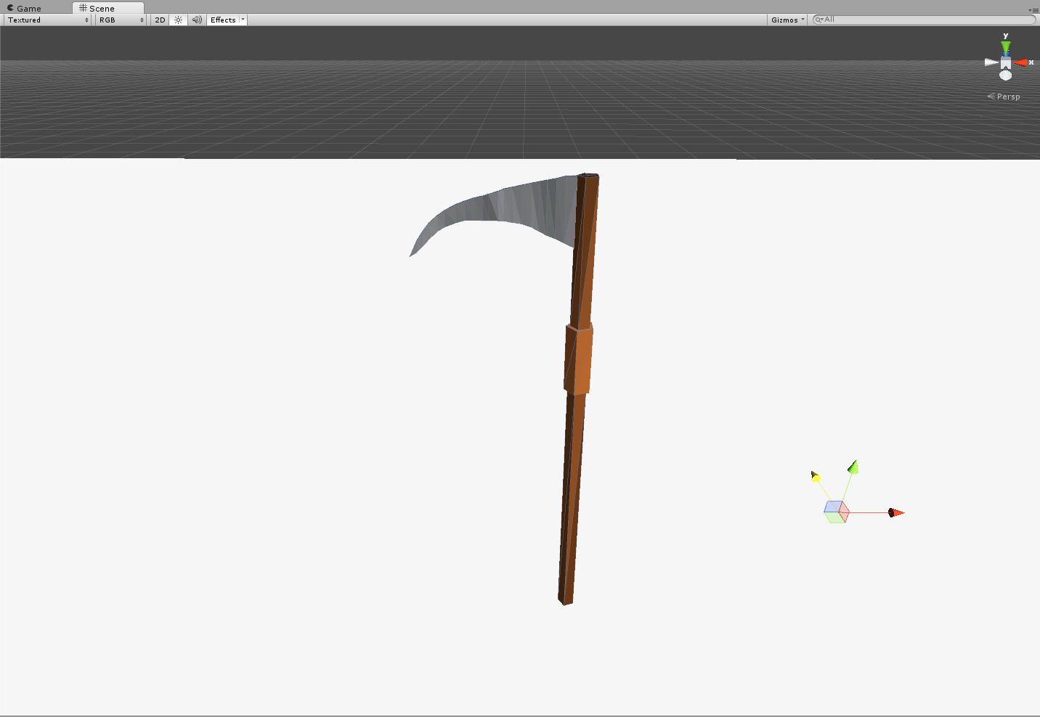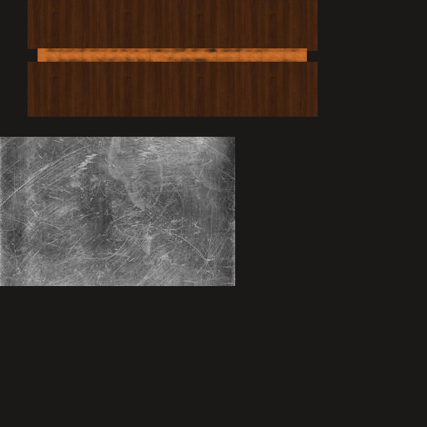

Figure : Sickle – 117 polys

### Space capsule

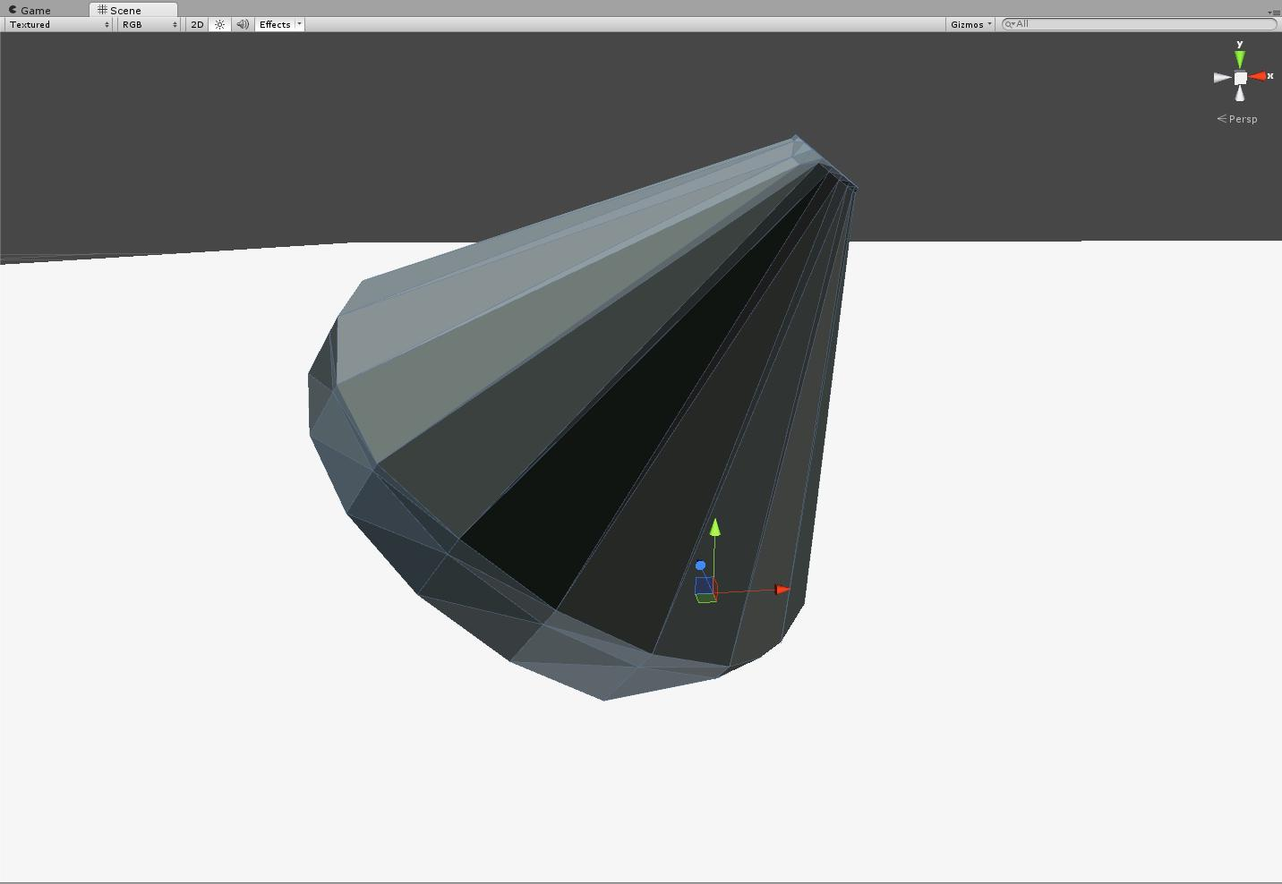

Figure : Space capsule – 160 polys

### Stanchion

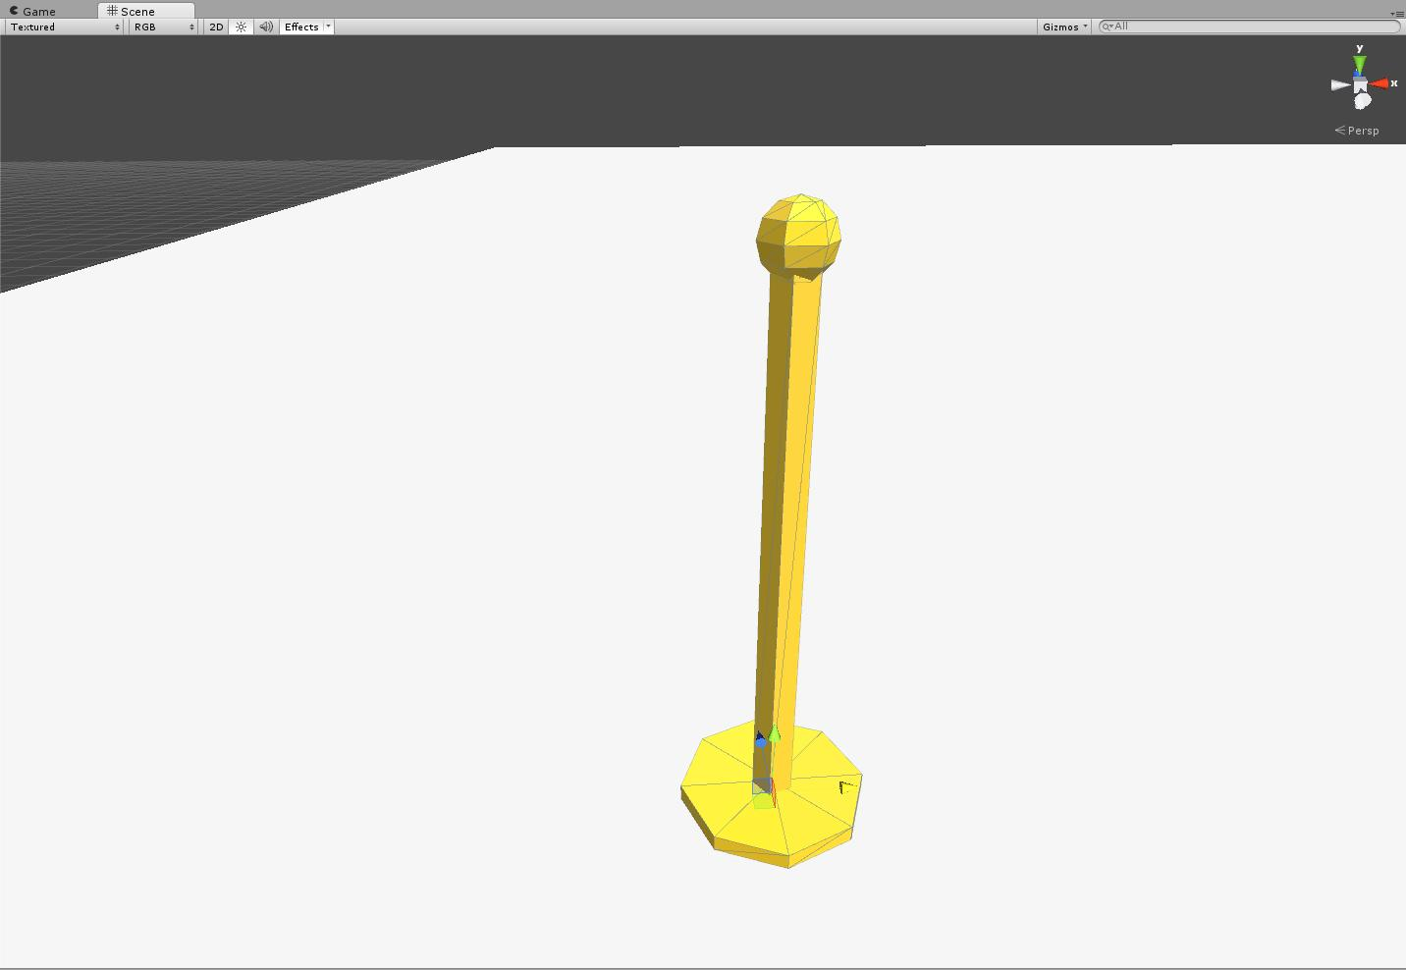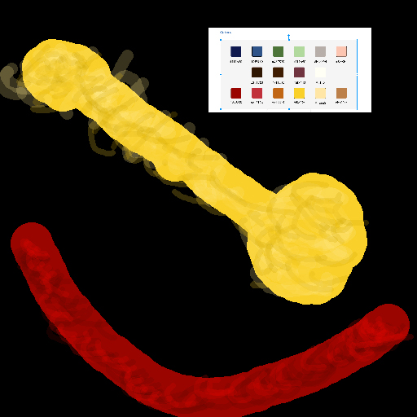

Figure : Stanchion – 58 polys

### Stanchion and rope

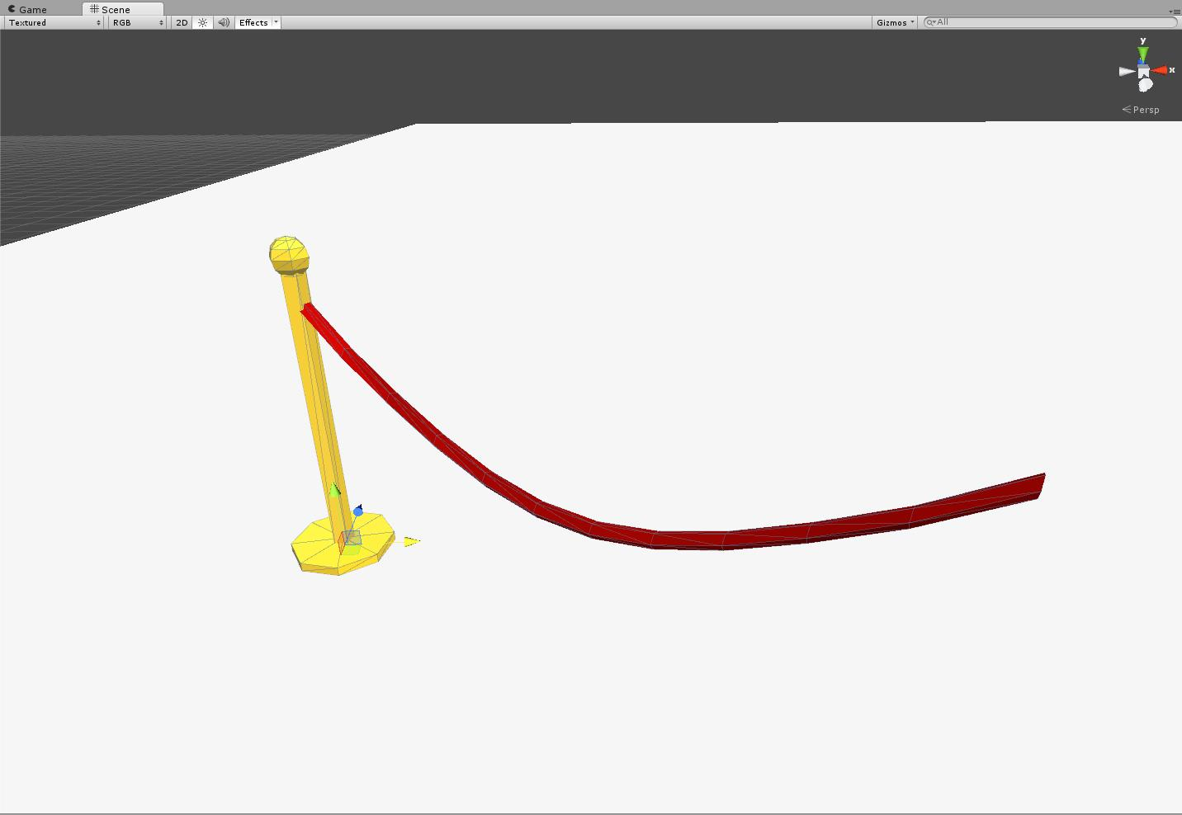

Figure : Stanchion and rope – 123 polys

### Stone wall

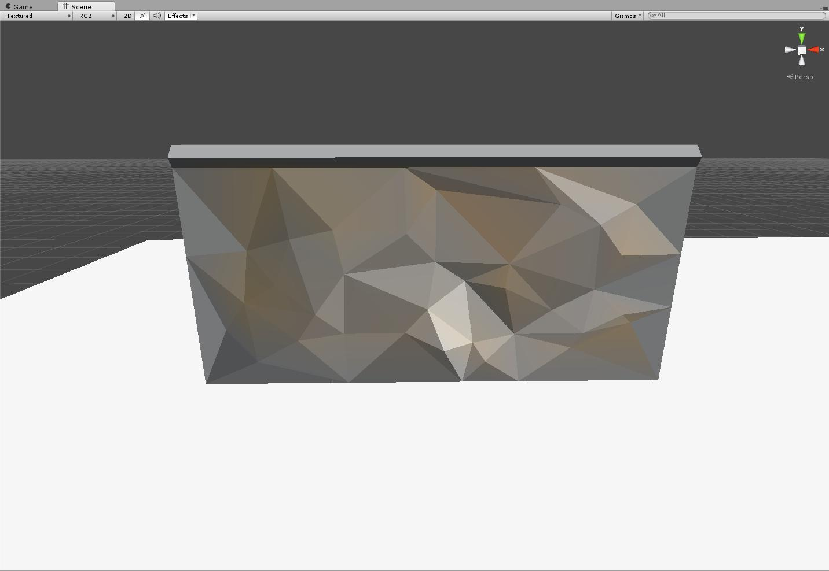

Figure : Stone wall – 64 polys

### Tall bush

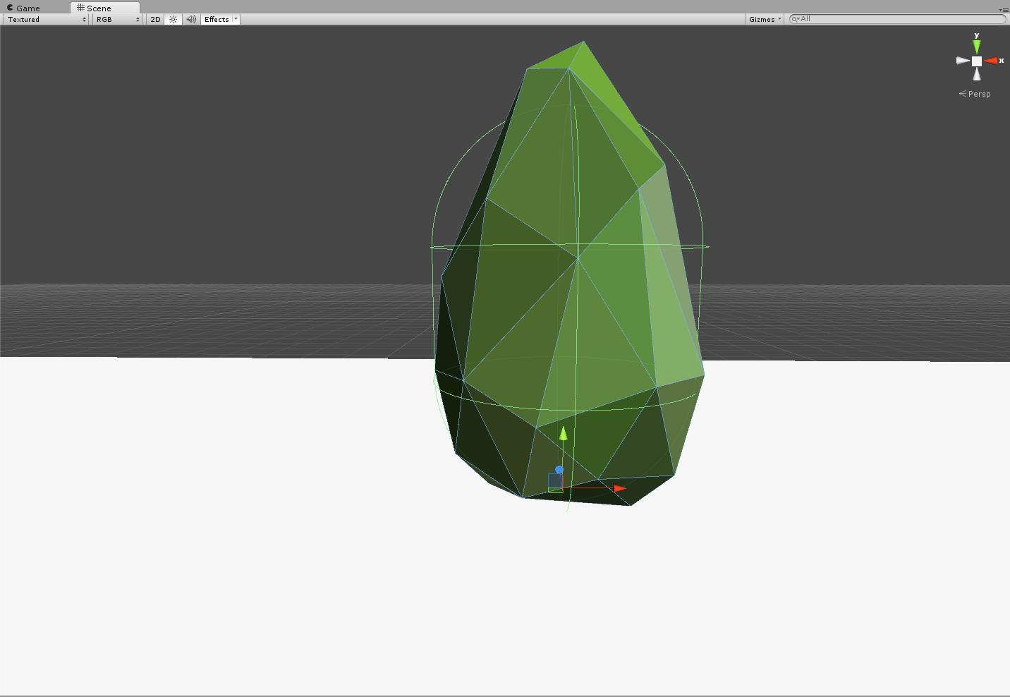

Figure : Tall bush – 66 polys

### Tall display case

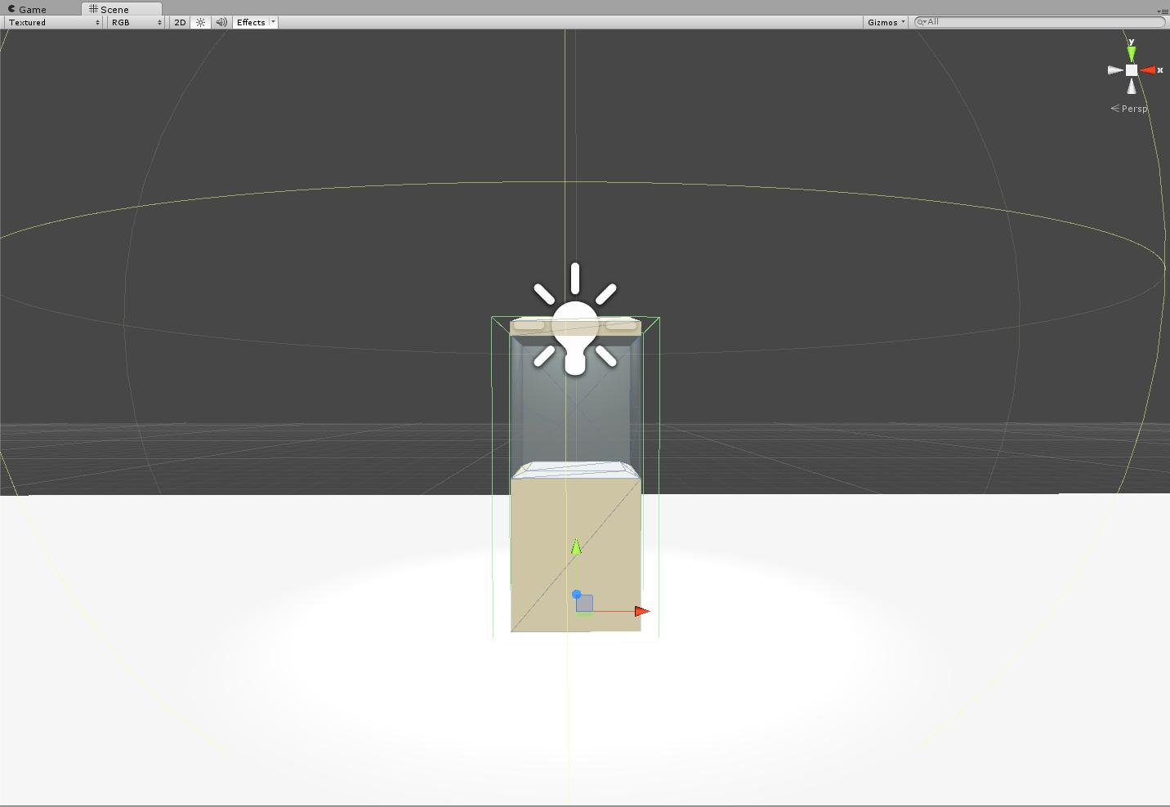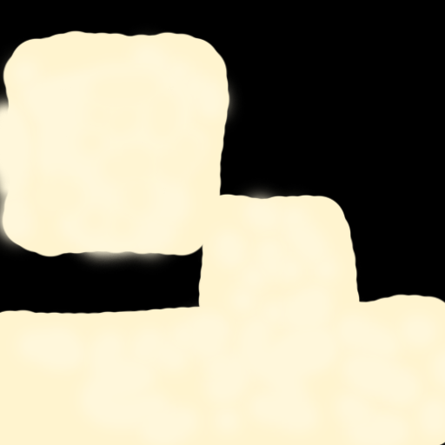

Figure : Tall display case – 28 polys

### Tank

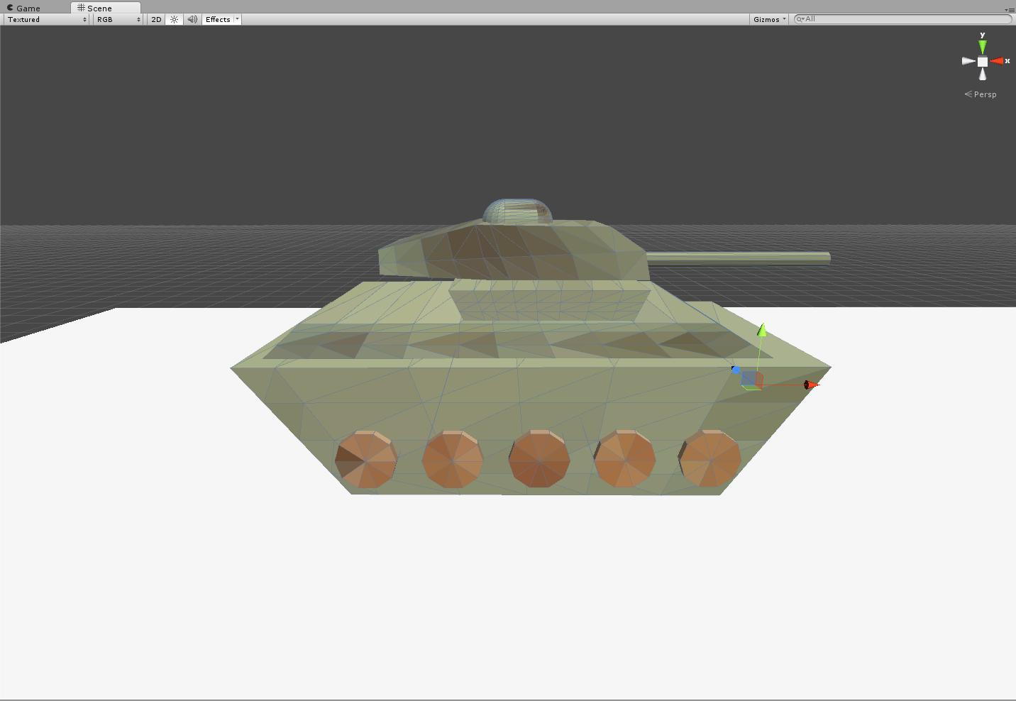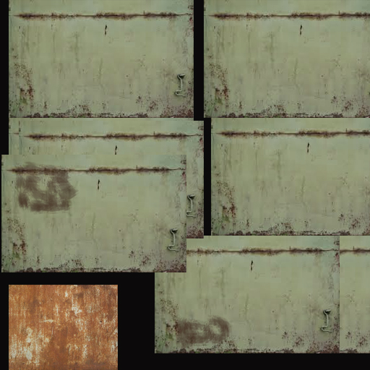

Figure : Tank – 262 polys

### Templar shield

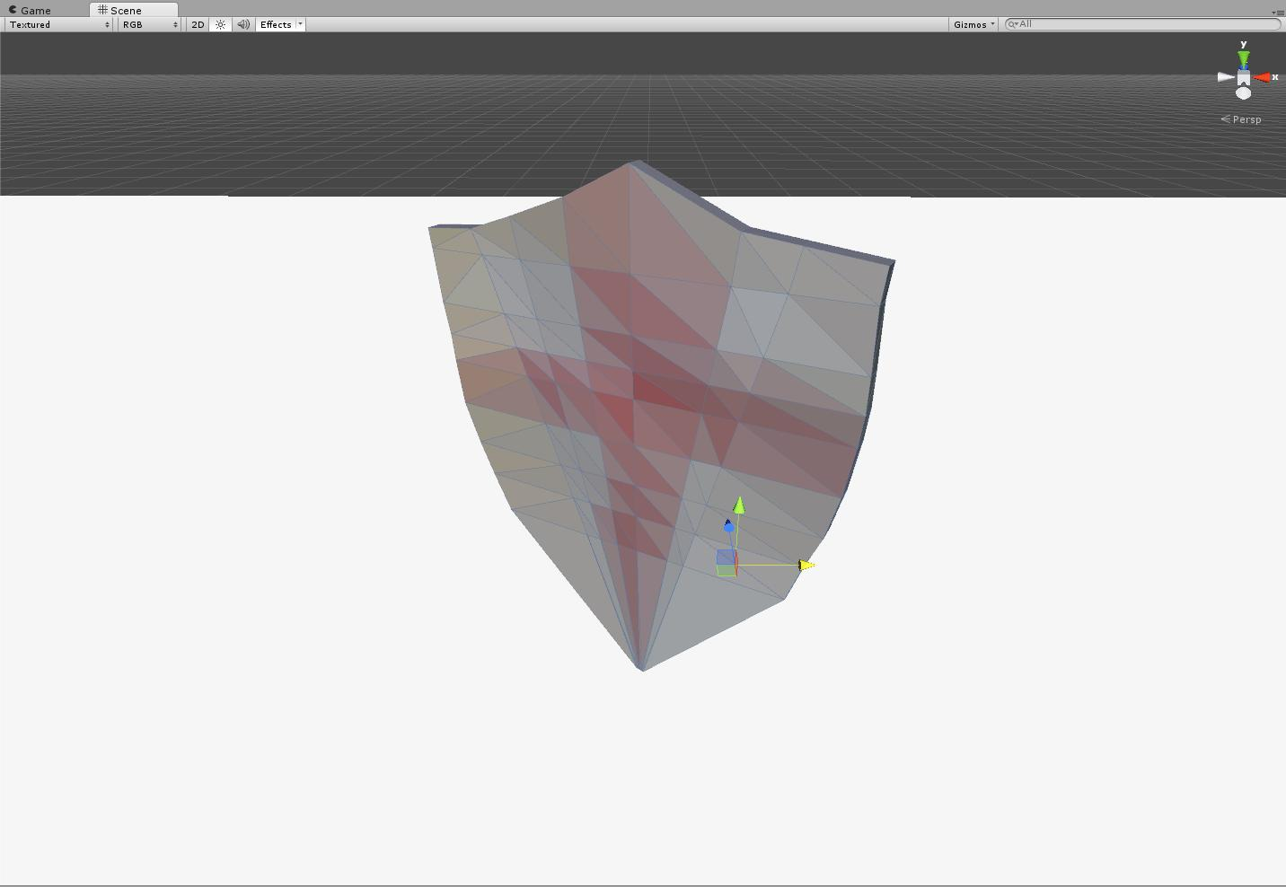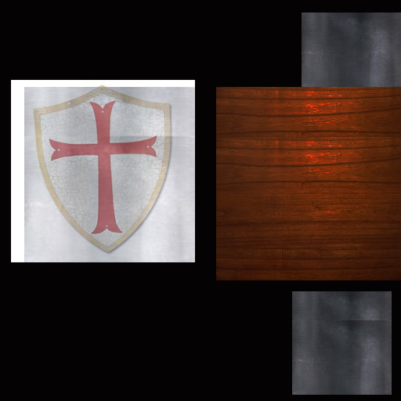

Figure : Templar shield – 176 polys

### Thompson sub-machine gun

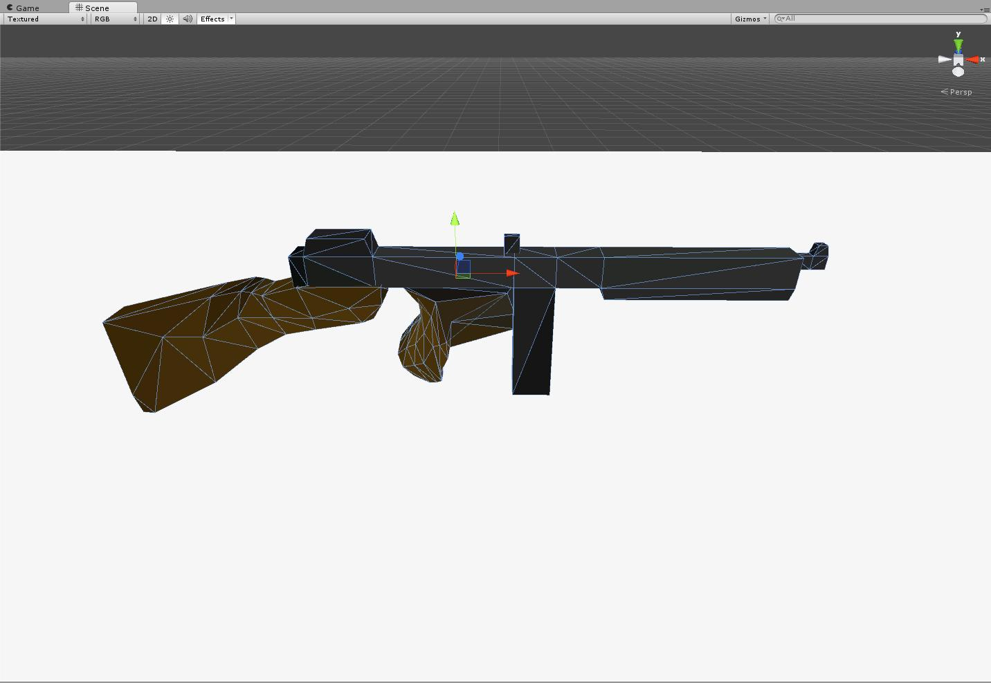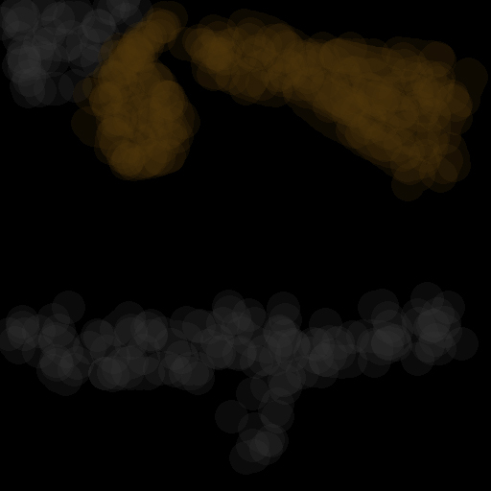

Figure : Thompson submachine gun – 164 polys

### Tree

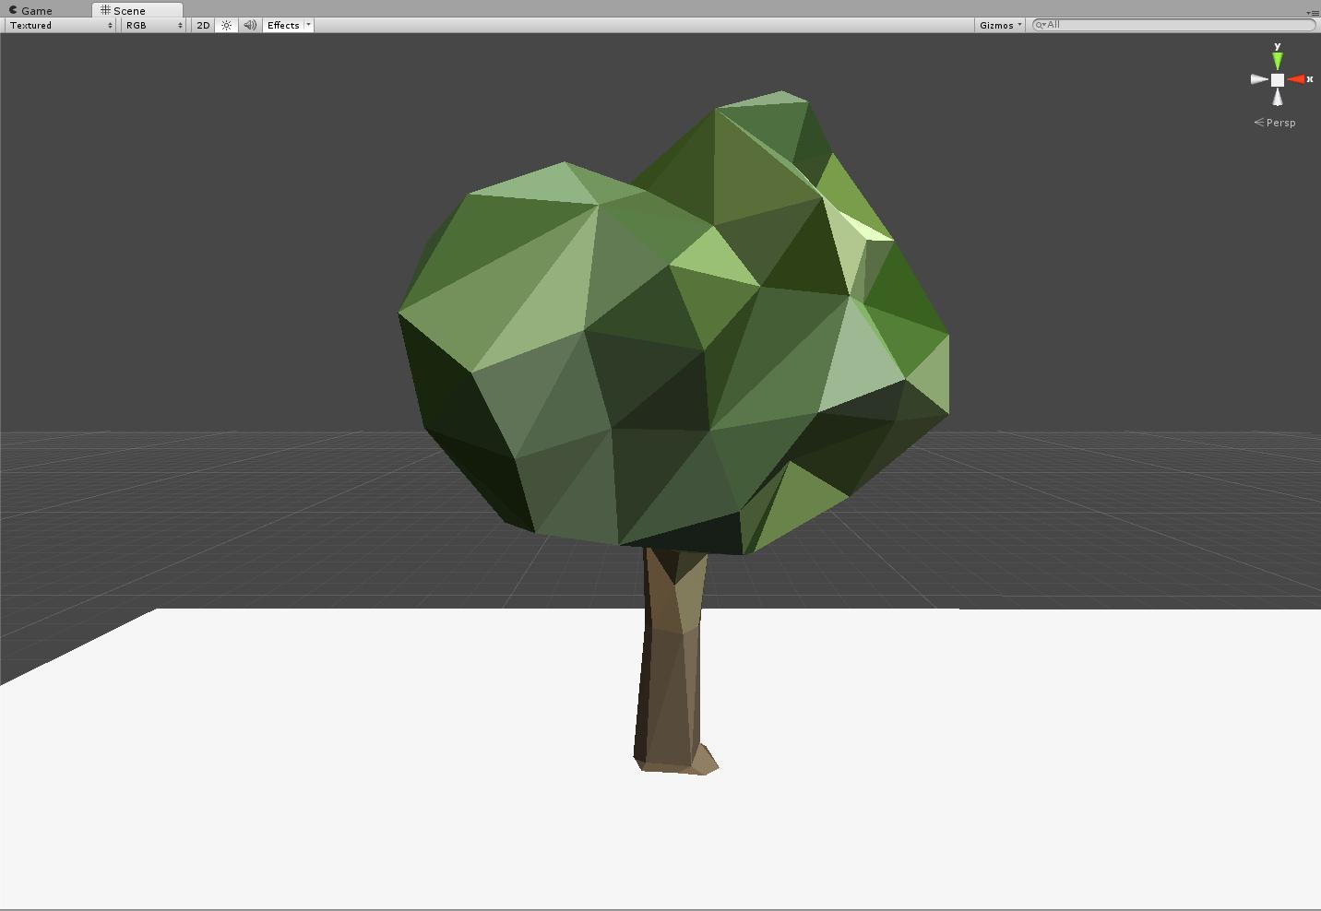

Figure : Tree – 256 polys

### T-Rex

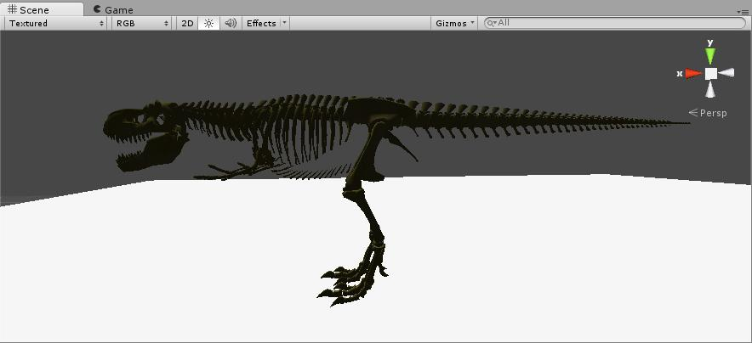

Figure : T-rex - 24916 polys

### Vase – brown

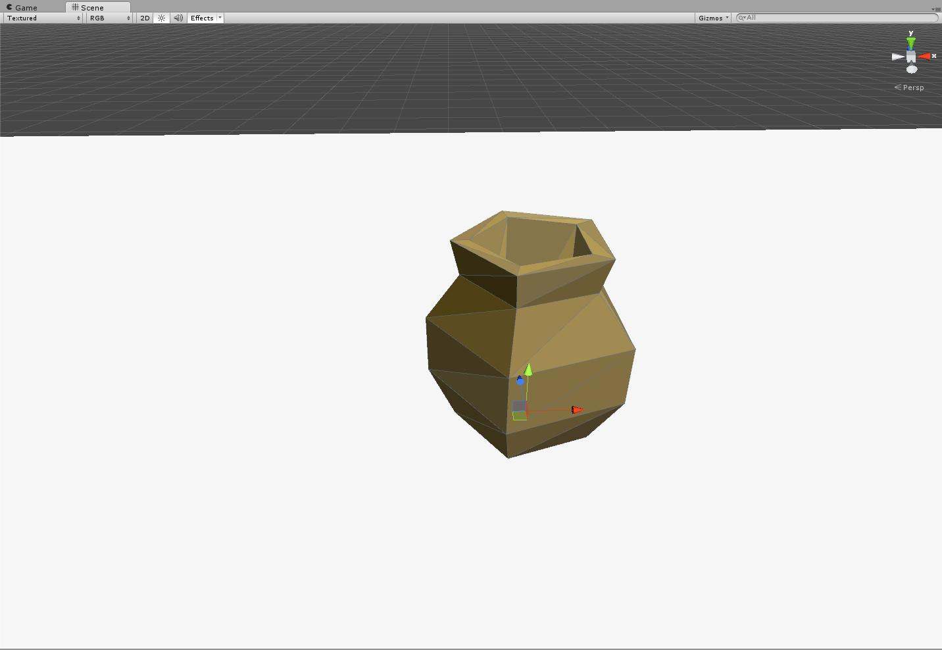

Figure : Vase – brown – 35 polys

### Vase – green

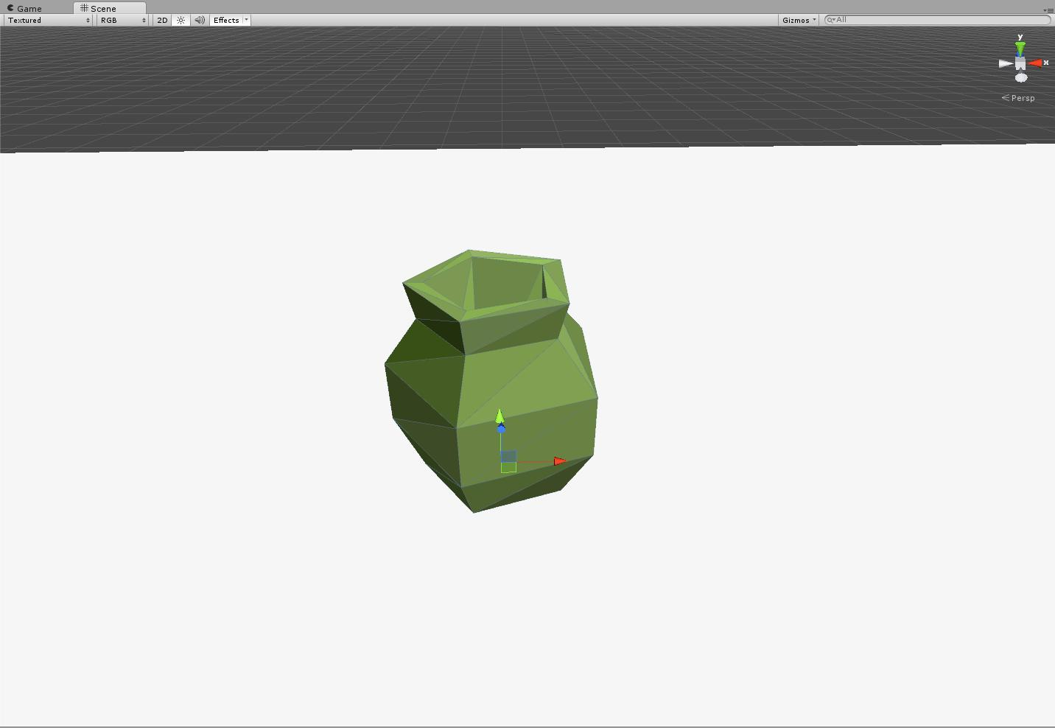

Figure : Vase – green – 35 polys

### Vase - light blue

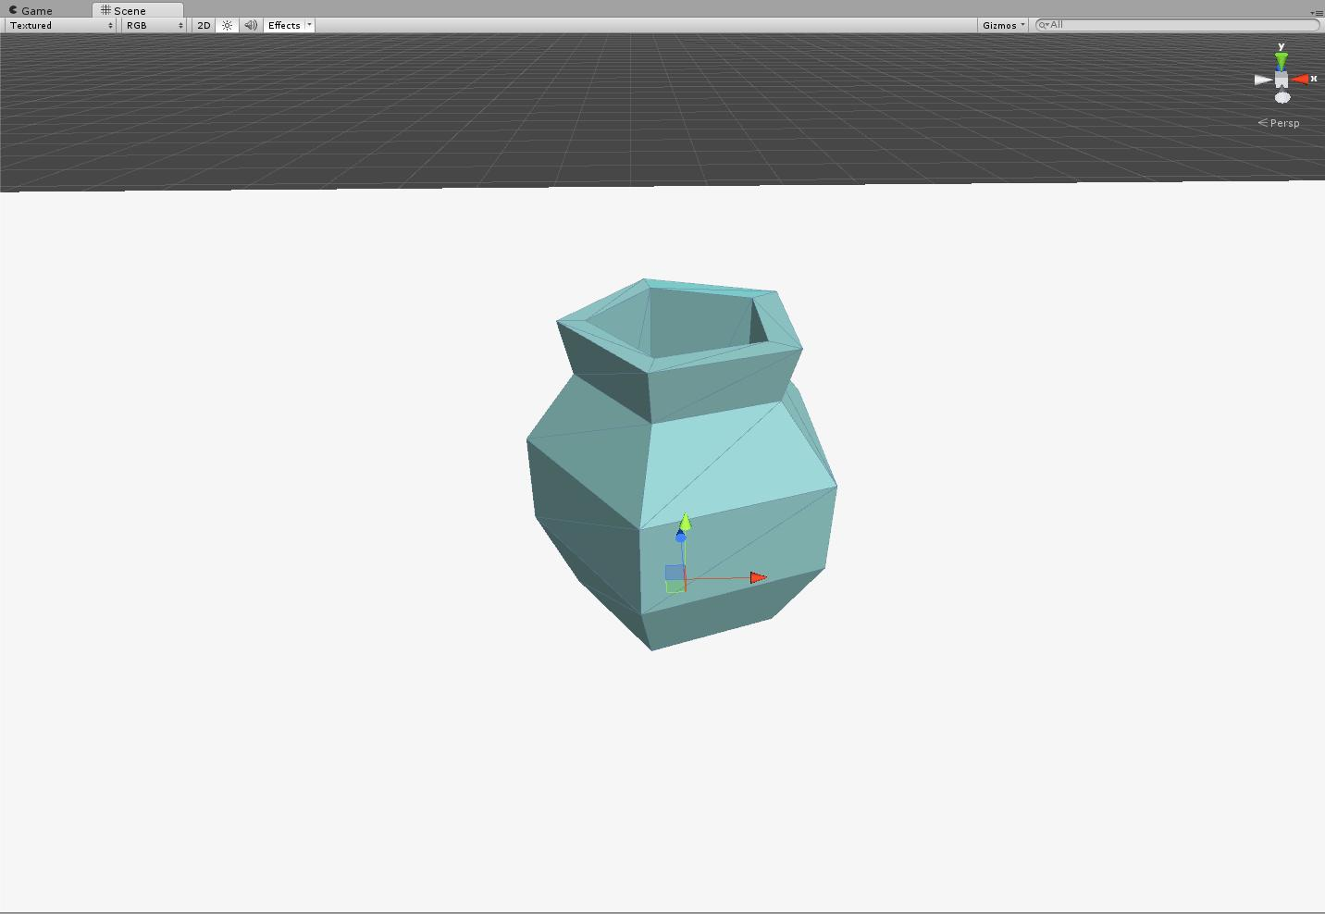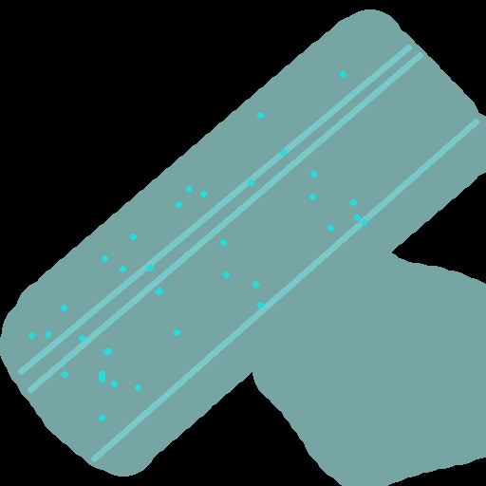

Figure : Vase – light blue – 35 polys

### vase – purple

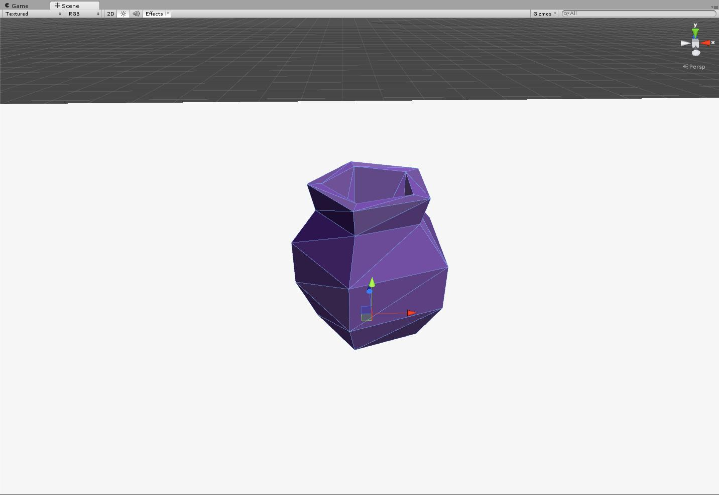

Figure : Vase – purple – 35 polys

### Window

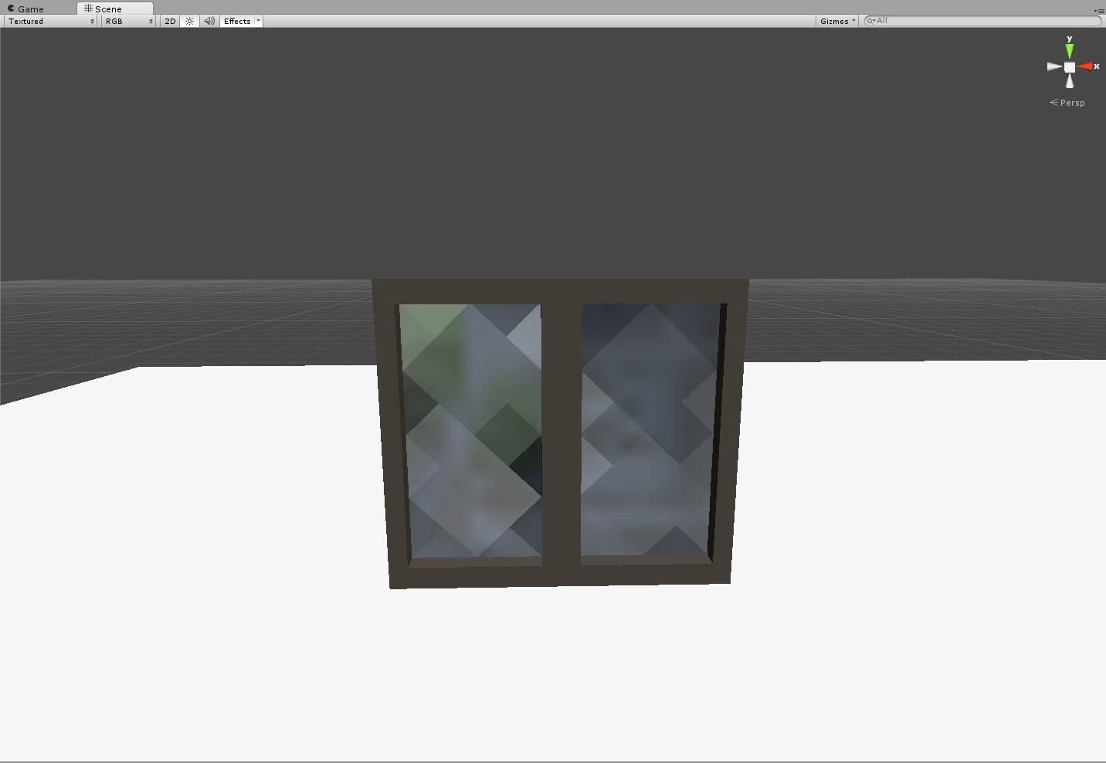

Figure : Window – 128 polys

### Wooden fence

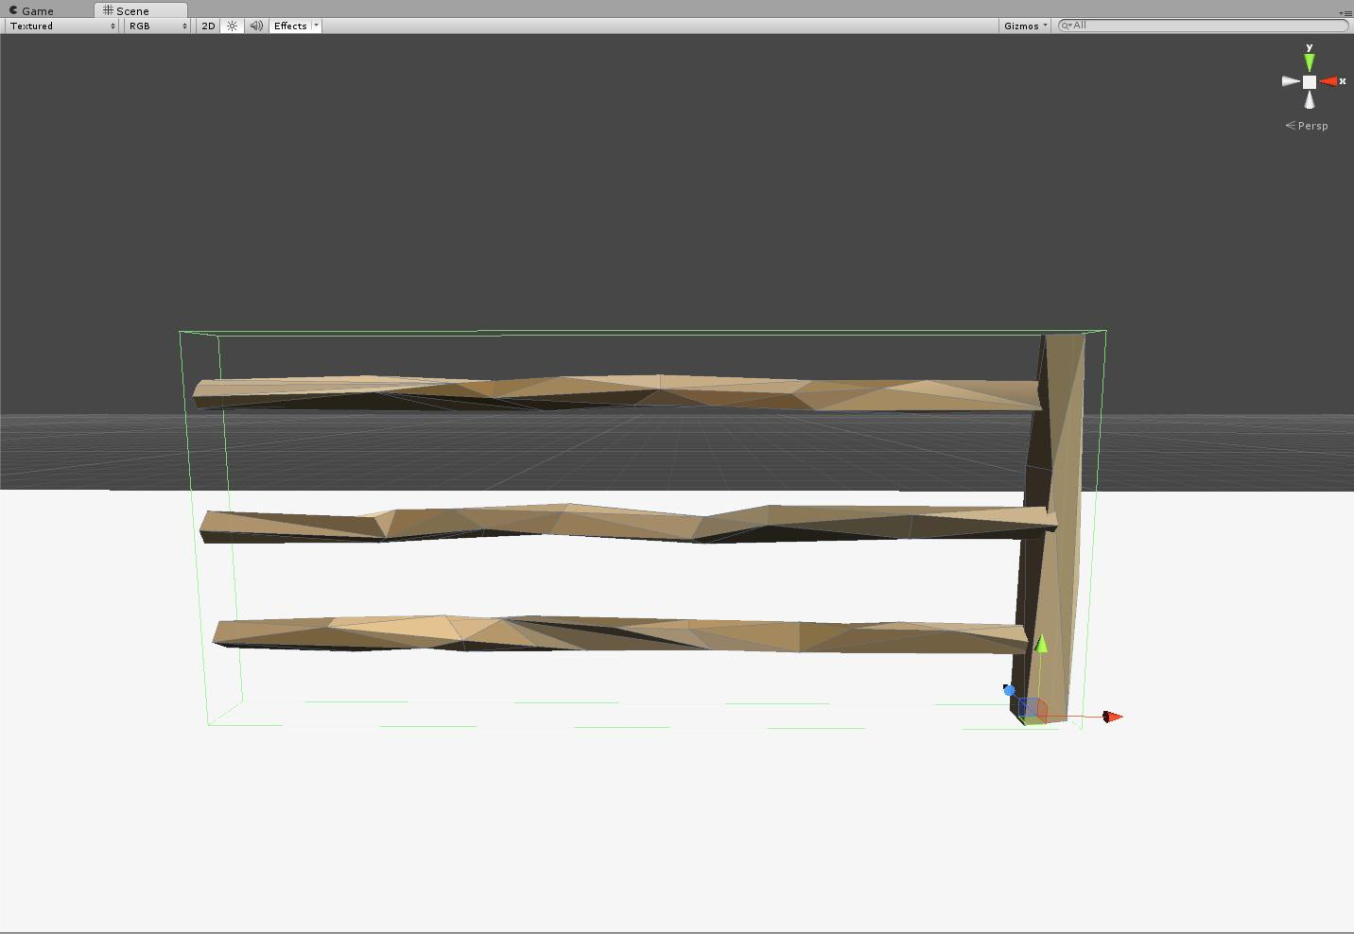

Figure : Wooden fence – 112 polys

## Animations:

* Kesh Idle Animation
  + Loops every second
* Kesh Run Cycle Animation
  + Loops every second
* Kesh Side Roll Animation
* Kesh Block
* Kesh 3 Melee Attacks:
  + Side Slash
  + Forward Jab
  + Downward Slice
* NPC/ Security Guard/ Cop Idle Animation
  + Loops every second
* NPC/ Security Guard/ Cop Run Cycle
  + Loops every second
* NPC Cower Animation
  + Loops every second
* Security Guard/ Cop Baton Melee Animation
  + 2 seconds long
* Cop Pistol Fire Animation
  + 1 second long
* Cop Machine Gun Animation
  + 0.50 seconds long

## Particles:

### Armor pickup

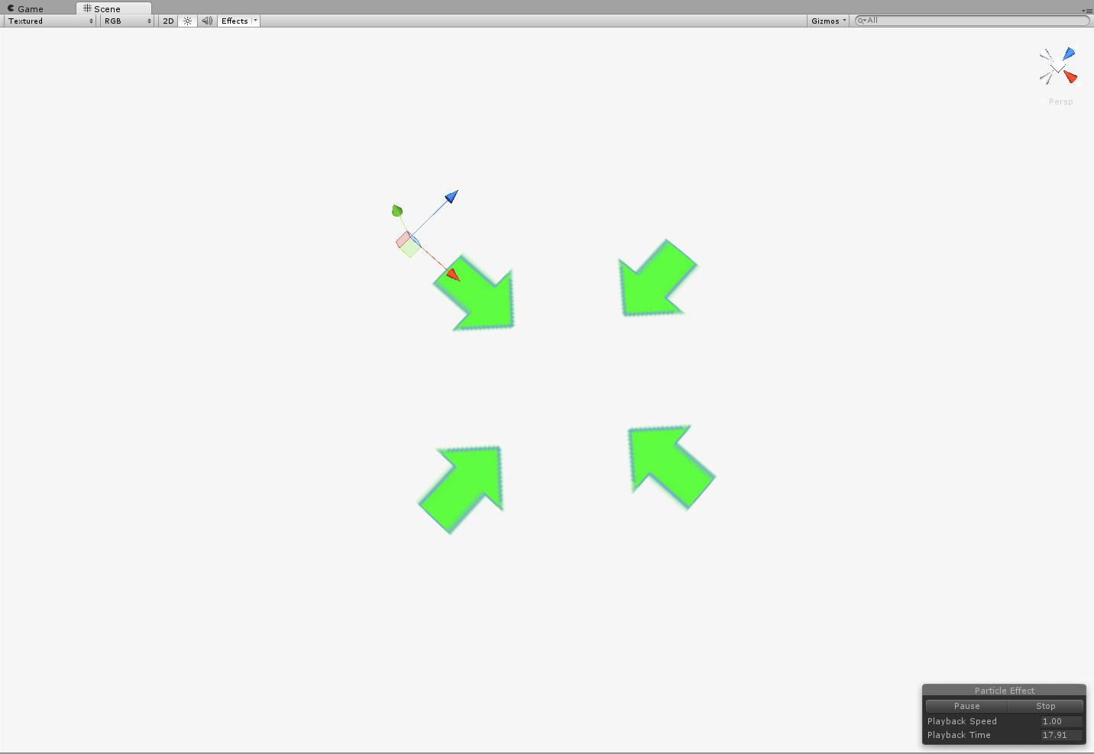

Figure : Armor Pickup

|  |
| --- |
| **Arrow** |
| Duration | 1 |
| Start lifetime | 1 |
| Start speed | 2 |
| Start size | 2 |
| Max particles | 1 |
| Emission | 10 |
| Shape | box |
| Color over lifetime | Alpha 0-255 255-0 Fade in, exist, fade out. |
| Render | Horizontal billboard |

### Block

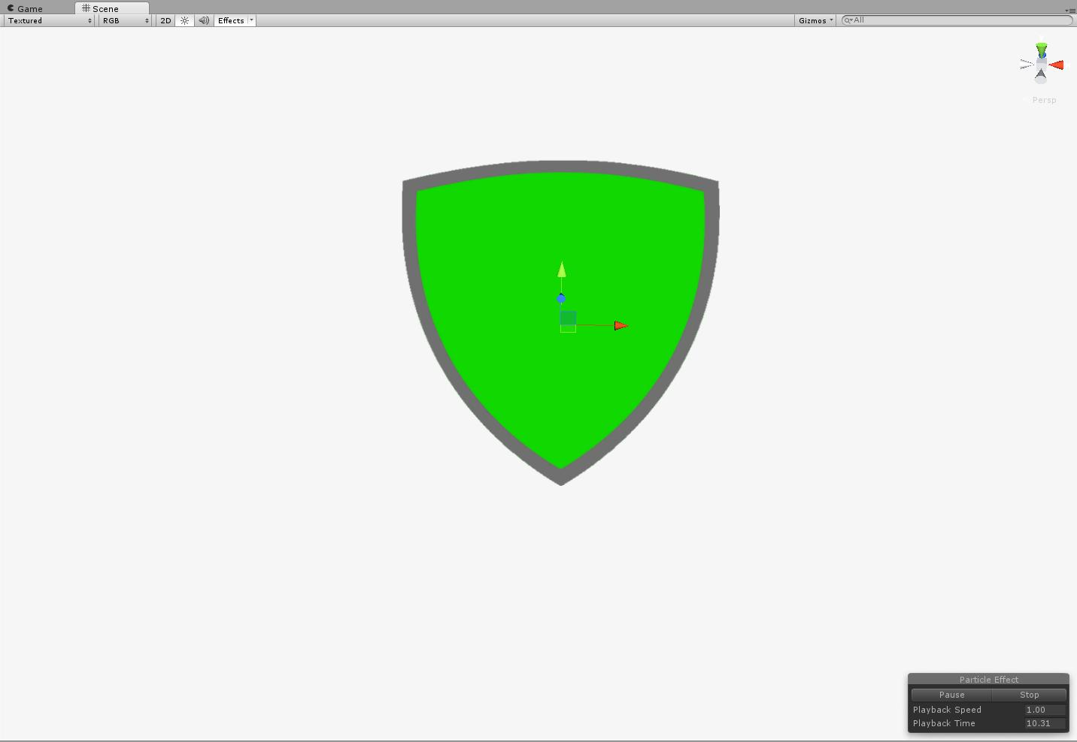

Figure : Block

|  |
| --- |
| **Shield** |
| Duration | 0.5 |
| Start lifetime | 0.5 |
| Start speed | 0 |
| Start size | 0.77 |
| Max particles | 1 |
| Emission | 10 |
| Shape | hemisphere |
| Render | Billboard |

### Blood burst

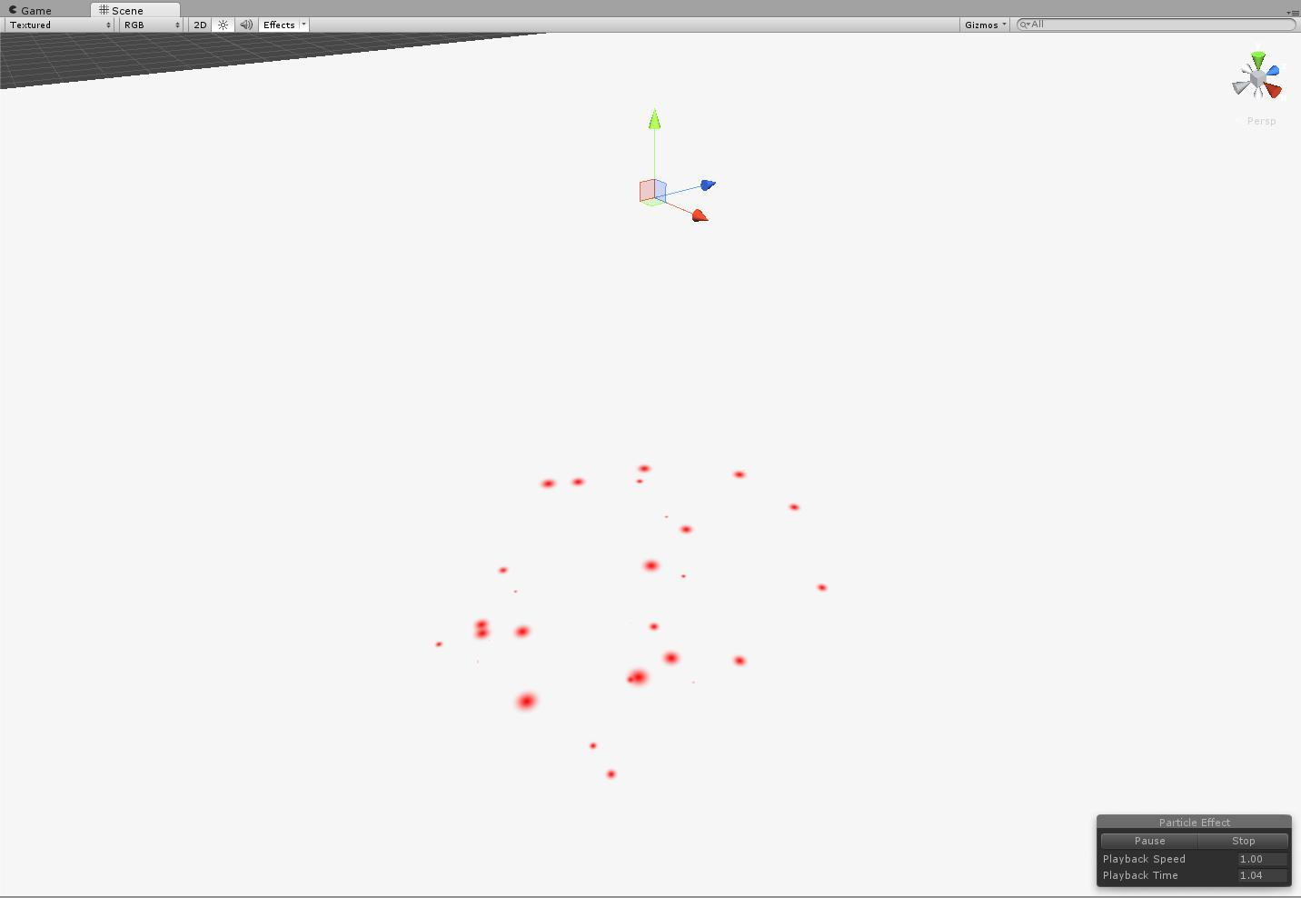

Figure : Blood burst

|  |
| --- |
| **Drops** |
| Duration | 0.2 |
| Start lifetime | 10 |
| Start speed | 1.13 |
| Start size | 0.2 |
| Gravity multiplier | 5 |
| Inherit velocity | 1.77 |
| Max particles | 60 |
| Emission | Burst, 30 |
| Shape | sphere |
| Size over lifetime | 100% - 300% 300%-0% |
| Collusion | Yes, planes |
| Render | Horizontal billboard |

### Charge

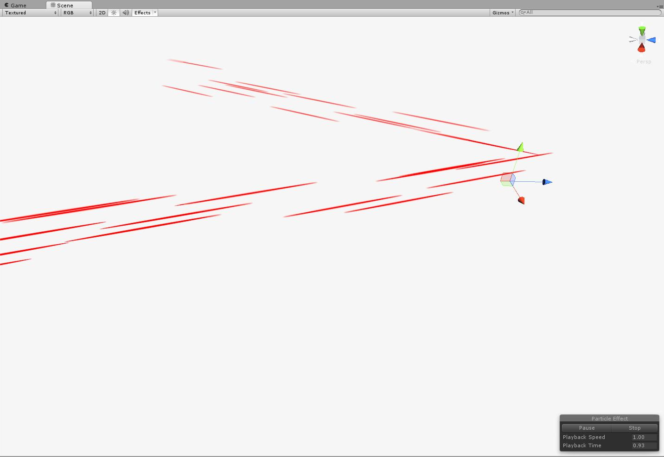

Figure : Charge

|  |
| --- |
| **Sparks** |
| Duration | 1 |
| Start lifetime | 1 |
| Start speed | 9 |
| Start size | 0.2 |
| Max particles | 1000 |
| Emission | 20 |
| Shape | box |
| Render | Mesh, plane |

### Drive

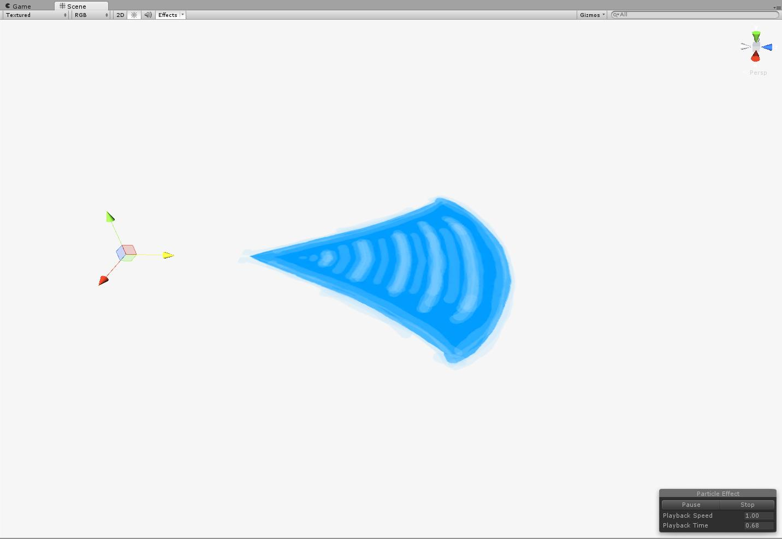

Figure :Drive

|  |
| --- |
| **Wave** |
| Duration | 1 |
| Start lifetime | 1 |
| Start speed | 5 |
| Start size | 0.1 |
| Max particles | 1 |
| Emission | 20 |
| Shape | box |
| Size over lifetime | Quadruple |
| Render | Horizontal billboard |

### Gunshot

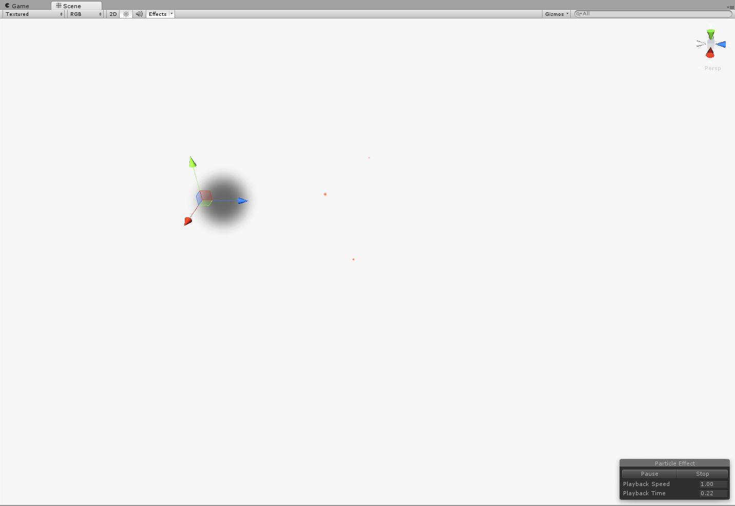

Figure : Gunshot

|  |
| --- |
| **Sparks** |
| Duration | 0.2 |
| Start Lifetime | 0.2 |
| Start Speed | 7.33 |
| Start Size | 0.02 |
| Gravity multiplyer | 0.78 |
| Max Particles | 40 |
| Emission Rate | 30 |
| Shape | Cone |
| Color over lifetime | Alpha 0-255 255-0 Fade in, exist, fade out. |
| Angle | 20.48 |
| Radius | 0.01 |
| Limit velocity over lifetime | yes |
| Color over lifetime | Alpha 255 – 255 – 0 exist, fade. |
| Size over lifetime | Yes |
| Render Mode | Billboard |

|  |
| --- |
| **Smoke** |
| Duration | 3 |
| Start Lifetime | 3 |
| Start Speed | 0.35 |
| Start Size | 0.5 |
| Gravity multiplier | -0.05 |
| Max Particles | 3 |
| Emission Rate | 10 |
| Shape | Cone |
| Angle | 8.98 |
| Radius | 0.025 |
| Color over lifetime | Alpha 255 – 255 – 0 exist, fade. |
| Size over lifetime | Yes, grow 3 times the size |
| Render Mode | Billboard |

### Exit Scene helper

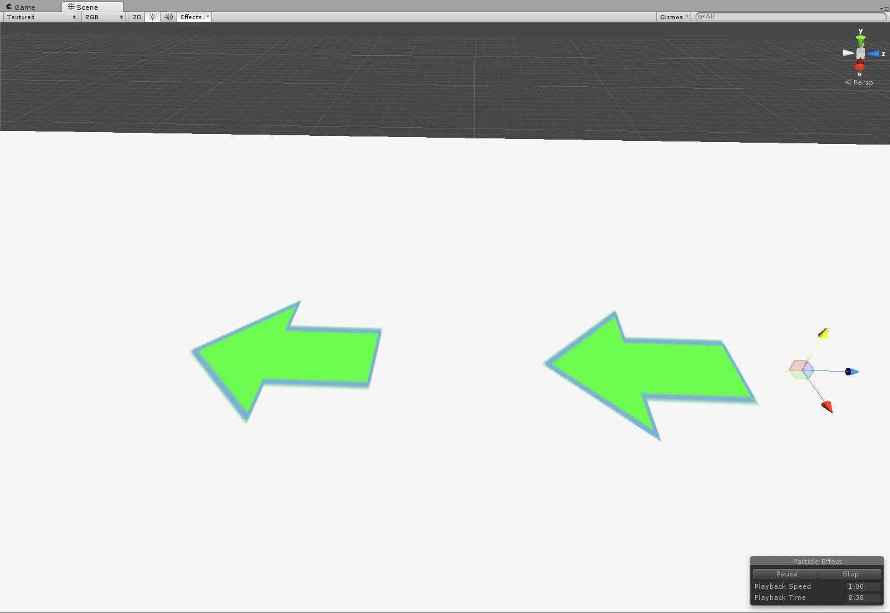

Figure : Exit scene helper

|  |
| --- |
| **Arrow** |
| Duration | 2.0 |
| Start Lifetime | 2 |
| Start Speed | 3 |
| Start Size | 8 |
| Start rotation | 90 |
| Play on awake | Yes |
| Max Particles | 1 |
| Emission Rate | 10 |
| Shape | box |
| Color over lifetime | Alpha 0-255 255-0 Fade in, exist, fade out. |
| Render Mode | Horizontal Billboard |

### Stalwart

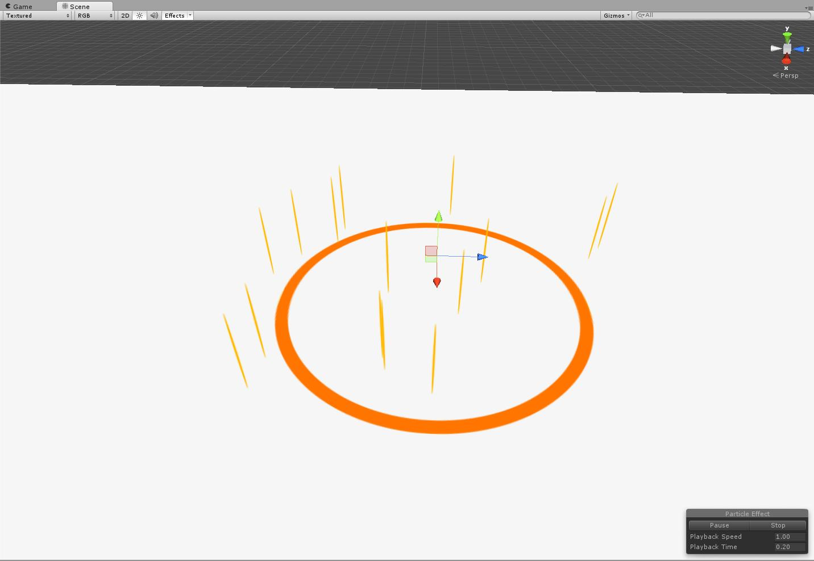

Figure : Stalwart

|  |
| --- |
| **Pillar Effect** |
| Duration | 0.50 |
| Start Lifetime | 0.50 |
| Start Speed | 1 |
| Start Size | 2 |
| Inherit Velocity | 0.5 |
| Max Particles | 15 |
| Emission Rate | 500 |
| Shape | Sphere |
| Radius | 0.71 |
| Render Mode | Vertical Billboard |

|  |
| --- |
| **Ring** |
| Duration | 0.50 |
| Start Lifetime | 0.50 |
| Start Size | 0.2 |
| Max Particles | 1 |
| Emission Rate | 1 |
| Shape | Sphere |
| Radius | 0.01 |
| Color over Lifetime | Alpha 0-255 255-0 Fade in, exist, fade out. |
| Renderer | Horizontal Billboard |

### Unbreakable

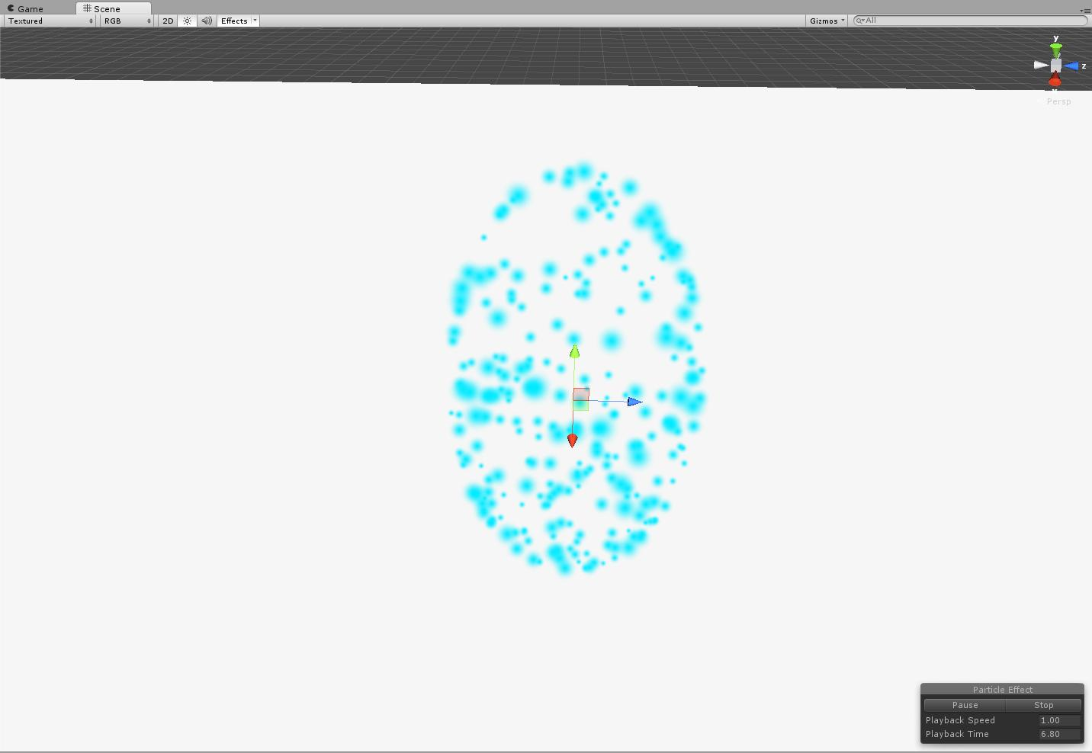

Figure : Unbreakable

|  |  |
| --- | --- |
| Duration | 15 |
| Start Lifetime | 0.5 |
| Start Size | 0.05 – 0.18 |
| Max Particles | 1000 |
| Emission rate | 500 |
| Shape | Sphere |
| Radius | 1.47 |
| Emit from shell | Yes |

## Textures and Materials:

* TBD